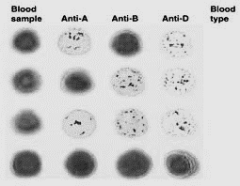

A+

GAB+

OAB+

AO-