1. hello

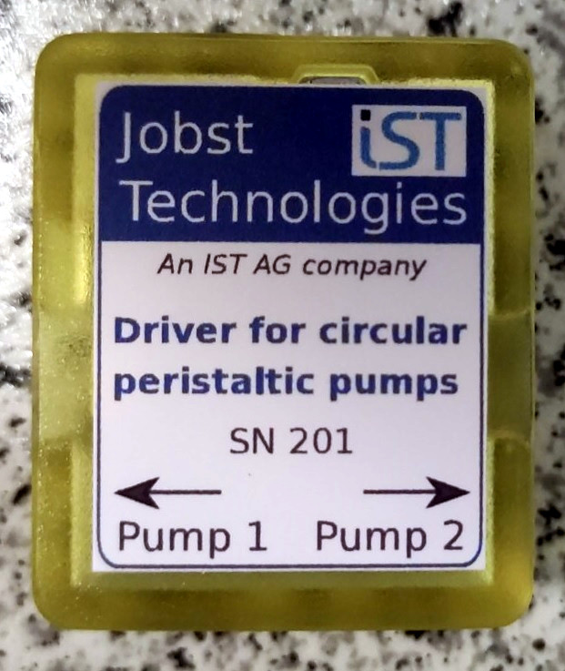Figure 1: Label on the pump driver housing.

1. hello