GST INVOICE by jgaonkar@gmail.com
1 . Screen - MainMenu
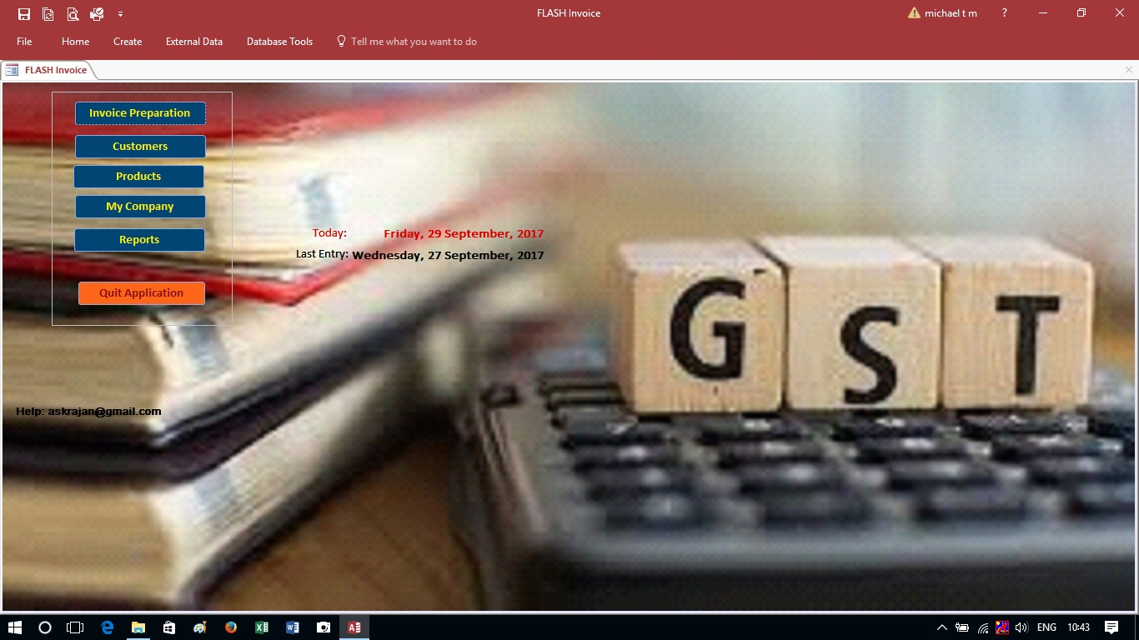
2 . Screen – Invoice Entry
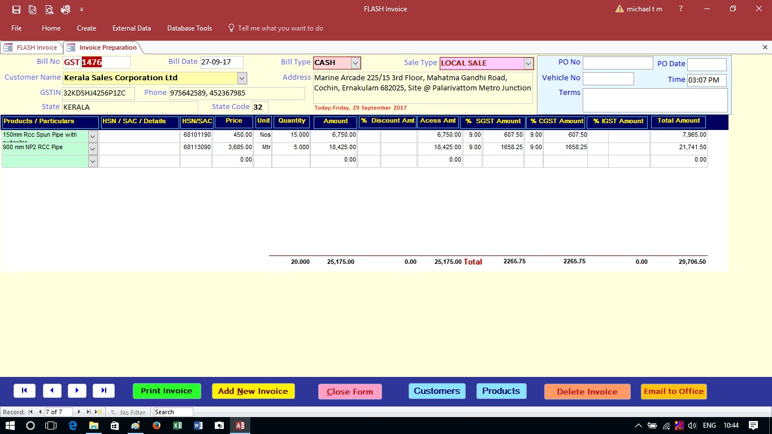
During the Invoice Entry, Double Click on Customer Name / Product Name to Add New to List…. Then select the same to enter invoice..

3 . Screen – Reports

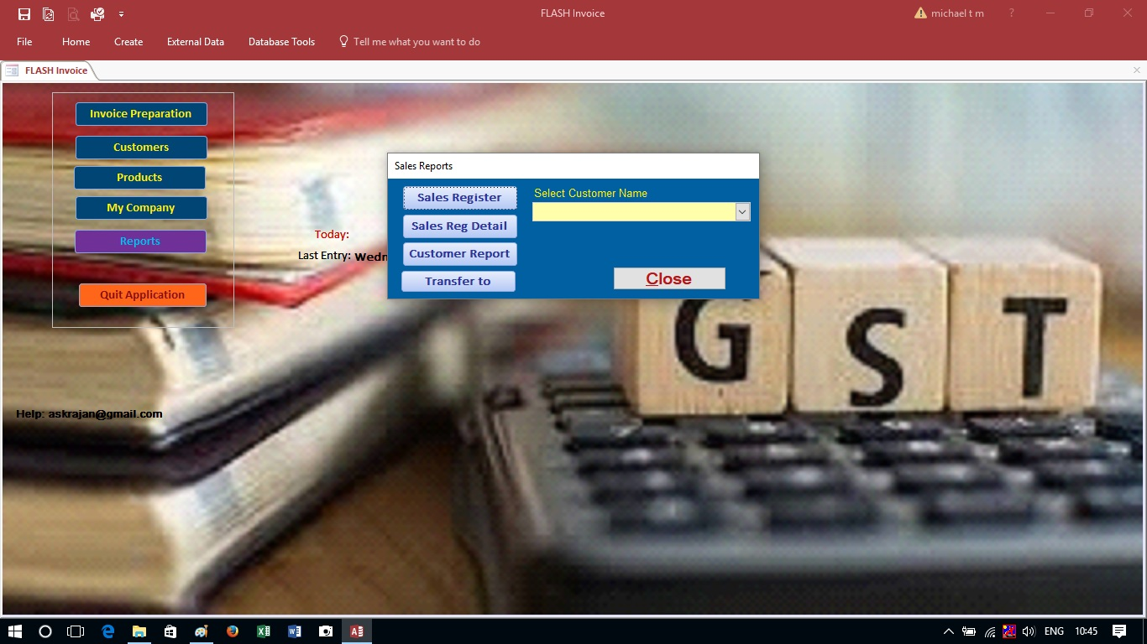

A new version with SALE / PURCHASE or INWARD / OUTWARD entries and STOCK / INVENTORY as on any date is available… Uploaded seperatively
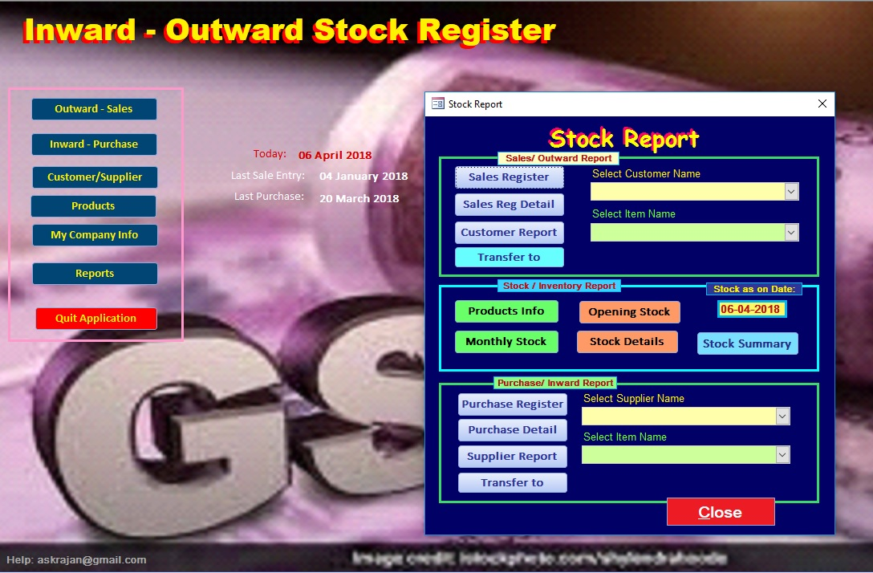

SALE / PURCHASE or INWARD / OUTWARD
entries and STOCK / INVENTORY as on any date is available….

