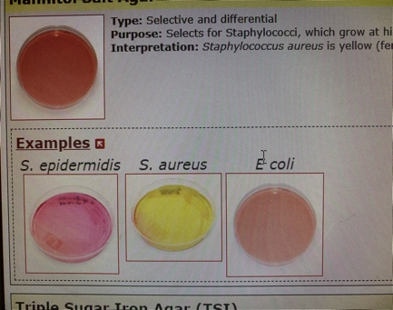
This is some text up here

3. This is some title here
a) This is some other text here corresponding to a question

b) This is some other text here corresponding to another question

