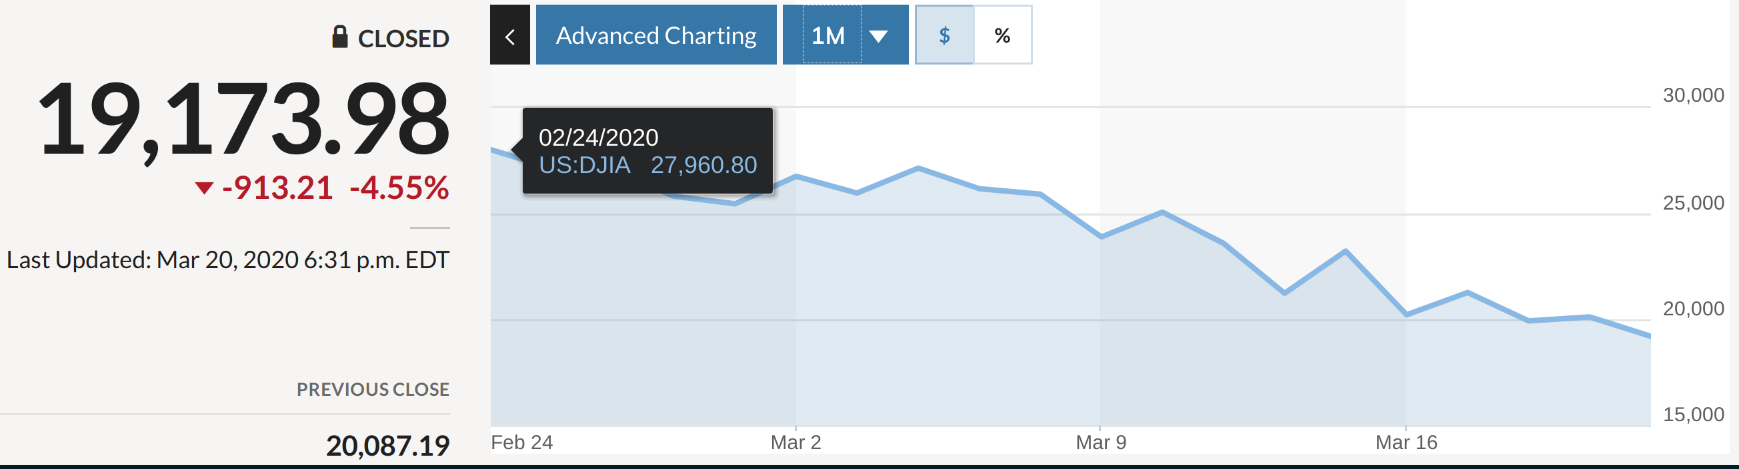

I, the undersigned, undertake to make the following payments to the for

Student name
Student ID
Semester

Dates | Amount

I Authorize the xx to cancel the classes’ registration in case I did NOT fulfill my obligation as stated above.

Student Signature Guardian Signature

Date (MM/DD/YY)

P.O. Box xxx | xxx - xx. | T: +xxxx | F: +xxx| E : xxxxxxxxx

