I cut a branch from a Green Ash tree (Fraxinus pennsylvanica, I think) outside of SLSRC. The section was about 3 mm thick and 8.5 mm in diameter. The dashed section on the photograph is the area imaged.
The ion images were made with the bottom 20% as transparent, then overlaid with the photograph.
Note that, for the first time, I see some ion images that are sacrificially in the wrong position. This is a retention time effect. These images are uncorrected, but in the future we may need to adjust the timing on a per-ion basis.

top left image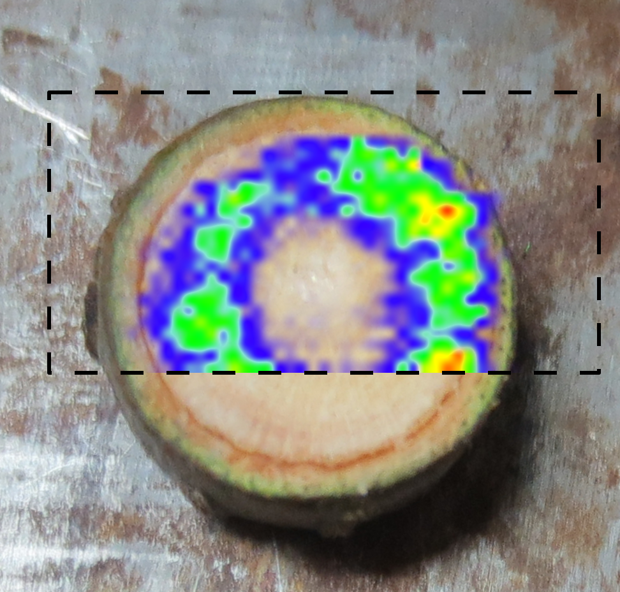
description
description
description
description
description

