AFRICAN CARBON ENERGY (AFRICARY)
THEUNISSEN UNDERGROUND COAL GASIFICATION PROJECT
EXECUTIVE SUMMARY OF UCG IN SA
- Key Points
- Eskom has been operating UCG successfully at Majuba since 2007, with continued investment to date.
- The Department of Mineral Resources and Energy (DMRE) included underground coal gasification (UCG) as part of the SA Government plan for a “Just Transition” in coal mining. UCG is included in the Independent Power Producer (IPP) Office’s Gas-IPP program, forms part of the SA Gas Utilization Master Plan (GUMP) and is included in the Integrated Resource Plan (IRP) forwarded to parliament.
- No ash, no particulate matter, no smog, no dumps, no dust, no stockpiles, no leaching, no trucks, no potholes, no blasting, no shafts, no chimneys, etc. (Figures 1 and 2 show the visible extent of the mining activity.)
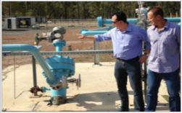Figure 1: Injection Well
- UCG can reduce CO₂ emission by 50% and uses 90% less water than conventional coal mining and power generation techniques.
- UCG is the safest and most suitable economic deep coal mining method that chemically extracts the coal through boreholes by transforming the coal to syngas underground.
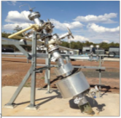Figure 2: Production Well
Environmentally outperforms conventional open-cast and board & pillar mining of coal and boiler power generatio
- Africary coal is more than 350m deep, making it one of the deepest SA coal operations, with negligible and manageable environmental impact.
- Africary is a BEE junior coal mining company with world leading mining technology and a proud member of the SA UCG Association (SAUCGA). Africary has sufficient coal resources under the farm owned by the applicant for 200 years of power generation.

- Overview
The applicant (the Africary group of companies) has acquired coal rights over an area of more than 300 square kilometres near Theunissen and developed an underground coal gasification (UCG) feasibility study as a means of effectively and efficiently exploiting the coal reserves to produce syngas which will be used to generate electricity.
UCG was first proposed in 1868 by Sir William Siemens, and the first patents were issued in 1909. It was encouraged by Lenin as a way of reducing fatalities and improving safety in the Soviet Union, where 15 power stations were built and operated using this technology from 1937 to reach end-of-life by 2000. The large Siberian gas pipeline extension meant that UCG was being superseded by natural gas.
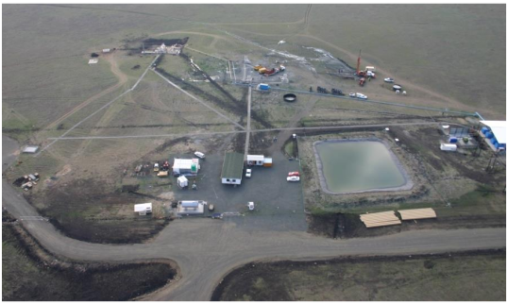Figure 3: Eskom Majuba UCG Test Facility
Eskom successfully proved the UCG technology in Mpumalanga (Volksrust/Amersfoort) by delivering syngas to Majuba power station from January 2007 until September 2011, when the pilot project ended and decommissioning commenced. This first phase was then followed by new larger facilities with continued investment by Eskom to date.
The aerial photo shown in Figure gives a good idea of the minimal visible mining activity and its impact on the surface. Aside from very significant environmental, health and safety advantages, there are also economic advantages in the form of carbon tax rebates as well as the substitution of fossil fuel imports (gas and oil).
UCG is generally recognised as “clean coal” technology and given that fossil fuels still make up more than 80% of world energy sources, UCG in combination with renewable energy, offers RSA the opportunity to phase out the use of old fossil fuel exploitation technology utilised for power generation.
Further, Eskom Transmission will benefit from the fact that the proposed Theunissen operation is located near the main north/south and east/west Eskom grid infra-structure and power can be distributed in any direction. Due to the location of the Theunissen project, it can also supplement other forms of renewable energy during peak consumption periods.
We would be pleased to elaborate on any of these advantages and benefits should the need arise.

- Africary’s Theunissen UCG Project
Africary acquired the prospecting rights from BHP Billiton. The project is located in the savannah grasslands of the Free State in the central region of South Africa. The towns of Theunissen, Welkom and Virginia are all approximately 25km from the proposed project area. The company’s aim is to generate and sell about 50 to 60 MW of electricity, via the gasification of about 5 million tons of coal over a period of 20 years on the farm Palmietkuil.
The power plant and ancillaries will have a footprint of about 3 hectares and will be connected to the national grid via a ±13 km power line already scoped by Eskom. An existing canal system will supply water to the site from the Sand-Vet Water Users Association (WUA) system. If technically and commercially successful, the project may be expanded in generation capacity and extended to the rest of the coal field.

- How UCG Works
UCG (Underground Coal Gasification) is an in-situ mineral beneficiation process that converts deep underground coal seams into combustible gas (“syngas”), which is extracted for beneficial use via boreholes. The carbon content of coal is converted to carbon monoxide (CO), a combustible gas (referred to as syngas), by the application of heat and oxygen (air). Gasification is an old, well-established industrial process that is applied world-wide. The CO may be used directly as a gaseous fuel or converted to a wide range of hydrocarbon products, as has been done by Sasol since the mid 1950’s.
At Sasol, gasification is based on coal that has been mined by conventional opencast and/or underground mining methods, and placed in reactors/gasifiers located on the surface, but it can also be done in-situ underground, without extracting the coal by conventional mining methods. Figure shows a
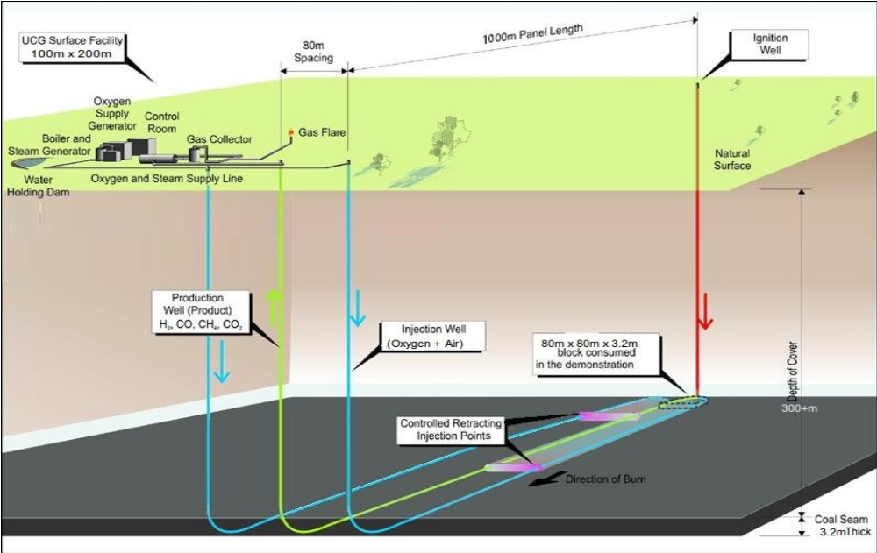Figure 4: UCG Panel Layout - Africary
typical layout
The underground coal seam is accessed by vertical drilling followed by horizontal drilling, to establish wells for ignition, injection of air and production. Heated air enriched with oxygen is pumped to the coal via the ignition well (red line in Figure ) to ignite the coal. Air enriched with oxygen is pumped to the coal via the injection wells (blue lines in Figure ) to maintain a burning front. The rate of gasification is controlled by the rate of oxygen delivery to the front. The coal is transformed by the combination of heat and oxygen, just as it would be in a gasification plant on the surface, leaving the ash behind. The gas is brought to the surface via the production well (greenish-yellow line in Figure ), where it is cleaned before being used as a fuel or a feedstock for hydrocarbon products. The coal ash remains underground as the underground gasifier is operated at a high enough temperature to vitrify the ash and render it chemically inert.
Underground coal gasification (UCG) offers a means of utilising coal reserves with minimal surface disturbance, without exposing workers to the typical safety risks of conventional mining methods and without creating heaps of overburden, discard coal and ash dumps on the surface. The environmental and safety advantages over conventional coal mining are significant. Therefore, this technology drastically reduces mine safety risks, surface impact and damage. It eliminates mine development waste, continuous opencast spoils in the case of an opencast mine, surface coal handling, solid waste discharge like coal discards, ash dumps, and has lower sulphur dioxide (SO₂), nitrogen oxide (NO_{x}) and particulate (PM₁₀ ) emissions.
The earliest recorded mention of the idea of underground coal gasification was in 1868. The first successful test was conducted by the Donetsk Institute of Coal Chemistry on 24 April 1934 at Lysychansk in the Soviet Union and a local chemical plant began using the gas commercially in 1937. A number of UCG projects were established across the world after the Second World War and UCG is recognised globally as a technically and economically viable clean coal method for accessing deep, otherwise unrecoverable coal reserves. It has been estimated by Eskom that UCG technology could effectively multiply the energy reserves represented by SA’s coal deposits.
- Environmental Impact Summary
An environmental impact assessment (EIA) has been undertaken by Africary and an environmental management programme (EMP) has been developed. Africary’s UCG project will produce enough gas to generate about 60 MW of electrical power by combusting the syngas in large gas engines – Refer Figure .
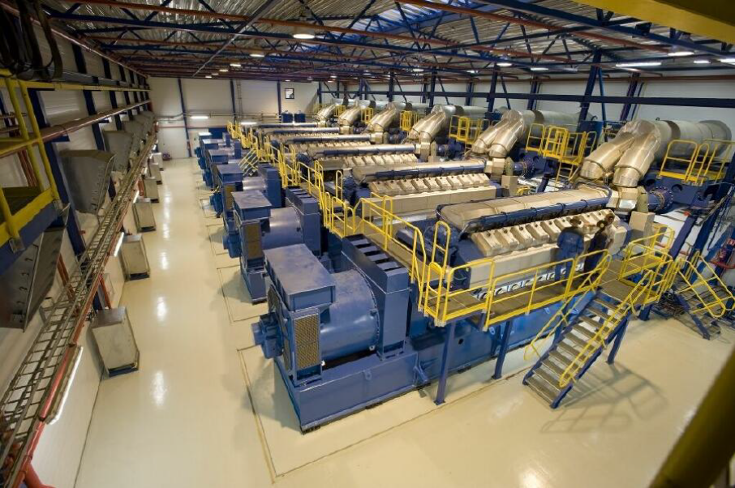Figure 5: Interior of a typical gas engine power plant (Wärtsilä)
Engineering for the project has been completed to a Bankable-Feasibility level, and construction can start immediately after financial approval. The surface area impacted will be approximately 3 ha on a farm owned by the applicant. There is no reason why farming and other activities cannot continue throughout construction and operations as has been the case for the past 7 years. Existing infra-structure in the project area will be utilised except for the included overhead power-line to connect the project to the existing Eskom infrastructure.
- Whilst the removal of minerals underground can result in subsidence on the surface, this can be reduced and/or eliminated by design. The risk of subsidence is significantly reduced due to the depth of the Theunissen UCG operations and the geology of the overlying area. This has been confirmed by Geophysical studies, which have predicted that limited subsidence might occur when required or desired controlled subsidence is implemented.
- It is estimated that fresh water consumption will only be required during the first year of operations. As the mine/gasifier grows in size over time, the natural operation will generate sufficient water to make the project water-neutral.
- The gasifier itself operates under high hydrostatic pressure levels, which means that it is not possible for the syngas to escape into the surrounding area, except as by design through the production well. Due to the depth of the gasifier there is no risk that it could run out of control, since the only way air can enter is through the wells and that is controlled. In any unforeseen emergency event, flooding the gasifier will terminate unintended actions and results. Once a gasifier (typically about 1km by 500m) has been depleted, it is shut down, stabilised and monitored. Eskom has shown that this can be done successfully in SA.
- The temperature at which the gasifier operates is designed to be such that the residual ash is glassified (becomes like glass) and thus chemically inert.
- The UCG technology employed Africary is a closed end-to-end system, which means that from the injection of air into the gasifier to the delivery of syngas for electricity generation or other uses there is nothing released into the environment other than the removal of small amounts of dried dusty solids, which will be contained and removed by competent waste removal services to an approved waste disposal site.
- Work by specialists in conjunction with SAUCGA, international experts and SABS have published ISO standards and requirements relating to the technology and the effective and safe operating of an UCG operation.
- The security concerns of local farmers are unjustified by the low number of personnel directly employed by the project.
The main impacts identified and the scientific studies completed are summarised below:

- Studies Conducted
Africary appointed Golder Associates Africa (Pty) Ltd to undertake an environmental impact assessment (EIA) and environmental authorisation process. The potential environmental impacts and recommended mitigation measures are as follows:
  - Surface water
Africary intends purchasing raw water from Sedibeng Water and treating it by filtration and reverse osmosis for use as process water. The reverse osmosis reject-water will be stored in a lined brine evaporation pond, together with wash-water from the workshop and engine room. The surface infrastructure will include a storm-water management system designed to ensure zero discharge of contaminated water.
  - Groundwater
The potential for contamination of the groundwater in the shallow aquifer with gasification products and the possibility of cross-contamination between the deep and shallow aquifers were raised as concerns during the public consultation process and in the subsequent appeals.
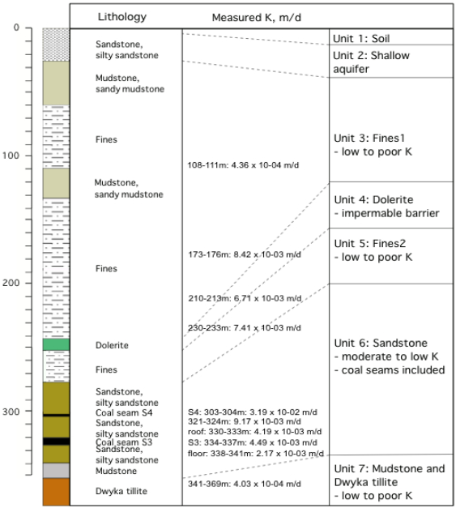Figure 6: Lithology of Target Area
The lithology of Africary’s target area is shown in Figure together with measured values of the hydraulic conductivity K for the various layers. Boreholes drilled for agricultural or domestic use are designed to access the shallow aquifer and they seldom exceed 100 metres in depth. The target coal seam is at a depth of about 350 metres and it is overlain by a number of rock layers as illustrated in Figure .
At this depth the groundwater is too saline for agricultural or domestic use, but even if it were fresh, it is too deep to extract economically for such use.
The various rock layers between the shallow aquifer and the groundwater at the depth of the target coal seam are effectively impermeable (very low K values) and ensure permanent natural separation between the shallow and deep groundwater.
Concerns were expressed during the public consultation process that the syngas could leak up the borehole and contaminate the shallow groundwater, and this has in fact occurred during some of the experimental UCG projects around the world. Africary’s engineers have made a thorough study of such projects and it is clear that such contamination occurs only when the borehole construction is inadequate. Africary will use a specialised drilling contractor with 30 years of experience in gas field drilling, with proper installation of casing and grouting in the injection and production boreholes, to prevent leakage of commercially valuable syngas.
  - Ground subsidence
Participants in the public participation process expressed concerns about surface subsidence above a gasified area. After completion of gasification and cooling of the underground gasification chamber, the rock layers immediately (±30 m) above the gasifier will undergo a slow collapse and the chamber will fill up with rubble over time. The effects at the surface depend on the depth of the gasifier below the surface, its dimensions and the characteristics of the overlying rock layers.
Africary’s UCG target area will have a footprint of about 1,000 m x 500 m. The specialist study for this configuration concluded that eventual surface subsidence of about 1.0 to 1.2 metres may be expected, which would have little or no effect on the suitability of the land for agricultural use. Such subsidence is much less than that typically caused by opencast coal mining or underground mining of coal at shallower depths and this has even proven to be beneficial (for example, by creating swales that prevent rain water run-off).
  - Air quality
Dispersion modelling concluded that normal operating conditions will not affect air quality in the region significantly. Venting during start up could raise ambient CO levels to 50% of the one-hour South African limit, and flaring during upset conditions could raise ambient SO₂ levels to 50% of the one-hour South African limit in the vicinity of the operation. Venting and flaring are expected to be rare events of short duration and the air quality impact can be mitigated to one of low significance by implementation of the recommended mitigation measures.
  - Noise
Noise modelling concluded that the gas engine-based power generation plant could cause night-time intrusive noise levels at the nearest farmstead only, which is owned by Africary.
  - Ecology
The ecology in the area has already undergone transformation due to agricultural activities. Construction will result in the removal of vegetation and topsoil from an area of about 3 hectares on the power plant site and vegetation from a 2 metre wide strip along the power line route. The specialist study concluded that post-closure rehabilitation could improve the ecology on the site from its pre-project condition.
  - Socio-economics
The construction phase will require up to 200 contract workers for a period of about 12 to 15 months and involve capital expenditure of approximately R3.0 billion with a local content of about 45% inclusive of 20% for labour and 27% for fabrication.
The initial operational phase will employ 33 people (or about ten people per shift) and the power production will increase the national power generation capacity by about 0.125%.
While these figures translate into a current low socio-economic impact initially, however the long term potential of this project is considerable and will unlock the use of vast quantities of non-viable coal reserves that can be utilised to generate power or other syngas derived products like ultra-low sulphur diesel, in a more environmentally friendly manner.
The operations will be located in the district identified by a presidential commission as the third most distressed in the country. Due to diminishing opportunities, the population in the area has declined by as much as 10% in spite of the concurrent growth in the country’s population. The project has already been identified by the local government and the business association as the cornerstone for planned economic recovery strategies.
  - Cultural and Heritage Resources
The two graveyards identified in the vicinity of the power plant site will not be affected by the project. Unearthing of buried remains and artefacts during construction cannot be ruled out and could potentially have a high impact, which can be mitigated to a low impact by applying the recommended chance find procedures.
  - Visual aspects
The construction and operational phases will potentially have moderate visual impact due to the establishment of tall structures in this largely rural area. Flaring at night would have a high visual impact.

- Methane Rights
Methane occurs in coal seams and remains trapped until the coal is disturbed by mining or the release of hydraulic pressure due to the lowering of the groundwater table. Tetra4 owns the methane rights in the area and has the right of abstract of naturally occurring gas also known as “natural gas” or “coal bed methane” (CBM). Africary is a coal mining company that mines its coal through a gasification method. It should be mentioned that Tetra4 has no gas resource on or close to the Africary proposed mining area and that their closest production borehole is more than 8 km from the UCG site. Tetra4 has also publicly stated that they currently have no intention of implementing fracking or a CBM project.
Tetra4 currently recovers methane in the vicinity of the gold mines between Welkom and Virginia, where the groundwater table has been lowered by the gold mines in order to maintain safe working conditions in the lower levels of the mines.
Tetra4 objected to, and lodged an appeal against, the environmental authorisation granted by the DMRE on the grounds that Africary’s UCG process would have adverse effects on Tetra4’s ability to utilise its rights to the methane. This is a commercial matter and Africary have indicated that they will engage with Tetra4 in an effort to ascertain the extent, if any, to which the UCG project may affect Tetra4, and to negotiate a mutually acceptable solution.

- More Examples of UCG in the World
- The Belgo-German UCG trial at Thulin (860m depth), Belgium, 1981-1987;
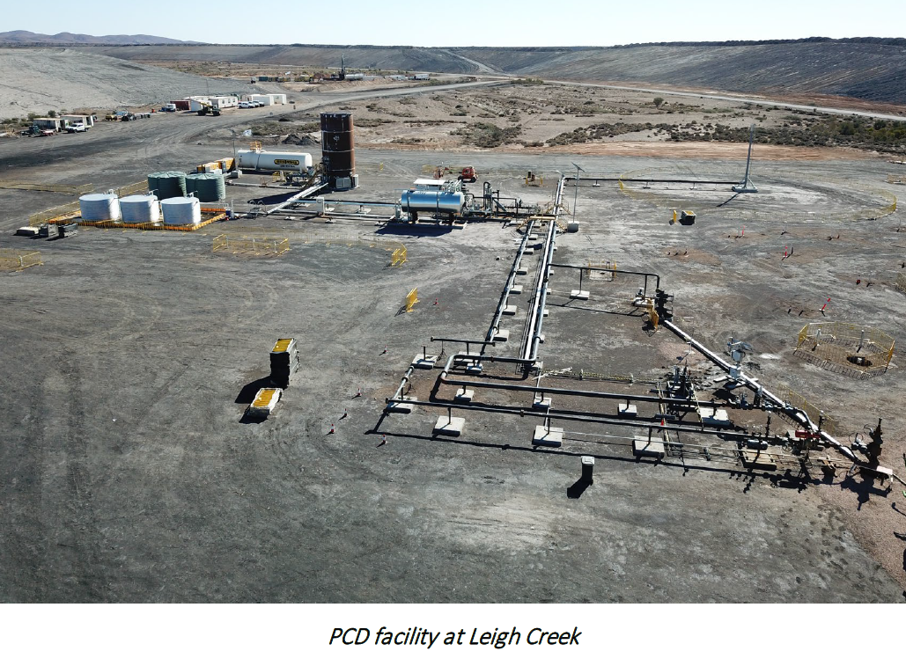Figure 7: Leigh Creek (Australia). UCG Plant operation from 2019 to 2020. Currently being expanded.
- The UCG Steeply Dipping trial at Rawlins (500m depth), Wyoming, USA, 1994-1996;
- The European UCG trial at El Tremedal (600m depth), Spain, 1991-1997;
- The Swan Hills Synfuels trial (1,400m depth), Alberta, Canada, 2007-2012;
- Rocky Mountain trials, Wyoming, USA - Rawlins (1979 - 1981) and Hanna (1986 – 1988);
- Solid Energy's Huntly, New Zealand trial in 1994 and 2013;
- Trial at WIDCO mine in Centralia, Washington State, USA (approx. 100m) 1981 – 1982;
- China has conducted 16 trials since the late 1980s; and
- India's ONGC is pursuing UCG in one lignite block in the state of Gujarat.
- Eskom in South Africa has had an operating UCG plant since 2007 feeding into the Majuba power station. Initial co-firing at Majuba power station was achieved in October 2010.
- Carbon Energy in Australia had an operating UCG plant and 4 gas engines and was selling 15 MW into the grid by 2012.
- Linc Energy in Australia had an operating UCG plant since 2001 and produced 25 barrels per day of diesel and jet fuel in 2012.
- The 2020 trial in Inner Mongolia appears to be advancing.
- The Indonesians have a research group who did a test last year and getting help from foreign affairs in Australia, who support a volunteer with them.
- Eskom in South Africa 2020, is in the design phase for a 100-140 MW open cycle gas turbine demonstration plant using UCG gas.
- Leigh Creek – Australia 2019, concept demonstration. (See ????). Currently going through the approval processes for a bigger operation.

- Key Findings and Controls of the DMRE Environmental Authorisation
The DMRE issued an EA on 1 August 2019. The EA authorises Africary to develop according to activities 12 and 33 of NEMA listing notice 1: GNR. 983; and Activity 17 of NEMA listing notice 2: GNR. 984.
Africary is authorised to conduct UCG in an area of 600 ha and process the gas and its end-products in an area of 3 ha. Site specific conditions (already in included in the Africary designs) are:
- Capture, contain, treat and recycle all contaminated water arising from the operations on site and prevent the discharge of contaminated water to the environment;
- Construct and operate storm water management systems in accordance with the requirements of Regulation 704 under the National Water Act;
- The revised amendment in accordance with National Norms and Standards for Disposal of waste to land, dated 23 August 2013 and certified by a registered professional Civil Engineer should be submitted to DWS for approval prior construction;
- The design report should demonstrate service life consideration for materials standards to be specified (for geo-membranes SANS 1526 or GRI GM 13) and the durability (e.g. compressive strength, water/cement ratio, permeability, percentage air voids) of the concrete if that option is selected;
- Prevent the ingress of contaminants from the brine pond and pollution control dam into the soil and groundwater by appropriate engineering design, construction and management in terms of GN R.633 to R.636;
- Prevent contamination of the shallow groundwater by producer gas leaking past the borehole grouting by monitoring and maintenance as and when required;
- Remain within the guidelines and standards for ambient air quality, dustfall and emissions as summarised in sections 11.1.1 to 11 .1.3 of the EIAR. Wet suppression must be applied during construction. Air quality must be monitored and the mitigation measures described in 11.1.6 must be implemented;
- Keep off-site noise levels at identified receptors within the national standards and guidelines and avoid the exposure of any receptors to intrusive noise levels by applying the monitoring and mitigation measures described in section 11 .2 of the EIAR;
- Soften the visual impact of the project by applying the mitigation measures recommended in section 11 .14 of the EIAR;
- Rehabilitate the disturbed areas to a condition fit for grazing and the resumption of ecological function after project closure; and
- Protect the cultural and heritage resources described in section 7.13.3 of the EIAR by appropriate fencing and education of personnel and contractors.

http://www.eskom.co.za/AboutElectricity/FactsFigures/Documents/OtherDocs/Underground_Coal_Gasification_UCG.pdf
Oct 19, 2019 -Diversified energy mix will tackle S. Africa's energy challenges http://www.xinhuanet.com/english/2019-10/19/c_138483698.htm
Nov 14, 2019 -South Africa eyes industrial boost through IRP https://www.petroleum-economist.com/articles/midstream-downstream/power-generation/2019/south-africa-eyes-industrial-boost-through-irp
Source: Eskom presentation at SAUCGA conference 2018.
Nameplate capacity of 77 MW.

