Bug report evaluation
BugID: 132588
Reviewer: Françoise Acevedo

Follow-up tests

Main goal | Test name | Expected results | Obtained results
Replicate | TC1_Set the keep ratio button with default settings for Frame  Prerequisites:  Default image setting applied:  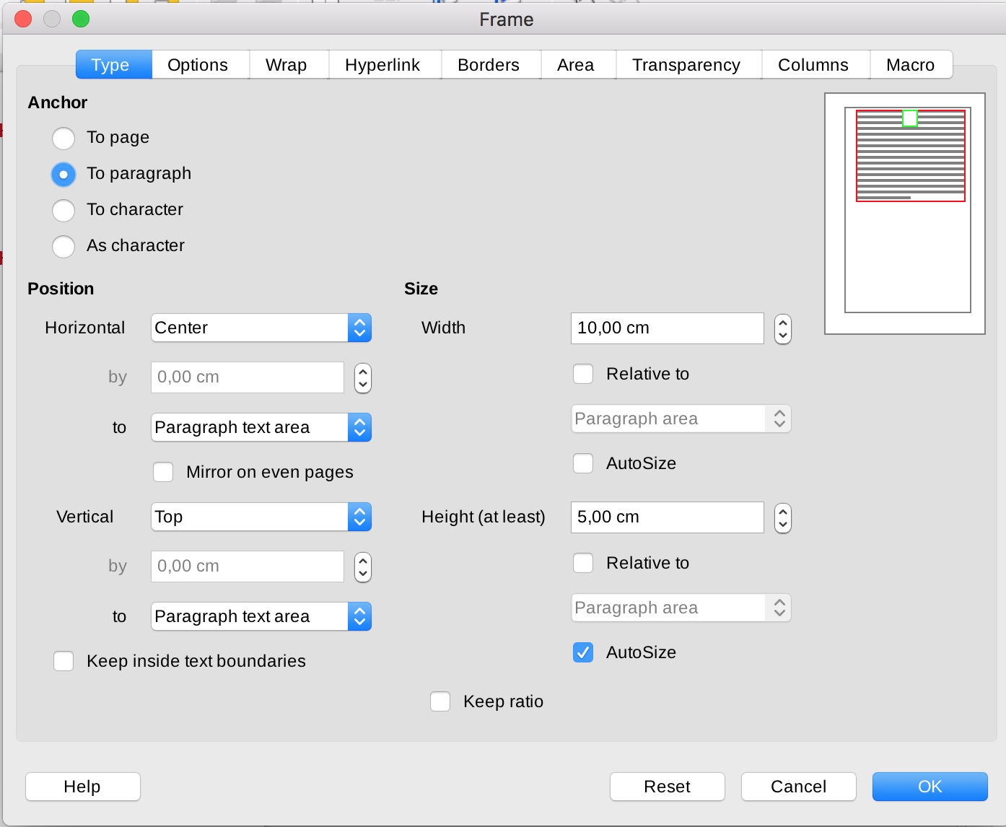  Sequence:  1. Open Writer  2. Insert -> Frame -> interactive frame  3. Format -> Format frame  and object -> Type tab.  4. Check Keep ratio  5. Press OK  6. Format -> Format frame  and object -> Type tab. | Disable the checkbox for frames or enable the functionality | Execution context:  1. Last available LibreOffice Version  Result:  Keep ratio can't be set  - Bug is reproducible  Version info:  Version: 7.0.0.0.alpha1 (x64)  Build ID: 6a03b2a54143a9bc0c6d4c7f1...  Subprocs. CPU: 4; SO: Windows 10.0 Build 17134; Repres. IU: Skia/rej. píx.; VCL: win;  Locale: es-ES (es_ES); UI: es-ES; Calc: threaded
Maximize  - Change system configuration | TC1_Set the keep ratio button with default settings for Frame | Disable the checkbox for frames or enable the functionality | Execution context:  1. Use MAC OS system  Result:  Keep ratio can't be set  - Bug is reproducible in different OS  - Windows/Mac same behavior  Version info:  Version: 7.0.0.0.alpha1  Build ID: 6a03b2a54143a9bc0c6d4c7f1...  CPU threads: 4; OS: Mac OS X 10.12.6; UI render: default; VCL: osx; Locale: es-ES (es_ES.UTF-8); UI: en-US; Calc: threaded
Maximize  - Change system configuration | TC1_Set the keep ratio button with default settings for Frame | Disable the checkbox for frames or enable the functionality | Execution context:  1. Previous stable version of LibreOffice  Result:  Keep ratio can't be set  - Bug is reproducible in previous version  Version info:  Version: 6.4.4.2  Build ID: 3d775be2011f3886db32dfd395a6a6d1ca2630ff  CPU threads: 4; OS: Mac OS X 10.12.6; UI render: default; VCL: osx;  Locale: es-ES (es_ES.UTF-8); UI-Language: en-US  Calc: threaded
Maximize  - Change behaviour | TC2_Set the keep ratio button with default settings for Image  Prerequisites:  Default image setting applied:  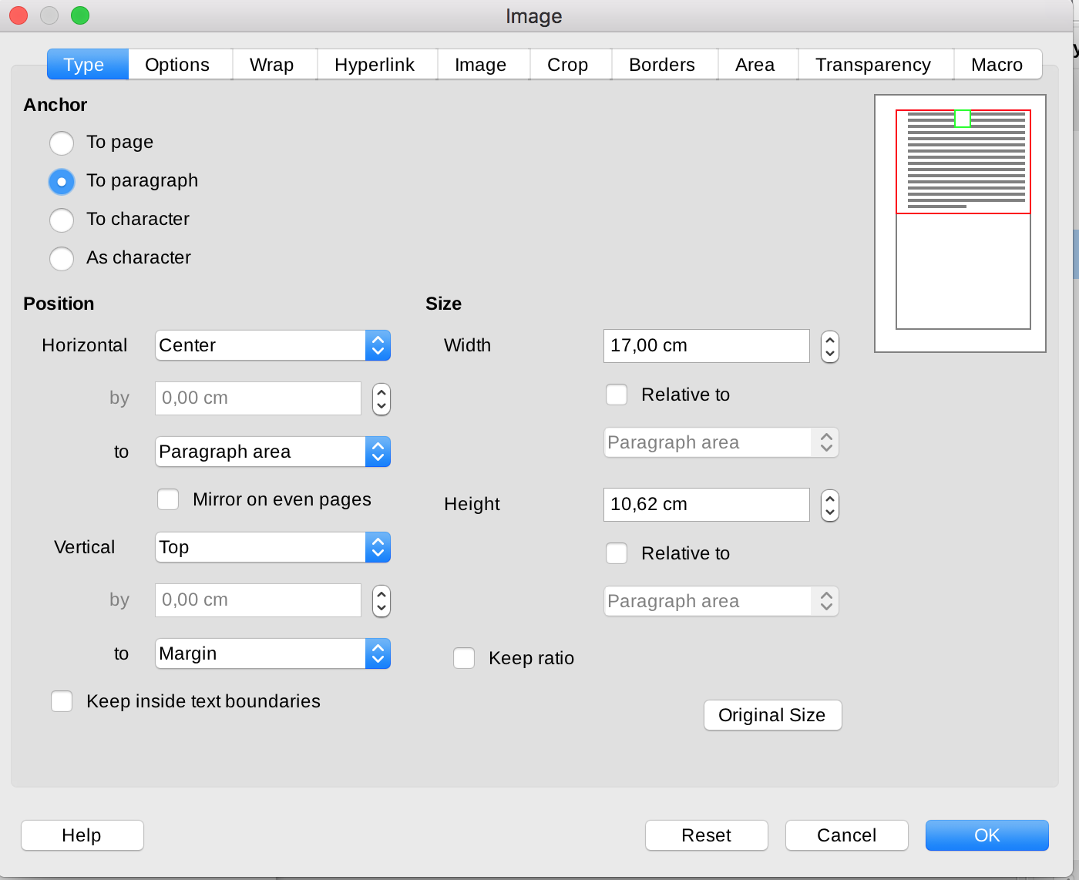  Sequence:  1. Open Writer  2. Insert -> Image  3. Format -> Image -> Properties  -> Type tab.  4. Check Keep ratio  5. Press OK  6. Format -> Image -> Properties  -> Type tab. | Disable the checkbox for frames or enable the functionality | Execution context:  1. Replace Frame by image  Result:  Keep ratio can be set  - Bug is not reproducible for Images  Version info:  Version: 6.4.4.2  Build ID: 3d775be2011f3886db32dfd395a6a6d1ca2630ff  CPU threads: 4; OS: Mac OS X 10.12.6; UI render: default; VCL: osx;  Locale: es-ES (es_ES.UTF-8); UI-Language: en-US  Calc: threaded
Replicate  - Change environment | TC3_Set the keep ratio button without auto size setting for Frame  Prerequisites:  Default image setting applied:  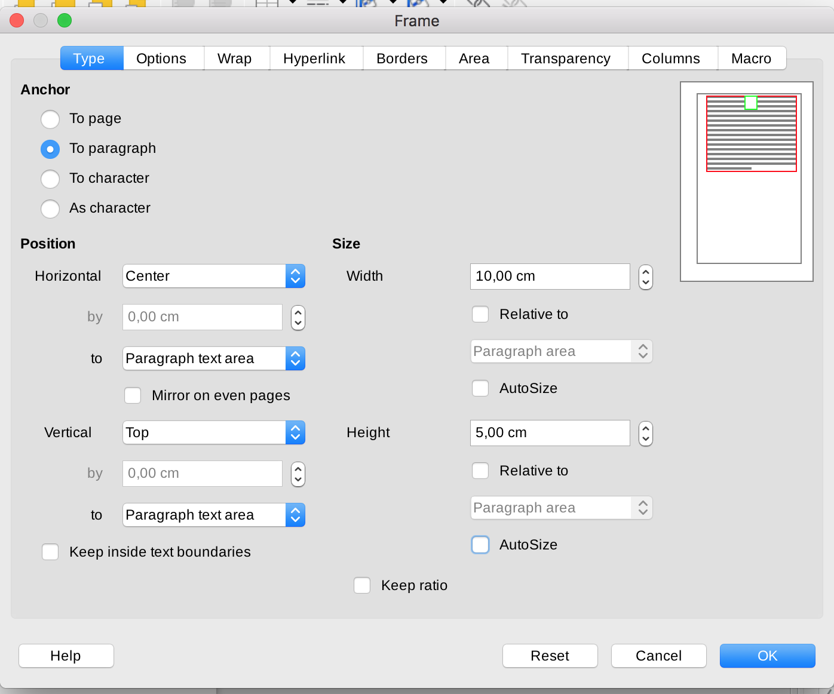  Sequence:  Same step sequence than TC1 | Disable the checkbox for frames or enable the functionality | Execution context:  1. Remove Autosize check from the Frame setting  Result:  Keep ratio can't be set  - Bug is reproducible  Version info:  Version: 7.0.0.0.alpha1 (x64)  Build ID: 6a03b2a54143a9bc0c6d4c7f1...  Subprocs. CPU: 4; SO: Windows 10.0 Build 17134; Repres. IU: Skia/rej. píx.; VCL: win;  Locale: es-ES (es_ES); UI: es-ES; Calc: threaded
Replicate  - Change environment | TC4_Set the keep ratio button with “relative to” setting option previously selected for Frame  Prerequisites:  Default image setting applied:  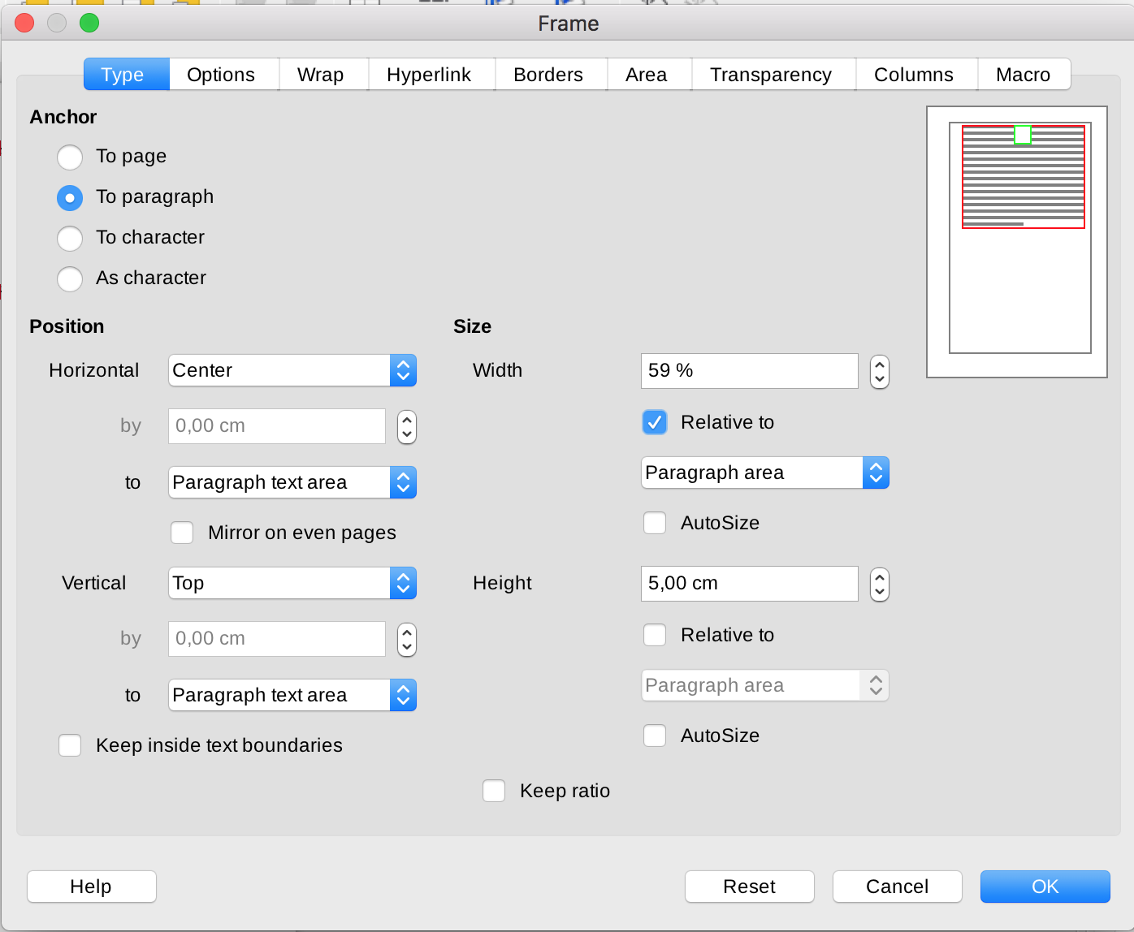  Sequence:  Same step sequence than TC1 | Disable the checkbox for frames or enable the functionality | Execution context:  1. Set size relative to Paragraph  Result:  Keep ratio can be set  - Bug is reproducible for Frame when a relative Size is already selected  - Same behavior for Width, Height or both  Version info:  Version: 7.0.0.0.alpha1 (x64)  Build ID: 6a03b2a54143a9bc0c6d4c7f1...  Subprocs. CPU: 4; SO: Windows 10.0 Build 17134; Repres. IU: Skia/rej. píx.; VCL: win;  Locale: es-ES (es_ES); UI: es-ES; Calc: threaded
Replicate  - Change environment | TC5_Set the keep ratio button and one of “Relative to” size for Frame at the same time  Prerequisites:  Default image setting applied:  Sequence:  1. Open Writer  2. Insert -> Frame -> interactive frame  3. Format -> Format frame  and object -> Type tab.  4. Check Width “Relative to” “Paragraph area”  5. Check Keep ratio  6. Press OK  7. Format -> Format frame  and object -> Type tab. | Disable the checkbox for frames or enable the functionality | Execution context:  1. Set size relative to Paragraph  Result:  Keep ratio can be set  - Bug is not reproducible for Frame when set, at the same time, ratio button and one size “Relative to” option  - Same result if select only Height “relative to”  - Checkbox state is kept when reopen settings  - When Keep ratio is active, we can see how Height is updated when change Width and in the opposite way.  Version info:  Version: 7.0.0.0.alpha1 (x64)  Build ID: 6a03b2a54143a9bc0c6d4c7f1...  Subprocs. CPU: 4; SO: Windows 10.0 Build 17134; Repres. IU: Skia/rej. píx.; VCL: win;  Locale: es-ES (es_ES); UI: es-ES; Calc: threaded
Replicate  - Change environment | TC6_Set the keep ratio button and both “Relative to” size for Frame at the same time  Prerequisites:  Same as TC3  Sequence:  Same sequence than TC3 except than  - select Width and Height “relative to” “Paragraph area” and check Ratio button | Disable the checkbox for frames or enable the functionality | Execution context:  1. Set size relative to Paragraph  Result:  Keep ratio can be set  - Bug is reproducible for Frame when set ratio button and both Size “Relative to” option  - In this case we cannot consider this behavior a bug because each dimension has its own referential then we cannot expect any correlation between Height and Width  Version info:  Version: 7.0.0.0.alpha1 (x64)  Build ID: 6a03b2a54143a9bc0c6d4c7f1...  Subprocs. CPU: 4; SO: Windows 10.0 Build 17134; Repres. IU: Skia/rej. píx.; VCL: win;  Locale: es-ES (es_ES); UI: es-ES; Calc: threaded

