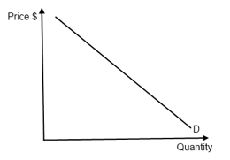

S0

S1

**Quantity Demand**

E0

E1

P0

P1

Q0

Q1

D=AR=MR

Quantity Demand

AR

Pe

D1

Quantity Demand

Price

**LRAC**

**LRMC**

D2

Firm

Q2



S1

S2

**Quantity Demand**

E1

E2

P1

P2

Q1

Q2

Industry