The Parishes of
St Andrew, Sutton-in-the-Isle,
St Martin, Witcham and St Mary, Mepal.
Notice Sheet for April 19th 2020

Easter Two
Live stream on YouTube
opens 9.25 am for 9.30 am Easter 2 from the Vicarage

Morning Prayer for the Easter Season

(Check on St Andrew’s Facebook page for the link address, or via email from MH. Recording available afterwards on YouTube.)

Prayer of the week
Risen Christ,
for whom no door islocked, no entrance barred:
open the doors of our hearts
that we may seek the good of others
and walk the joyful road of sacrifice and peace
to the praise of God the Father.
Amen.

Readings for today:
Acts 2.14a,22-32; Psalm 16;
1 Peter 1.3-9; John 20.19-31
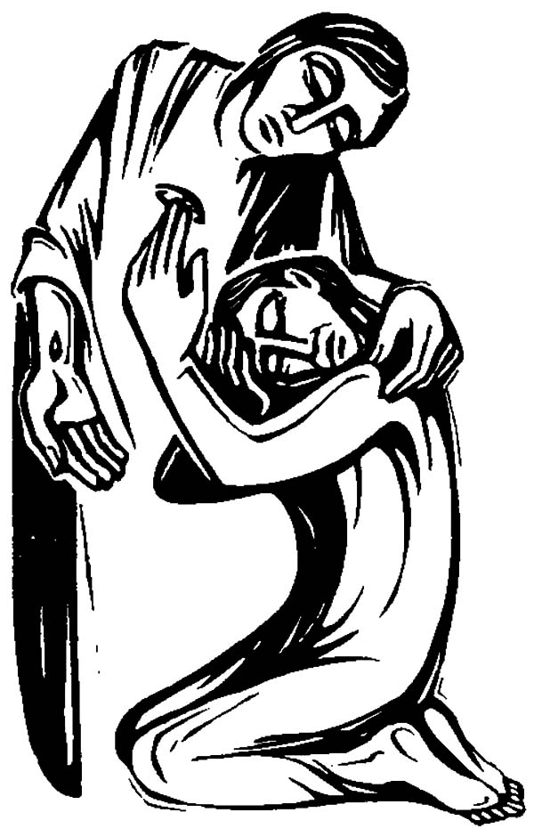
Psalm 16 response:
The Lord is at my right hand; I shall not fall.

Today’s Gospel Reading: John 20.19-31

Jesus Appears to the Disciples
When it was evening on that day, the first day of the week, and the doors of the house where the disciples had met were locked for fear of the Jews, Jesus came and stood among them and said, ‘Peace be with you.’ After he said this, he showed them his hands and his side. Then the disciples rejoiced when they saw the Lord. Jesus said to them again, ‘Peace be with you. As the Father has sent me, so I send you.’ When he had said this, he breathed on them and said to them, ‘Receive the Holy Spirit. If you forgive the sins of any, they are forgiven them; if you retain the sins of any, they are retained.’

Jesus and Thomas
But Thomas (who was called the Twin), one of the twelve, was not with them when Jesus came. So the other disciples told him, ‘We have seen the Lord.’ But he said to them, ‘Unless I see the mark of the nails in his hands, and put my finger in the mark of the nails and my hand in his side, I will not believe.’

A week later his disciples were again in the house, and Thomas was with them. Although the doors were shut, Jesus came and stood among them and said, ‘Peace be with you.’ Then he said to Thomas, ‘Put your finger here and see my hands. Reach out your hand and put it in my side. Do not doubt but believe.’ Thomas answered him, ‘My Lord and my God!’ Jesus said to him, ‘Have you believed because you have seen me? Blessed are those who have not seen and yet have come to believe.’

The Purpose of This Book
Now Jesus did many other signs in the presence of his disciples, which are not written in this book. But these are written so that you may come to believe that Jesus is the Messiah, the Son of God, and that through believing you may have life in his name.

A Reflection from Rev’d Alan

Our focus today is on Thomas, because this Gospel reading is set every year for this Sunday. The readings from the Acts and the Epistle change, but the Gospel doesn’t, so it clearly has an importance that we should recognise. But this familiar and well-loved story has its problems– one of them being that through that very familiarity we can easily miss what is going on.

We don’t know a lot about Thomas. Matthew, Mark and Luke tell us only that he is one of the Twelve specially chosen by Jesus to be his particular companions. He’s also mentioned in Acts, and if we list the Apostles in groups of four he is consistently in the second group. In John’s account he is mentioned a mere three times. Firstly in chapter 11 he is the one who encourages the others to continue with Jesus to Bethany when they heard that Lazarus was dead. “Let us also go and die with him”, Thomas says, which shows an interesting mix of loyalty, fear, courage and pessimism! Then in chapter 14, he interrupts Jesus reassurance: “There are many dwelling places in my Father’s house, … I am going to prepare place for you… and you know the way I am taking…” by bursting in “Lord we do not know where you are going so how can we know the way?” Does this suggest that Thomas has difficulty with abstract notions, that he is more a practical down-to-earth chap, rather than a thinker? And finally we have the episode in today’s Gospel.

Here we can see enough of Thomas to glimpse a picture of the man who comes out of the shadows to become the centre of attention for a brief period. And what else?
It seems to me that there are three things to be drawn out of this encounter that Thomas has with his fellow Apostles and with Jesus.

Firstly, Thomas isn’t going to be sucked in by peer pressure. I think that’s an important lesson for us to learn in these days because peer pressure can be one of the most insidious and intimidating things. Peer pressure is undoubtedly one of the major factors behind the acquisitiveness we see for the latest gadgets, the ever bigger, ever flatter television screens, the smartest phones, the coolest brands. Maybe the current lockdown situation and the expected aftermath will dampen that a bit. The other disciples could be jumping up and down with excitement saying, “We have seen the Lord, we have seen the Lord”, but for Thomas the evidence of the other Apostles was not enough. He couldn’t take their word for it; he had to see with his own eyes. Thomas is not going to be swayed by the enthusiasm of his friends and colleagues, however persuasive they might be. Catherine of Siena once wrote: "Be who God meant you to be and you will set the world on fire.” Going with the flow of peer pressure diminishes us.

Secondly, he is not going to be fobbed off with second best: he wants a personal encounter with this risen Jesus, not somebody else’s experience. He gives voice to his doubts, and lays down his criteria for belief: he must touch as well. He must have that physical reassurance that nobody is playing tricks here, no smoke and mirrors. To me, this confirms that impression I mentioned earlier, that Thomas is a practical man, not given to abstract stuff.

Thirdly, by issuing his challenge, ‘Unless I see the nail marks in his hands and put my fingers where the nails were, and put my hand into his side, I will not believe’, Thomas helps to establish that Jesus’ resurrection is truly physical.

Jesus is not a ghost, not a disembodied spirit but really, physically, bodily present. Changed in some respects, yes but undisputedly real. That is one of the important things about Thomas’ doubt. The resurrected Jesus is the crucified Jesus, no question about it. Thomas’ doubt allows us certainty. Our collect for St Thomas’ day underscores that: ‘Almighty and eternal God, who, for the firmer foundation of our faith, allowed the apostle Saint Thomas to doubt the resurrection of your Son till word and sight convinced him, grant to us also, who have not seen, that we also may believe and so receive the fullness of Christ’s blessing; who is alive and reigns with you and the Holy Spirit, one God, now and for ever’

The fullness of Christ’s blessing. Being what God means us to be. These are key concepts in putting the Resurrection into focus for our time and for ourselves. We see Peter, transformed by the fullness of Christ’s blessing into the leader that Jesus said he was to be. No longer frightened, giving in to the pressures that made him deny Christ three times, but boldly proclaiming the good news on the day of Pentecost.

Underpinning all that is Thomas. Not so much Doubting Thomas, but the Thomas who exclaimed, ‘My Lord and my God’, when Jesus graciously accepted his challenge. The Gospel writer does not tell us whether or not Thomas did actually touch Jesus, or whether just his appearance was enough. The 17th century painter Caravaggio paints the scene with Thomas’ finger in the spear’s wound, and we wince in sympathy. A few years later another 17th century painter, Rembrandt, has Thomas reeling back, and not reaching out to touch Jesus. That’s not the important point. The important part is Thomas’ new certainty, that echoes down the ages, ‘My Lord and my God’, and all that springs from that conviction. But these are written so that you may come to believe that Jesus is the Messiah, the Son of God, and that through believing you may have life in his name.

Alan

News

Do you need help?
Many of us have sorted out how to get the everyday things done during this period of lock down or shielding. Please contact Rev’d Mary or your church wardens if you need help to keep going – it may be help to get food or other practical things, advice or a friendly ear. There are also volunteers in the villages who will fetch and carry for you if you are unable to leave your home. Just ask and we can most probably help get it sorted!

Bishop Stephen
A recent letter to the clergy from Bishop Dagmar brought the news that Bishop Stephen will be making a phased return to work from Monday 20 April.

Parish finances
Many of you give to your church via a regular scheme (eg, weekly envelopes, standing order or direct debit). The last two ways of giving are still continuing although we are not able to have services – and thank you for keeping them going.
But, obviously, it hasn’t been possible for you to give to your church with the envelopes or putting cash in the offertory plate since our churches were closed. Please would you consider moving to a standing order or direct debit if you are not using that? Some day our church buildings will be open again – hopefully sometime in the summer – and your donations will ensure that they are ready for use again. In the meantime, the Church is still alive and working in our parishes – that is us, not the buildings – and your giving will ensure that we can keep on being here as a Christian community supporting each other and our villages.

Please contact the treasurers or church wardens to find out how to set up a standing order or direct debit (both simple procedures).

Services this week

For Sutton, Mepal and Witcham Parishes
Sunday morning Live streamed YouTube service of an Easter Season Morning Prayer from the Vicarage
9.25 am for 9.30 am. Available on YouTube as a recorded service afterwards.

Wednesday Compline (Night Prayer)
YouTube recorded service will be available – see Facebook page or email for link.

Elsewhere
BBC
TV:
BBC1 Sunday 10 am ‘Sunday Worship’ from St David’s Cathedral, Pembrokeshire.
BBC1 Sunday 1.15 pm ‘Songs of Praise’ from Salvation army, Liverpool.
Radio:
R4 Sunday 6.05 am ‘Something understood’
R4 Sunday 8.10 am ‘Sunday Worship’ a virtual service from Manchester
R3 Sunday 3 pm ‘Choral Evensong’ from Dallas, Texas
R3 Wednesday 3.30 pm ‘Choral Evensong’ from Royl Holloway College

Ely Cathedral
Sunday 10.25 for 10.30 am – Eucharist for the Second Sunday of Easter
(on the Cathedral’s YouTube channel or via its Facebook page)
Details of the Cathedral’s resources and links to resources from other places are shown on Ely Cathedral’s website ‘Worship at Home’ page.

Ely Diocese
Resources and ideas from the Diocese for children at home to use during the Easter.season can be found on the Diocese’s website – search for childrens workers support during coronavirus

Royal School of Church Music (RSCM)
Hymn for the Day and Sunday Self-Service (a short service including hymns, readings, and prayers, which you can find updated each week) both available on the RSCM website..

Parishes’ Prayer Chain
Although we cannot meet physically at the moment we can still pray ‘together’. I will be setting aside half an hour each day, starting at 3.00pm, to pray for our church family. I shall be lighting a candle, and if you feel that you would like to join me in your own home (we are self-isolating at the moment) please do. If you have any special prayer requests please me know on 01353 776172.
Thank you, Yvonne Jesson

If you are receving a paper copy of this news letter (which is replacing the usual news sheet for the time being) but have on-line access, please let me know if you would prefer to communicate via email, etc. If you are off grid then I will try to add suggested prayers and services you can do at home. Any personal data you give me will be treated according to the General Data Rrotection regulations as given in the PCC’s and my data privacy notices – we take good and proper care of your personal data.
If you do not wish to receive any paper or electronic communications from me or the PCC then please tell me.

Current postion of the Church of England
Our church buildings are still closed for public worship, private prayer and all other meetings and activities except for vital community services (eg, food banks) until further notice. All weddings and baptisms have been postponed. No funerals are permitted in the church but currently graveside funerals are possible with immediate famiy only. Funerals in crematoria are currently limited to a maximum of 10 mourners. Fenland Crematorium can live stream funeral services, and make it available for viewing later too. Cambridge Crematorium can record the service and put it on the internet afterwards for viewing.

Useful Links:
Church of England
On the C of E website, pages for covid-19 guidance for churches, and covid -19 liturgy and prayer resources you will find the following:
- Weekly service broadcasts - these be made available each Sunday through the Church of England’s Facebook page.
- Time to Pray app - everything you need for Prayer During the Day, with variations according to the day of the week and the season of the Church’s year. Download for free.
- Daytime prayer and Night prayer service audio - building on the existing daily prayer feed, this includes daytime prayer and night prayer for each day. It will be available as a downloadable app in the coming weeks.
- Live streaming services from churches - AChurchNearYou.com now lists hundreds of churches offering livestreams of services from across the country..
- Increasing the number of training webinars - to help churches stream sermons, events and make the most of digital platforms. Sign up for free.
- The BBC's Daily Service and Sunday Worship - On Sundays listen to the 8 am Sunday Service on R4, and watch the morning service on BBC1 at 10.45 am (Palm Sunday), at 11.25 am (Easter Sunday), and Songs of Praise at 1.15 pm on BBC1.
- Prayer for the day - each day the Church of England publishes audio and text of the Prayer for the Day.
- Smart speakers – daily prayer and #LiveLent audio content can be accessed via the C of E smart speaker apps.
- Mental health reflections – 13 daily reflections that seek to provide hope, reassurance and comfort. The C of E has also published five tips to help tackle loneliness and isolation.
- NEW EasterPilgrim: The Lord’s Prayer – Bishop Steven Croft leads a 40-day pilgrimage throught he Lord’s Prayer with a daily reflection. To find out more about this, and to sign up to receive them daily, visit cofengland.org/EasterPilgrm.

RIP: Marian Lord, Olwyn Buckley, Ron Bowden (a friend of Brenda & David)

Year’s Mind:
James (Jim) Edward Cone (19th), Jacob Nicholas Wright (20th),
Marilyn Joy Rowe (20th), Susan Willis (21st), Beryl Fordham (21st),
Phyllis May Sculthorpe (22nd), Wilhelmina Violet Stranks (23rd),
Ethel (Freda) George (24th).

Prayers to help you

Lord Jesus Christ, you said to your disciples, ‘I am with you always.’
Be with me today, as I offer myself to you.
Hear my prayers for others and for myself,
and keep me in your care.

Psalm prayer for Psalm 16

Give to us, Lord Christ,
the fullness of grace,
your presence and your very self,
for you are our portion and our delight,
now and for ever.
Amen.

If you have an item for inclusion in the weekly news letter
forward it to David & Brenda Styles,31 Chestnut Way, CB6 2YP
01353 778198 or preferably by email to david.styles@outlook.com

If you need pastoral support please contact:
Rev’d Mary Hancock on 01353 778722, or your churchwardens:
Nick Wilson on 01353 775271 & Linda Jackson on 01353 777276 (Sutton),
Kate Steen 01353 777178 (Witcham)
& Elizabeth Stazicker 01353 778129 (Mepal).

