content | content | content
content | line should only appear left to thi | content
 | but appears also left here | content
content | content | content

View from Word 2013
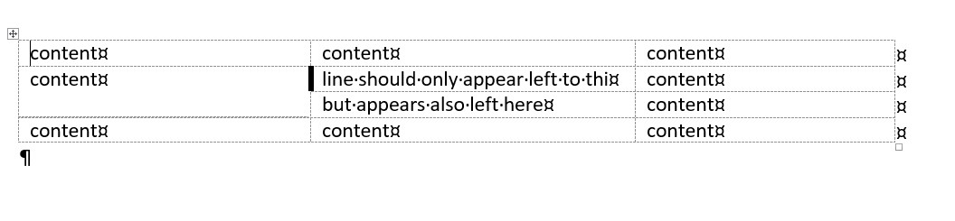
View from LibreOffice
