|  |  |  |
| --- | --- | --- |
| content | content | content |
| content | line should only appear left to thi | content |
| but appears also left here | content |
| content | content | content |

View from Word 2013

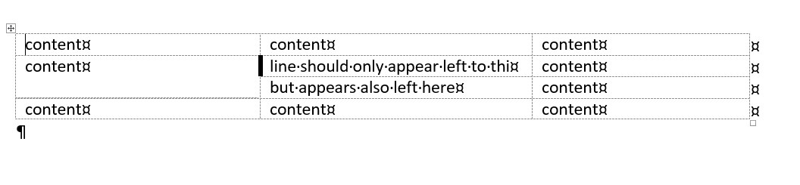

View from LibreOffice

