The rtf document with the hidden characters:
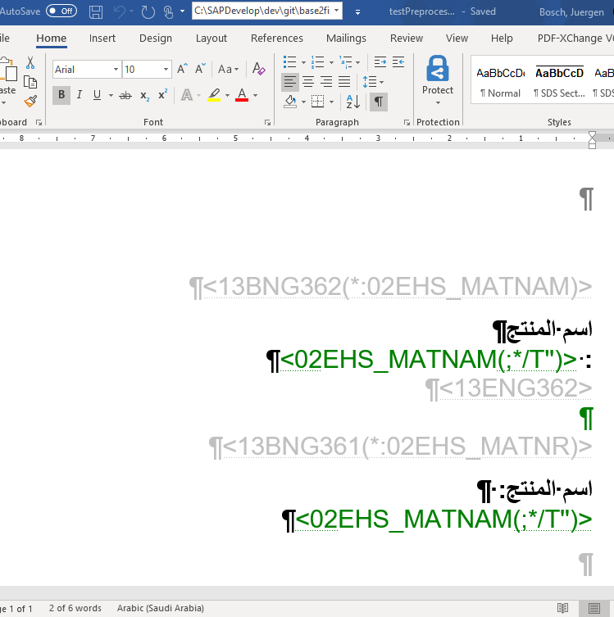

The rtf document on hide the hidden symbols:
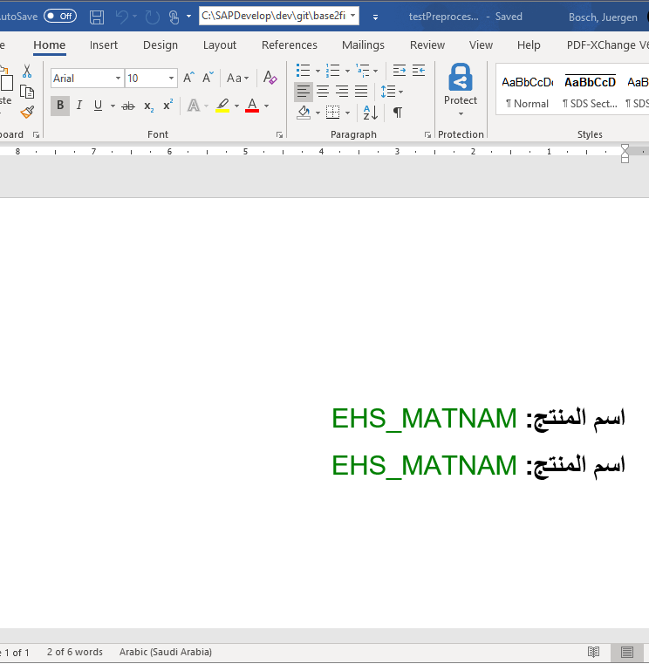

The converted PDF result:
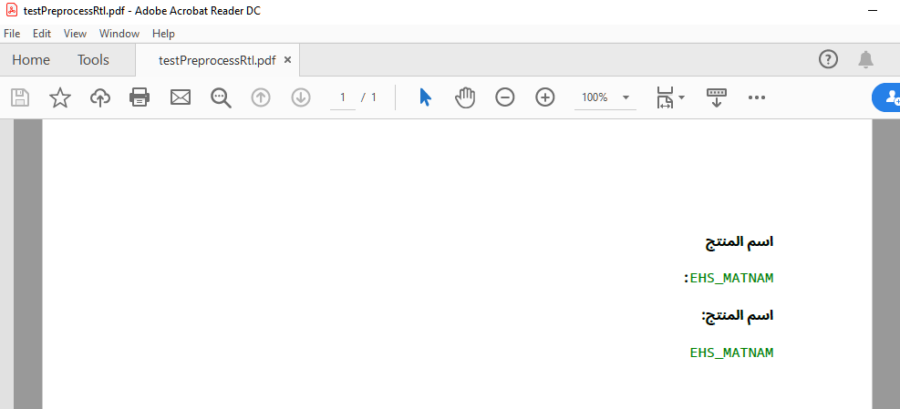
In the result of the first line the colon is at the wrong position and the linebreak is rendered.
In the second line the colon is on the right position but also the linebreak is rendered.

