Error Id 10016 DCOM
Windows 10 64Bit
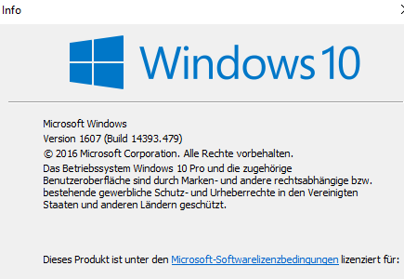

CLSID and APPID -> reffer to Wseach

