Author: | John Smith
 | R&D: SW Designer
Department: | Research & Development

Document Interface Specification
This document is generated by ComMA version 3.3.0.

Versioning

Interface | Version
IVendingMachine | 0.3

Software Interface Design

Syntax

Data types and constants

Global User-Defined Types

ENUMS
productName
Enum with the available products
WATER
COLA
JUICE
coinStatus
When a coin is inserted in the vending machine it can be either rejected or accepted
ACCEPTED
NOT_ACCEPTED
result
Type for the result of the operation for requesting a product
DELIVERED
NOT_ENOUGH_MONEY
NOT_ENOUGH_SUPPLIES
switchOnResult
SWITCH_ON_OK
LOAD_PRODUCTS_FIRST
RECORD TYPES
Product
Type for information about the products that can be ordered from the vending machine
enum productName | name | the name of the product
int | cost | the price of the product

Signature

Interface IVendingMachine

COMMANDS
void loadProducts(in int colaSupplies, in int juiceSupplies, in int waterSupplies)
Description | Loads bottles of cola, juice and water into the machine.
Parameter colaSupplies | the number of loaded bottles of cola
Parameter juiceSupplies | the number of loaded bottles of juice
Parameter waterSupplies | the number of loaded bottles of water
enum coinStatus coinThrowedIn()
Description | A coin is thrown in the machine
Returns | indicates if the machine accepts or rejects the coin
int returnMoney()
Description | Command for returning the current credit.
Returns | the amount of returned money
enum result orderProduct(in enum productName prodName)
Description | Command for ordering a product
Parameter prodName | indicates the product name
Returns
enum switchOnResult switchOn()
Description | Command for switching on the machine
Returns | if the total number of bottles in the machine is more than 0  the result is SWITCH_ON_OK, otherwise the result is LOAD_PRODUCTS_FIRST
SIGNALS
switchOff()
Description | Non-blocking call for switching off the machine
EVENTS
zeroTotalSupplies()
Description | Indicates that the machine is out of products
outOfOrder()
Description | Indicates that an internal error occurred
inventoryInfo(int items)
Description | Indicates the total number of bottles in the machine
Parameter items

Semantics

State behavior

Interface IVendingMachine

Global Variables
Type | Name | Comment
int | credit
int | colaSupply
int | juiceSupply
int | waterSupply

Variable Initializations
Variable | Value | Comment
credit | 0
colaSupply | 1
juiceSupply | 1
waterSupply | 2

STATE MACHINE vendingMachine

Transitions defined in every state :
Event | Guard | Actions
- |  | inventoryInfo

Transitions defined in every state except states Initial:
Event | Guard | Actions
switchOff() |  | -
returnMoney() |  | reply

Initial State Initial
Event | Guard | Target State | Actions
switchOn() | (colaSupply + juiceSupply + waterSupply) > 0 | Operational | reply(switchOnResult::SWITCH_ON_OK)
loadProducts(int colaSupplies, int juiceSupplies, int waterSupplies) |  | Initial | reply
State Operational
Event | Guard | Target State | Actions
coinThrowedIn() |  | Operational | reply(coinStatus::ACCEPTED)
coinThrowedIn() |  | Operational | reply(coinStatus::NOT_ACCEPTED)
orderProduct(enum productName prodName) |  | Operational | reply(result::DELIVERED)  reply(result::NOT_ENOUGH_MONEY)  reply(result::NOT_ENOUGH_SUPPLIES)  reply(result::DELIVERED)  reply(result::NOT_ENOUGH_MONEY)  reply(result::NOT_ENOUGH_SUPPLIES)  reply(result::DELIVERED)  reply(result::NOT_ENOUGH_MONEY)  reply(result::NOT_ENOUGH_SUPPLIES)
- | (colaSupply + juiceSupply + waterSupply) = 0 | Empty | zeroTotalSupplies
- |  | Error | outOfOrder
State Empty
Event | Guard | Target State | Actions
State Error
Event | Guard | Target State | Actions
- |  | Error | outOfOrder

Timing constraints

Interface IVendingMachine

Constraint TR1

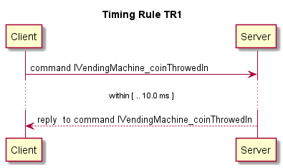

Constraint TR2

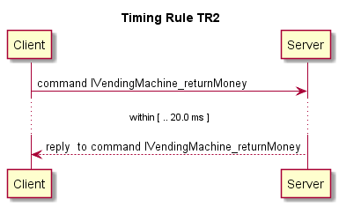

Constraint OutOfOrder

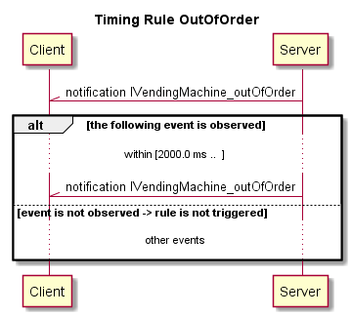

Data constraints

Interface IVendingMachine
Constraint DC1

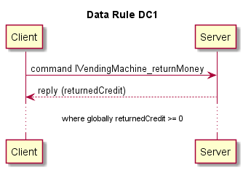

<DELETE THIS PAGE BEFORE FINALIZING THE DOCUMENT CREATED FROM THIS FORM>

<This page is NOT part of the controlled document you create from this form. This section contains information on the History and Control of the form.>

Control of the Form
Approver | (approval via electronic signature in document management tool)
GEN: Process Owner

Q&R: Q&R Manager

History of the Form
Revision | Doc. Date | Author | CR-ID | Description
03 | 2017 Aug 22 | Rob Albers,  Benno Tonissen | 2017/112 | - Comply with new format  - Added dedicated software interface design specification sections with guidance.
<List the changes and dates of approved revisions of the form/template. List three revisions maximum, with the most recent change mentioned first. Approved revisions are identified as 'NumberNumber', starting with 00. Always include the change request identification number under CR-ID. Make sure the date in the table matches the form / template date in the footer of the document.>

