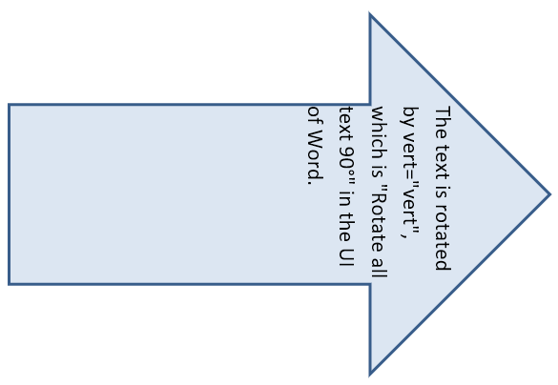

The text is rotated by vert="vert", which is "Rotate all text 90°" in the UI of Word.