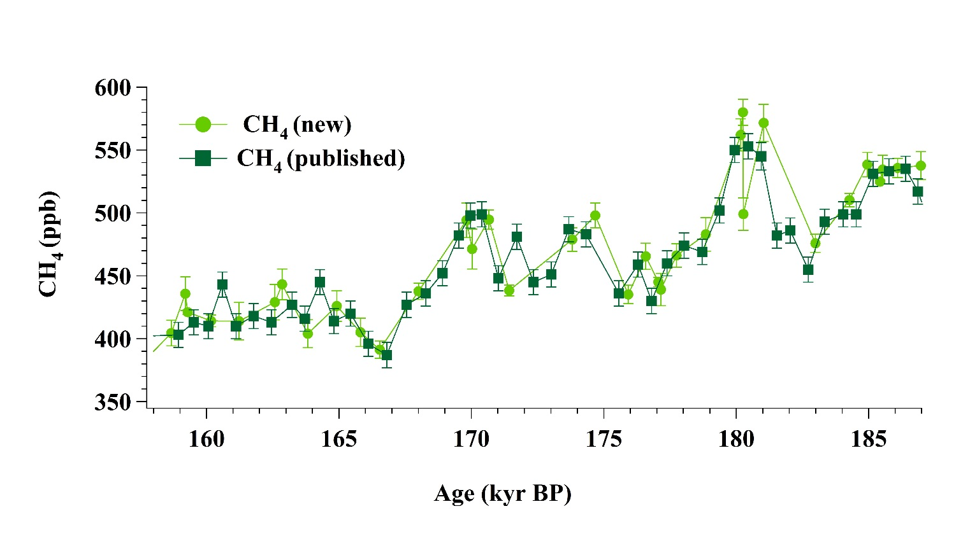
Figure 1: Atmospheric CH₄ concentrations from EDC ice core during MIS 6. Both dark green squares (Loulergue et al., 2008) and light green dots (this study) were measured at IGE.

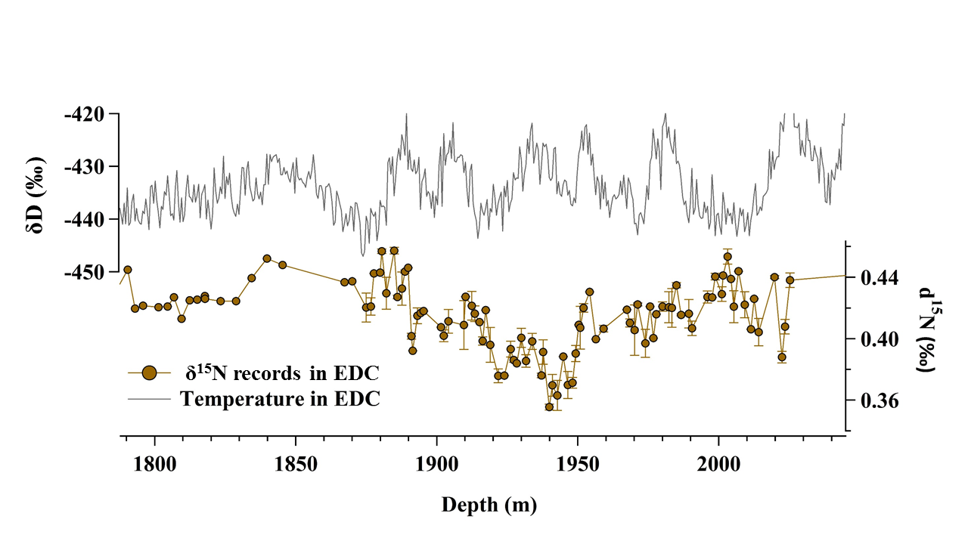
Figure 2: δD and δ¹⁵N from EDC ice core plotted as a function of depth. For δ¹⁵N, 88 new data points are added to the previous measurements (Landais et al., 2013). The error bar indicates the standard deviation of replicate.

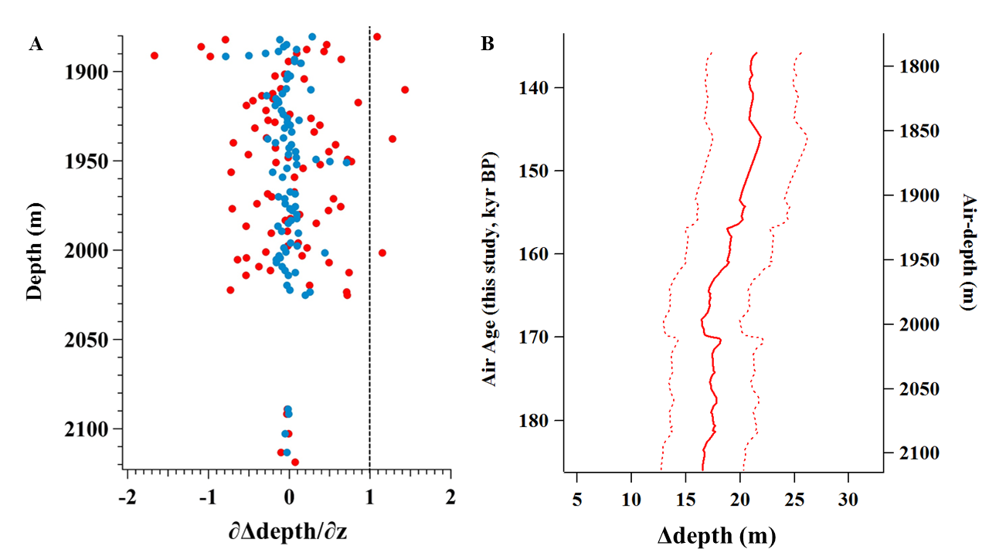
Figure 3: A: ∂Δdepth/∂z as a function of depth. Red dots from the raw δ¹⁵N measurements. Blue dots from a 3-point running mean weighted by 500/dT. Vertical dashed line indicates when ∂Δdepth/∂z function is 1. B: ∆depth (bold line) for EDC from 1787.5 to 1870.2 m below the surface, deduced from δ¹⁵N and the thinning function calculated in this depth range. The two dash lines corresponds to the analytical uncertainties.

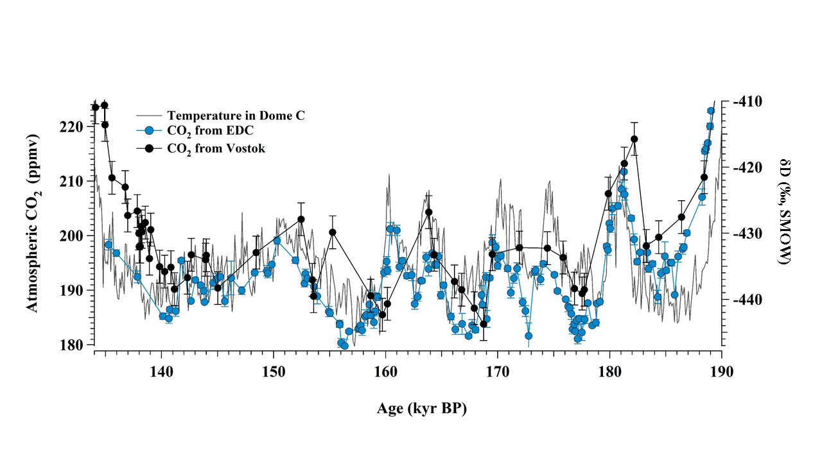
Figure 4: Atmospheric CO₂ from EDC (blue, this work) and Vostok (black, Petit et al., 1999) ice cores, compared to the δD of water at EDC (temperature proxy) (Jouzel et al., 2007) from 190─135 kyr BP.

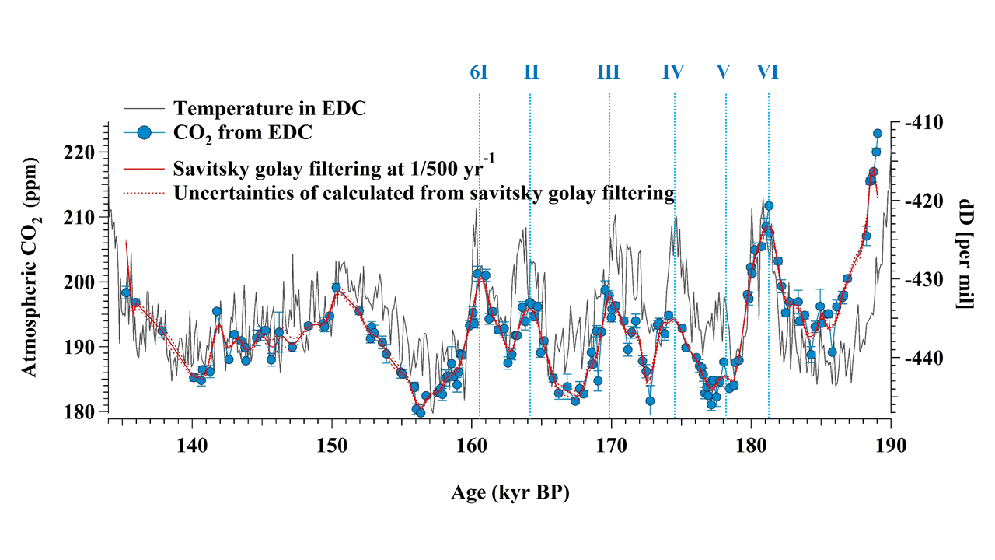
Figure 5: Atmospheric CO₂ from EDC (this study) and EDC water isotopic record (Jouzel et al., 2007). Red line indicates Savitsky Golay filtering curve made with a 500 yr cut-off period (red dotted line) Vertical dotted lines indicate the six CDM events that we identify during the early MIS 6.

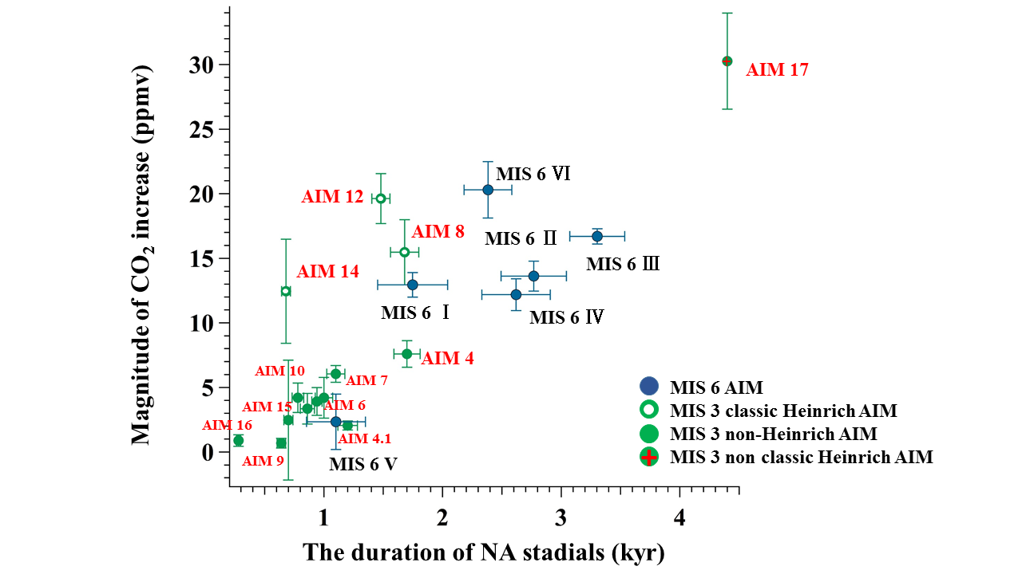
Figure 6: The relationship between North Atlantic Stadial duration and magnitude of CO₂ increase during the early MIS 6 period. Green dots indicate non-Heinrich AIM events during MIS 3, green dots with a white dot in the middle indicate classic Heinrich AIM events during MIS 3, and green dots with a red cross in the middle indicate non classic Heinrich AIM events during MIS 3 period. Blue dots indicate AIM events during MIS 6 respectively.

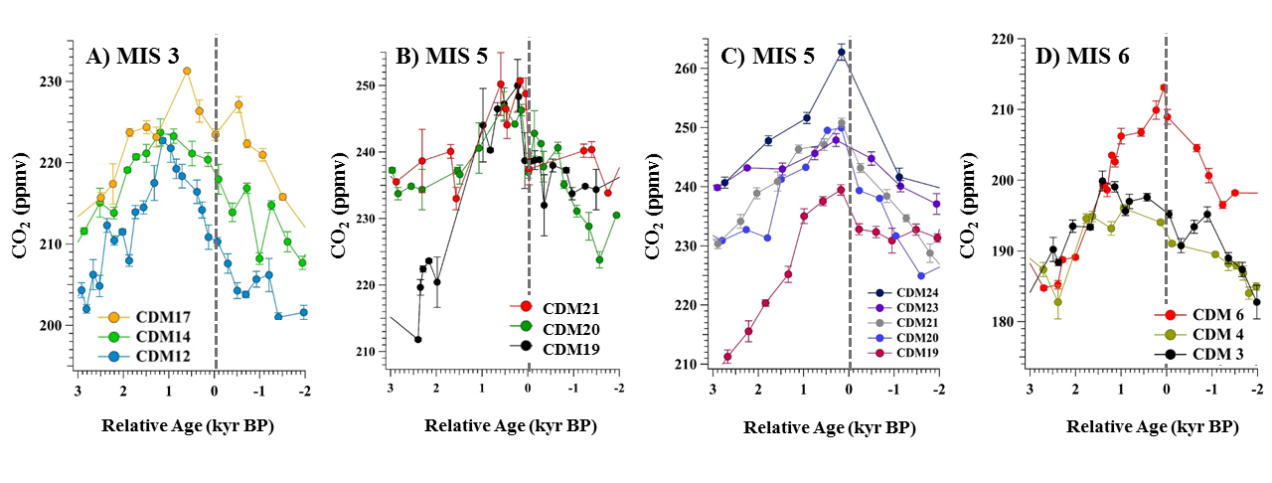
Figure 7: CDM lags relative to abrupt temperature increase in Northern Hemisphere. Grey dotted line indicates when climate changes abruptly in Northern Hemisphere. A: Atmospheric CO₂ was recorded from TALDICE (MIS 3), B: Atmospheric CO₂ was recorded from Byrd (MIS 5), C: Atmospheric CO₂ was recorded from EDML (MIS 5), D: Atmospheric CO₂ was recorded from EDC (MIS 6).

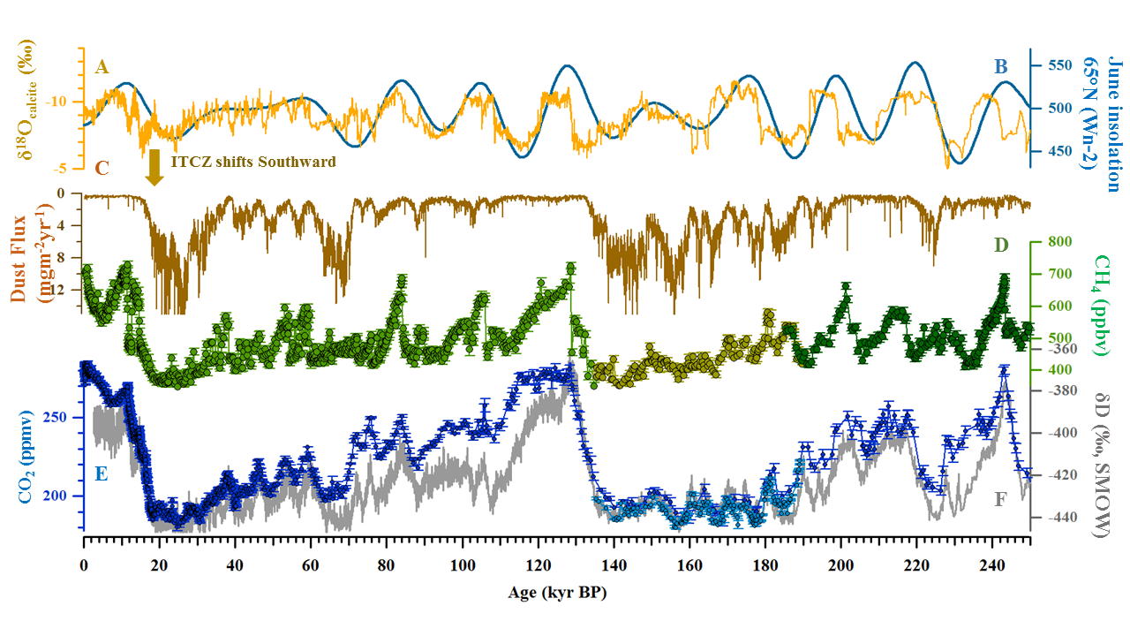
Figure 8: Proxy data during 250 kyr BP. A: δ¹⁸Ocalcite from Sanbao cave, corresponding with the strength of the East Asian monsoon (Cheng et al., 2016). B: 21 June insolation for 65°N (Berger, 1978). C: Dust flux in EDC (Lambert et al., 2012). D: Atmospheric CH₄ in EDC (green dots) (Loulergue et al., 2008) and Atmospheric CH₄ in EDC in this study (light yellow dots). E: Atmospheric CO₂ from EDC in this study (light blue dots) and composite CO₂ from Antarctic ice cores (dark blue dots) (Bereiter et al., 2015). F: δD composition in EDC, Antarctica (Jouzel et al., 2007).

