SCS-002

Entry 1/1 | Page / | Printed: Aug 6, 2019 6:17:43 PM
Created: Fri Nov 16 09:06:15 CET 2018 | Carried out by: Stefan Schmidt
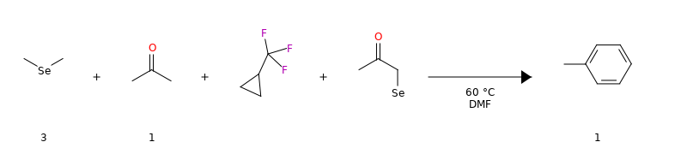
Reference amount: | 5 mmol | Solvent: | DMF | cryostate: | true | electricalOther: | Test
Gas: | Ar | gasPress: | 11 bar | heatingStirring: | true | howToQuench: | quc
notes: | not | overnight: | true | Pressure: | 5 bar | reflux: | true
Lab: | 4477 | Solv.: | DMF | specialRisks: | spc | T (°C): | 60
vacPump: | true
Reactants
# | eq | Structure | Substance name | Formula/CAS No. | MW | n [mmol] | c [%] | m [mg] | ρ | V [ml] | Hazard codes
A | 3 | 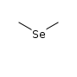 | C2H6Se | C₂​H₆​Se | 109 | 15 |  | 1635 | 0.866 | 1.89 | 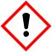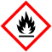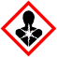
B | 2 | [MISSING IMAGE: , ] | Ru-MACHO®  250 mg / -5.07 mg - Chemical storage, P3 | C₂₉​H₃₀​ClNOP₂​Ru  1295649-40-9 | 607 | 10 |  | 6070
C | 1 | 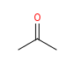 | Aceton  5 l / 5 l - Solvents, Solvents (Stefan Schmidt) | C₃​H₆​O  67-64-1 | 58.1 | 5 |  | 290 | 0.79 | 0.368
D |  | 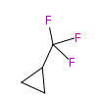 | MOF-5 | C₄​H₅​F₃ | 110
E |  | 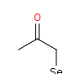 | C3H5OSe | C₃​H₅​OSe | 136 |  |  |  | 0.79
Reagents
# | eq | Structure | Substance name | Formula/CAS No. | MW | n [mmol] | c [%] | m [mg] | ρ | V [ml] | Hazard codes
R1 |  | 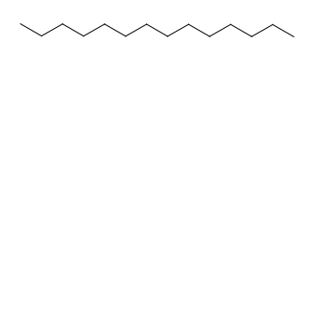 | Tetradecane  129.8 ml - Chemical storage, N2 | C₁₄​H₃₀  629-59-4 | 198 |  |  |  | 0.767
Procedure
SCS-001
Saved it yes
Test
zum Speichern
X | Y | Z
2 |  |  | Test
3 |  |  |  | &&&
4
- Test
- Test
- Noch einer
Observation
Test
Products
# | eq | Structure | Substance name | Formula/CAS No. | MW | n [mmol] | c | m [g] | Y_{Isol} / Y_{Ana} | Hazard codes
1 | 1 | 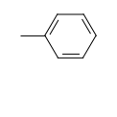 | methylbenzene | C₇​H₈  108-88-3 | 92.1 | 5 (100% = 0.461 g) |  | 50 | 10900 /

