List that MS Word saved
- 0
- 1
- 2
- 3
- 4

- 0
- 1
-------------------------------------------------------------------------------
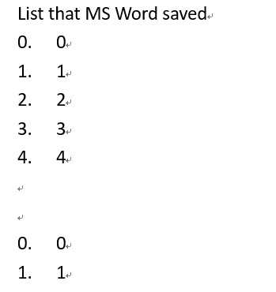
Here's the original order in MS Word

