Weekend 8 Test

- Please add one Phlegm resolving herb (or 2 when specified) that you would use to treat the following conditions (16 marks)
Epilepsy:
Chronic headache:

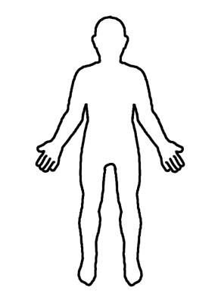
Phlegm misting mind:
Nausea x 2:
Sinusitis:
Thyroid disease:
Inguinal hernia:
Oesophageal reflux:
Cold Phlegm in lung x 2:
Ovarian cyst:
Bi syndrome:
Hot Phlegm in Lung x 2:
Sore throat:

- Name one stop cough herb you would use as the primary herb for each of the following types of cough (4 marks)?
Cold cough
Yin xu cough
Dry cough
Hot cough

3. Name an astringent herb you would use to treat the following conditions (6 marks):

Insomnia
Diarrhoea
Allergic asthma
Female infertility
Urinary incontinence
Spontaneous sweating

4. A 26 year old woman presents with painful and inflamed joints due to rheumatoid arthritis. The acute pain is in her wrists and fingers which are red, swollen, hot, stiff and very tender. Can you name 4 Wind damp and Channel opening herbs you would consider using to treat her and give one reason why you have chosen each herb? (8 marks).

1.

2.

3.

4.

5. Can you give a secondary action for each of the following herbs? (4 marks).

Xi Xian Cao
Si Gua Lou
Wu Jia Pi
Sang Ji Sheng

6. Pick a herb used to treat Bi syndrome and provide 2 pieces of information you have learned about this herb as a result of in vitro or in vivo research. (2 marks)

1.

2.

Total 40 marks

