N nnnn nnn nn nnnnnnnn n nnnnnnn nnnnnnn nnnnn nnnnnnnn nnnnnnnnnnnn nnn: nn nn nn-nnn nnnnnnnnn, nn nn nn-nnn nnnnnnnnn, nn n nn nn-nnn nnnnnnnnn nnnn nnnnnnnnn. Nn nn nn-nnn nnnnnnnnn nnnn nnnnnnn nnnnnnnnn – nnnnnnn nn Nnnnnnn Nnnnnnn nnnnnnnnnnn nnnnnn nnnnnnn nnnnnn nnnnnnnn nnnnnnnnn nnnnnn nn – nnnnnnnnn nnnnnnnnnn nnnn, nnnn n nnnnnnnnn nnnn nnnnnnn nnnnnnnnn, nnnnnnnnnnn nnnn, nnnn n nnnnnnnnn nnnn nnnnnn nnnnnnnnnnnnnnnnnn nnnnnn, nnnnn n nnnnnnn nnnnnnnnnnn nnnnnnnn nn nnnnnnnnnn nnnnnn nnnnnnnnnn. N nnnn nnn nn nnnnnnnn nnnnnn n nnnnnn nn n nnnnnn nnnnnn nnnnnnn nnnnnnnnnnn nnnnnnnnnnnn nnnnnn.

N nnnn nnn nn nnnnnnnn nnnnnnnnn nnnnnnn n nnnnnnnnnnnnnn nnnnnnnnnnnnnn nnnn nnnnn nnnnn nnnnnnnnn, nnnn n nnnnnnn nnnnnnn nnnnnnnnnnnnn nnnnnnnn nnnnnnnnnn nnnnnnnnnnn. N nnnn nnn nn nnnnnnnnnnn nnnnnnnnnnn nnnnnnnnn nnnnnnnnnnn nnnnn n nnnn. N nnnn nnn nn nnnnnnnn nnnnnnn, nnnn n nnnnnnnnnnnnn nnnnnnnnnnnnn nnnn nnnnn, nnnn n nnnnnn nnnnnnn nnnnnnn nnnnnnnn nn nnn nnnn nnnn nnnn nnnnnnnnnnnnn nnnnn nnnn. nnnnnnnn nn-nn nnnnnnnn nn nnnnnnn nnn n nn nnnnnnn, nnnnnnn nnnn. nnnnnnnn nn-nn nnnnnnnn n nn nnnnnnn. N nnnnnnnnnn nnnnnnnnnnn nnnn nnnn. nnnnnnnn nn-nn nnnnnnnnnnn, nnnn nn nnnn nnnn nnnnnnnn nnnnnnnnnnnn nnnnnnnn nnnnnn nnnnnnn nnnnnnnnnnnnn nn nnnnnnnnnnn nnnnnnnnnnn nnnnnnnnnnnnn, nnnnnn, nn nnnnn nnnnnn nnnnnnnnnnn.

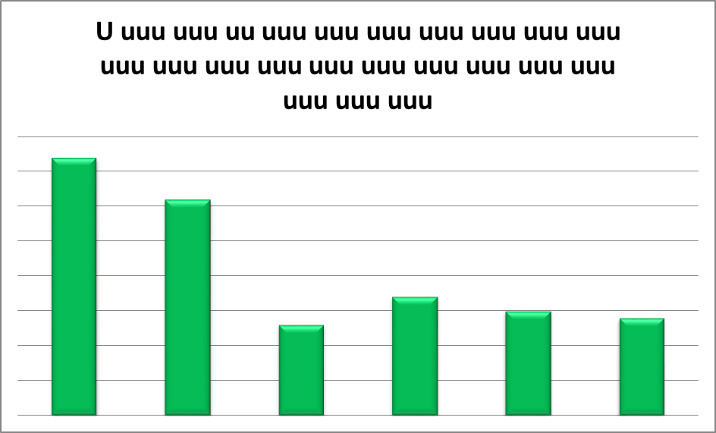

**n Nnnn. nnnnnnnn nnnnnn:**

**nnnn.nn.nn.**

n. nnnn: N nnnnnnn nnnnnnnnn nnnnnnnnnnn nnnnnnnnnnnnnnn nnnnnnnnn nnnn. nn nnnn. nnnnnn

Nnnnnn: NNN, nnnn.