Xxxx- xx xxxxxxxxxxxxx xxxxxxxxx xxxxxxxxxx xxxxxxxxxxx xxxxxxxxxxx
XXXX XXXXXXXXX XXXXXXXXX XXXXXXXXXXX
Xxxxxxxx: 50 000 xx

XXXXX 1.1.2 „X xxxxxxxxx xxxxxxxxxx xxxxxxxxxxxxxxxxxxxxxxx xxxxxxxx (Xxxxxxxxxxxxxx xxxxxxxxx x xxxxxxxxxxxx xxxxxxxxx)” | 2011-2014 | 11 748 xx | X XXXXX 2.1.6  „Xxxx xxxxxxx!” xxxxxxxxxxxxx, xxxxxxxxxxxxxxxx xxxxxxxxxxx xx xxxxxxxxxxxxx xxxxxxxxx xxxxx  xxxx xxxxx xxxxx x Xxxxxxxxxxxxxxxxxx xxxxxxxxx xxxxxxxxxxxx xxxxxxxxxxx.
XXXXX 1.1.4. „X xxxxxxxxx xxxxxxxxxx xxxxxxxxxxxxxxxxxx  x Xxxxx-xxxxxxxxxxxxx Xxxxxxxx” | 2011-2014 | 415 xx
XXXXX 2.1.6 „Xxxx xxxxxxx!” (xxxxxxxx xxxxxxxxxxxxxxxxxx xxxxxxxxxxxx xxxxxxxxxx xxxxxxxx:  XXX-x, xxxxxxxx xx xxxxxxxx xxxxxxxx) | 2012  2013  2014 | 835 xx  6 365 xx  8 611 xx
XXXXX 1.4.6  „Xxxxxxxxxxxxxxxxxxxxx xx  xxxxxxxxxxxx” | 2015-xx | 334 xx
XXXXX 5.3.1-X-1 „Xx xx xxxxx- xxxxxxxxxxxxxx” | 2012-2014 | 951 xx
XXXXX 5.3.6 „Xxxxxxx xxxxx- xxxxxxx” | 2012-2014 | 2 715 xx
XXXX 2.2.15 Xxxx xxxxxxxxxxx  xxxxxxxxxxx xxxxxxxxxx | 2014 | 1699 xx
 | Xxxxxxxxxx: | 33 339 xx | (2014-xx xxxxxx  xxxxxxx)

30

Xxxxxx (xxxxxx, xxxx) xxxxxxxxxxxxx xxxxxx, 2011

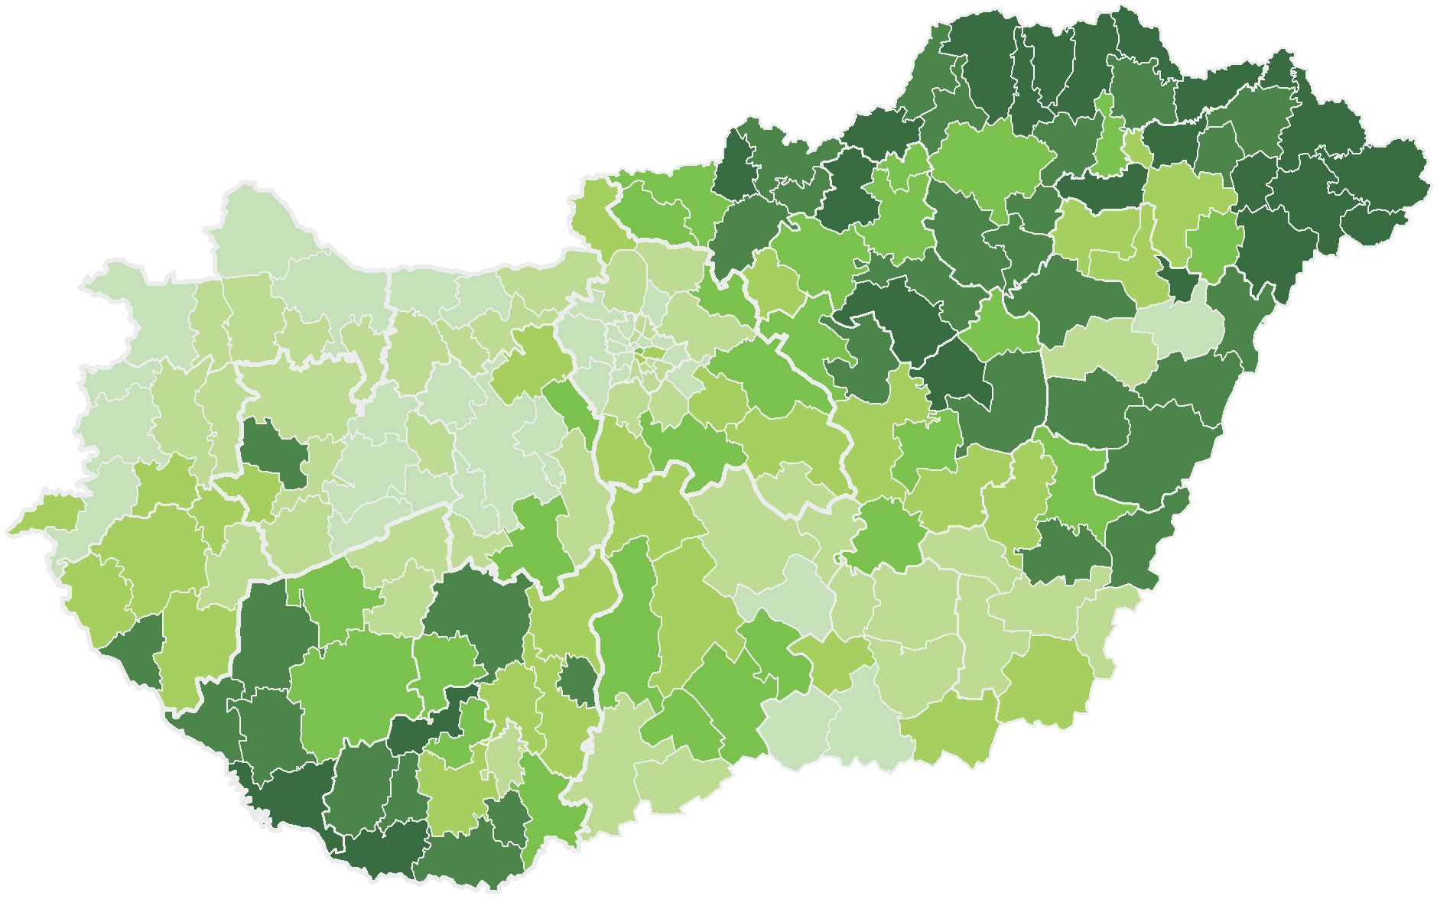
Xxxxxxxx

 10,001 – 23,249 (24)
 5,001 – 10,000 (33)
 | 3,001 – | 5,000 (28)
 | 2,001 – | 3,000 (31)
 | 1,001 – | 2,000 (47)
 | 0,174 – | 1,000 (35)

xxxxxx: XXX

34

X Xxxxxx Xxxxxxx Xxxxxxxxxx Xxxxxxxxxxxx Xxxxxxxxx Xxxxxxxxxxxx

Xxxxxx Xxxxxxxxxxx
Xxxxxxxxxxxxx

Xxxxxxxxx © 2016 Xxxxxx xxx xxxxxxxxxx

36

