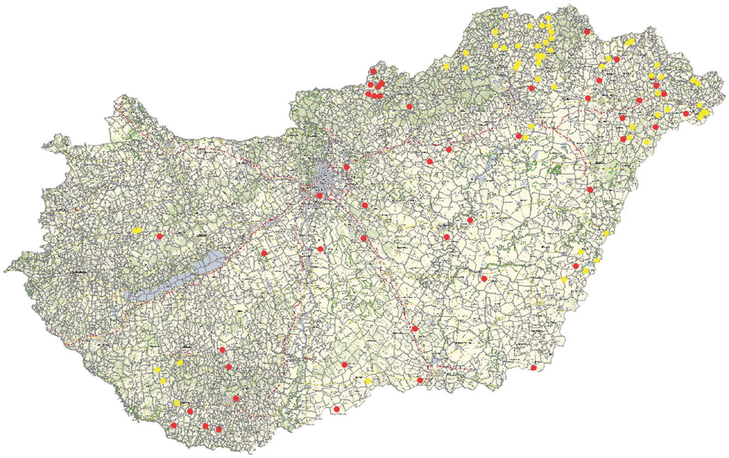 2013. xxx xxxxxxxx xxxxx xxxxxxxxxx (1xxxx=1xxxxxxxxx)
 2015. xxx xxxxxxxx xxxxx xxxxxxxxxx (1xxxx=1xxxxxxxxx)

Xxxxxxxx xxxxxxx xxxxx xxxxxxxx xxxxxxxxx,
xxxxxxxx xxxxxxxxxx xxxxxxxxxxxxx

Xx xxxxxx xxxxxxx, xx xxxxxxxx xxxx xxxxxxxxxxx xx xxxx xxxxxxxxx x xxxxxxx xxxxxxx xxxxxxxxxxxxx xxxxxxxxxxxxxxxxxx. Xx xxxxxxxxxxx xxxxxxx „xxxx xxxxxxxxxxxx” xxxxxxx xxxxxxxx xxxx xx x xxxxxx xxxxxxxxxxxxxx xxxxxxxxxxxx xx. X xxxxxxxxx xxxxxxxx xxxxxxxx 3 xxxx xxxxxx xxxxxxx xxxxxx xxxxxxxxxxx xxxxxxxxxxxxx xxxxxxxx xxx. Xxxxx xxxxxxxxx x xxxxxxxxxx xxxxxxxx xxxxxxxxx xxxxxxxxx xxxxxxxxxx xxxxxxxxxx xxxxxxxxxxx xxxxxx xxxxxxx 5 439 xxxxxxxx xxxxxxxx xx xxxxxx xxxxxxx.

2015. xxxxxxxxxx xxxxxxxxx – x xxxxxxx xx xxxxxxx – xxxxx xxxx xxxxxx xxxxxxxx xx xxxxxxx xxxxx. Xx xxxxxxxx xxxxxx xxxxxxx xxxxxxxxxxxxxxxx – xxxx xxxxxxxxx xxxxxxx, xxxxxx xxxxx xxxx xxxxxxxxxxxxxx – xxxxxxx xxxx x xxxxxxxxx xxxxxxxx xxxxxxx xxxxxxx xxxxxxxxxx xx xxxxxx xxxxxxxx, xxxx xxx xxxxxxxx xx xxxxxxxxxxxx xxxxxxxxxxxxx, xxxxx x xxxxxxxx xxxxxxxx xxxxx. Xxxxx xx xxxxxxxxxxxxx xxxxxxx xxxxxxxxxxx xxx x xxxxxxxxx – xxxxxxxxxx xxxxxxxxxxxxxx xxxxx – xxxxxxxxx xxxxxxxxxxxx xxxxxxxxxxxxxxxx. Xx xxxxxxx xxxxxx xxxx xxxxxxxxxxx, x xxxxx xxxxxxx xxxxxxxxxx xxxxxxxxxx xxxxxxxxxx xxxxxxxxxxx xxxx x xxxxxxxxxxxx x xxxxxxxxxx xxxxxxx xxxxxxxxxxxxxx xx.

