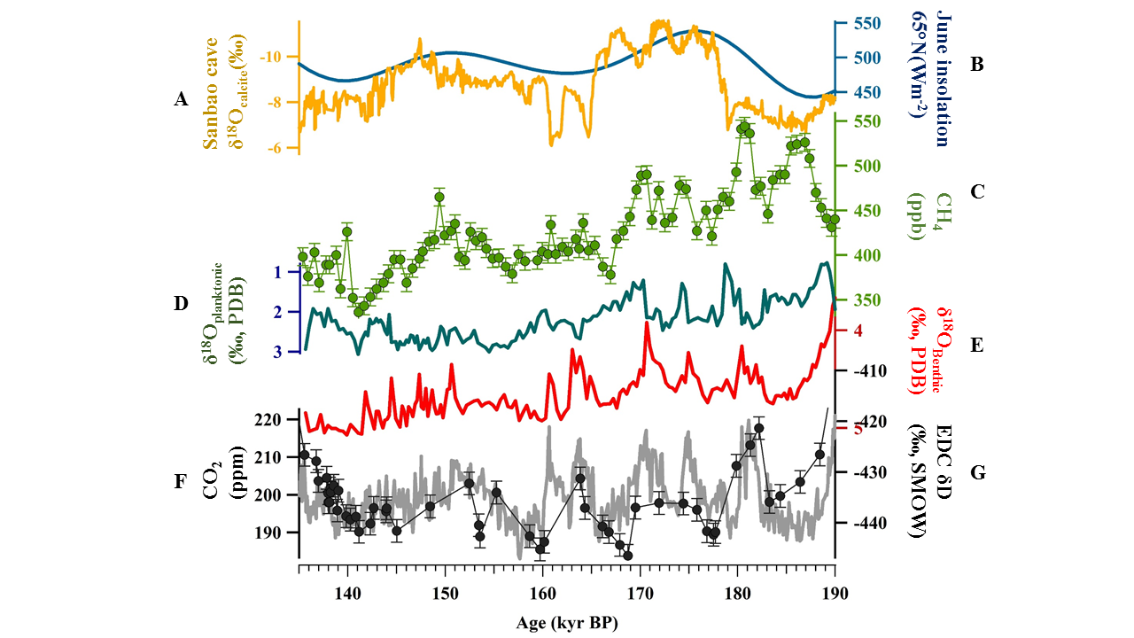

**Figure 1.** Atmospheric CO2 and proxies during MIS 6 period. A: Monsoon intensity from δ18O calcite of speleothem in Sanbao Cave, China (Cheng et al., 2016). B: 21 June insolation for 65°N in Northern Hemisphere (Berger, 1978). C: Atmospheric CH4 from EDC (Loulergue et al., 2008). D: δ18O of planktonic foraminifera in the Portuguese margin marine Core MD01-2444 (Margari et al., 2010). E: δ18O of Benthic foraminifera in the Portuguese margin marine Core MD01-2444 (Margari et al., 2010). F: Atmospheric CO2 from Vostok ice core (Petit et al., 1999). G: Temperature variabilities in Antarctica from δD composition of EDC (Jouzel et al., 2007).