Hello, this is a “Title”. Calibri Light (Headings) 28
And this is “normal text”. I am just a normal paragraph, Calibri (Body) 11
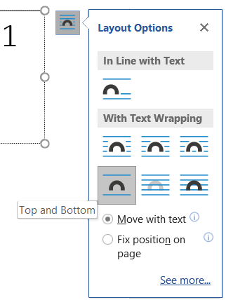
The text boxes are aligned Top and Bottom (multiple text boxes cannot be selected if they are “in line with text”).

In Word, the text style in the text boxes are the same as advertised, Title and Normal.
In LO, the Title is still Title, and the Normal is formatted as Frame Contents.

U1: I am UNGROUPED text box 1 (Title style)
Normal: I am a text box created in MS Word. I am also free and not grouped to anything else.

U2: I am UNGROUPED text box 2 (Title style)
Normal: I am a text box created in MS Word. I am also free and not grouped to anything else.

In Word, I can see styles on the following grouped text boxes.
In LO, no styles are present. In fact, LO does NOT recognize any style, and the text is not even formatted as Frame Contents, something that is seen in the ungrouped text boxes.

G1: I am GROUPED text box 1 (Title style)
Normal: I am a text box created in MS Word. I am also grouped to G2.

U2: I am GROUPED text box 2 (Title style)
Normal: I am a text box created in MS Word. I am also grouped to G1.

What I see in Word:
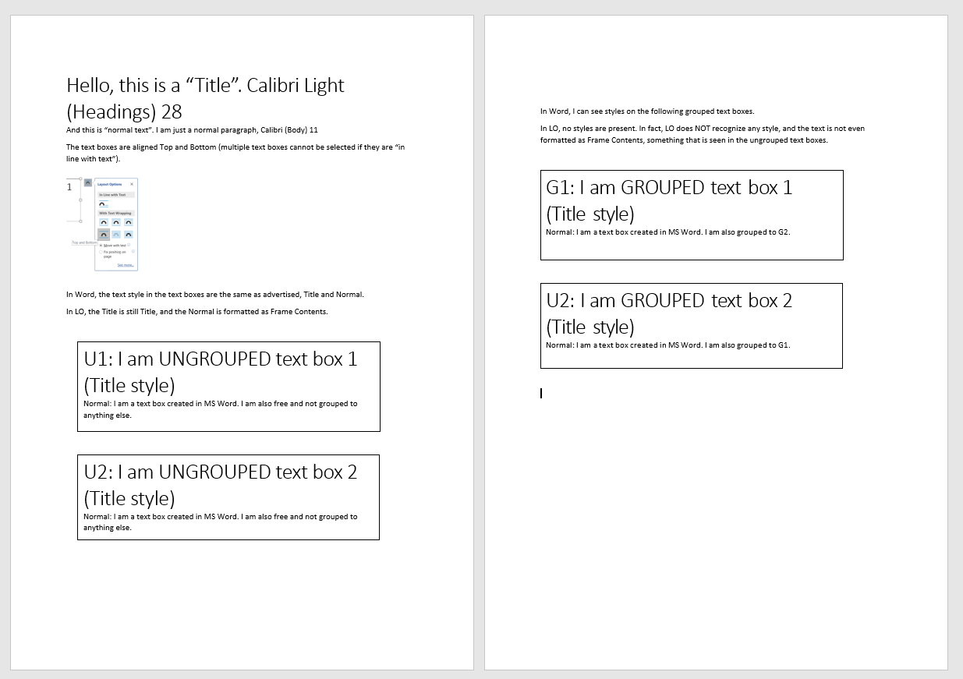

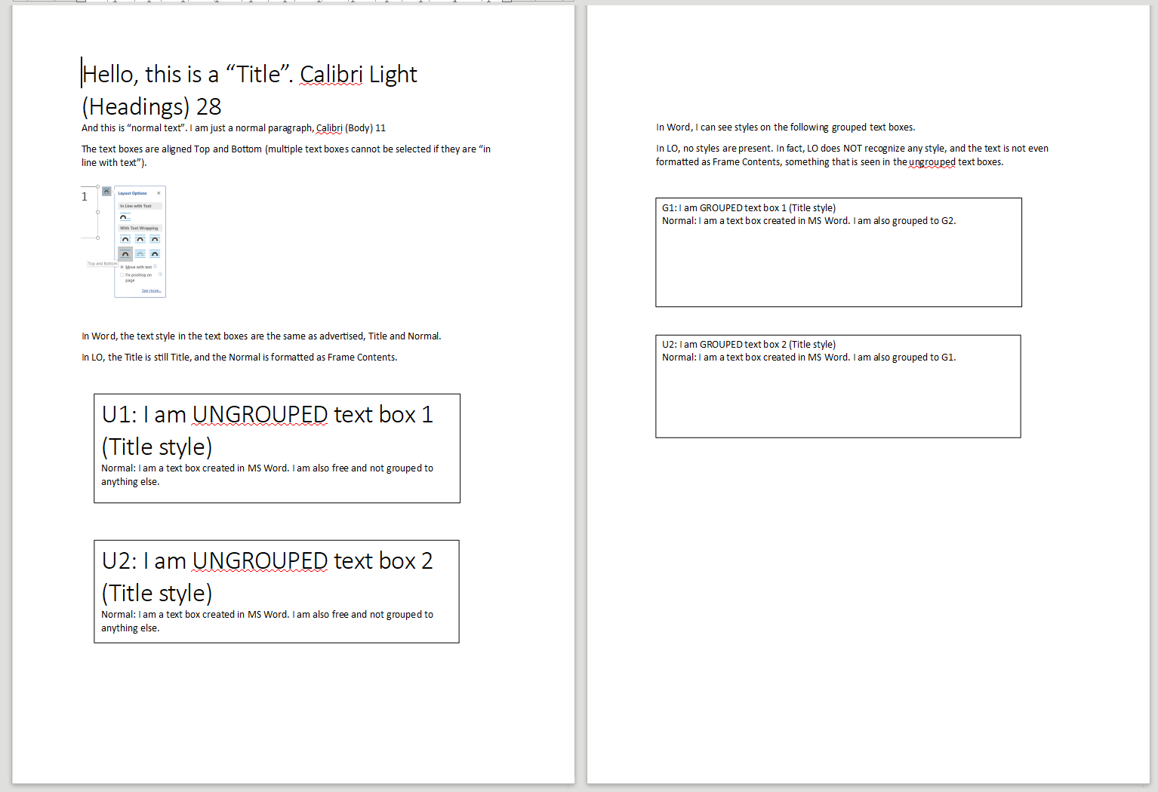
What I see in LO 6.5.3.

