Target audiences:
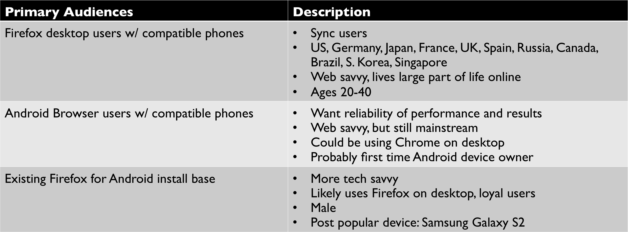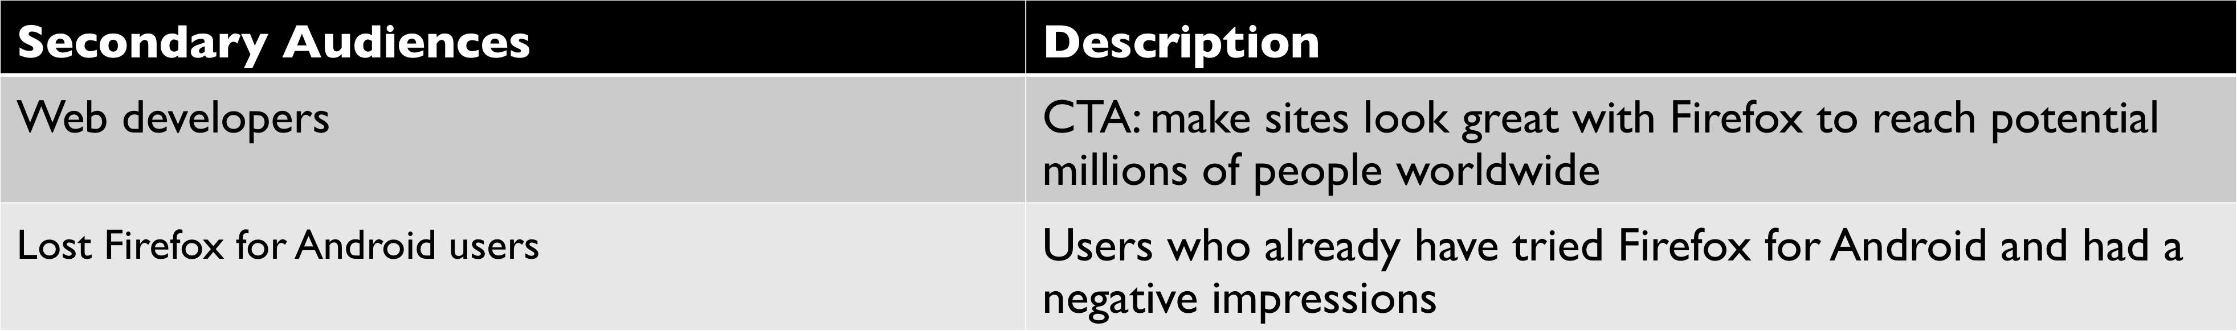

Call to action
Download Firefox for Android
Learn more about Firefox for Android

Mandatory elements
- Firefox logo
- Android guy logo (take advantage of Android’s established mindshare)
- “Firefox for Android”

We want to the viewer to know and feel:
Audience should discover:
- For those who have not tried Firefox for Android: It’s the best mobile Web browser out there for Firefox desktop users who own Android devices
- For those who have tried Firefox for Android: It has been updated with improved performance, a redesigned look and feel, + more and deserves a second chance
- Firefox is a contender in the mobile Web browser space

Audience should feel:
- Excited, rallied - Firefox is back in the game with mobile
- Delighted, surprised

Tone (from the brand book):
Unconventional, Engaging, Honest, Human, Smart, Confident

Guidelines:
- More about a “new update” than “completely overhauled”
- Shiny, realistic phones instead of graphic phones
- Localizations will be needed

Deadlines:
Late March – Beta
Early June – Final Release

APPENDIX