Test PNG image inserted not copied/pasted.

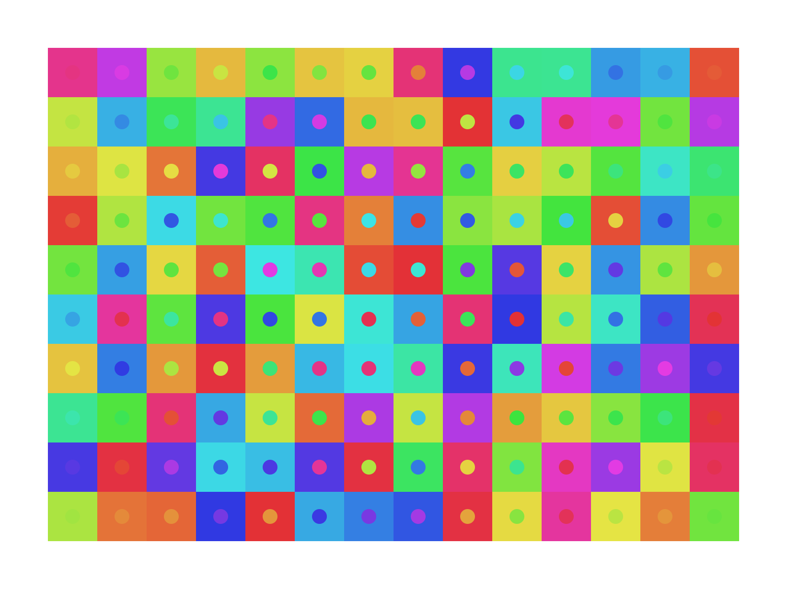

Test text.

