The impact of pollinator flower constancy and pollen clogging in simulated flowering plant communities

Alan Dorin, Tim Taylor, Mani Shrestha, Adrian Dyer.
Martin Burd? Julian Garcia? Sept 2017

Suggest submit to: PLoS Computational Biology. Perhaps via Assoc. Editor: Stefano Alessina.
http://journals.plos.org/ploscompbiol/s/submission-guidelines

Abstract.
This article explores the impact of pollen clogging on the population dynamics of two competing species of self-incompatible flowering plants. A spatially explicit individual-based simulation of flowering plants and insect-pollinators is presented to demonstrate that symmetrical pollen clogging results in a driven process of self-reinforcing competitive exclusion of one species. The symmetrical absence of pollen clogging from what is otherwise the same system, results in very different dynamics: under otherwise identical conditions the two plant species may coexist for extended periods, with eventual fixation of one species arising via a stochastic dynamic rather than a driven one. In our model, unilateral pollen-clogging always results in the dominance of the species that does not suffer pollen clogging over its competitor. This highlights an important impact of pollen clogging on plant community assembly for driving signal evolution such as colour and/or olfaction to promote pollinator constancy, or the evolution of morphological traits to physically exclude generalist pollinators.

Introduction.

Honeybees and bumblebees are flower visitors renowned for their “flower constancy” – the tendency to repeatedly forage from the same species of rewarding flower. This tendency is beneficial to the flowers as well as the bees. From the flower’s perspective, it promotes pollination [REFs]. However, when flowers that bloom together look alike, bees often make mistakes, inadvertently breaking flower constant behaviour [REFs]. In some cases, for instance after receiving lower or infrequent rewards, bees may deliberately break their flower constancy and search for alternative flowers [REF Reverse learning]. There are several consequences for flowering plant reproduction of a breakdown in constancy by a pollinator. These consequences may also arise as a result of the fact that other flower visitors, like flies or butterflies, may not exhibit flower constancy to the same degree as bees (Chittka et al. 1999; butterflies; flies). The potentially adverse consequences can include:

- Wasted pollen. Pollen from a species X that is intended for a conspecific may be lost for no reproductive gain. This may occur because the pollen is deposited on the stigma of a floral species Y, lost during flight, groomed or brushed off, or eaten (in which case it is a floral reward to the pollinator).
- Wasted pollinator. A visit to any flower that is not species X is, from species X’s perspective, wasted insect time.
- Wasted stigma - pollen clogging. Lastly, foreign pollen from species Y may be deposited by an insect onto the stigma of species X where it blocks stigma surface from access by reproductively useful pollen from species X. Species X has been “pollen clogged”.

We can see from points (i) and (ii) that both allowance for pollen loss, and facilitation of successful pollen delivery to conspecific flowering plants are important aspects of the success of angiosperms. Since pollen is metabolically expensive for angiosperms to produce, alternative rewards like nectar are often presented to attract pollination vectors [CruddenFaegriIverssen 1989, more ref for nectar: Pyke 1991, Roy et al 2017]. Also, even when such reward mechanisms are available, pollen transfer may be limited by the availability of pollinators [Knight et al 2004, 2005, Williams & Mazer 2016 ]. In response to the complexity of the pollination scenario, a variety of mechanisms of pollen transfer have evolved. These range from the mass production of pollen and its blanket distribution by wind (anemophily) (examples include …), to the narrowly targeted distribution of pollen to conspecifics via closely co-evolved insect pollinators (e.g. orchids: Johnson et al 1997, Manit et al 2005, Gasket 2011and Long tong fly++ Paudel et al 2015,16; Pauw et al 2009, Anderson Johnson 2008, Manining & Goldbalt 1997, Goldbalt and Manning 2000).

Points (i–iii) all indicate the importance to a flowering plant of its pollinator’s flower constancy. This current article focuses on the impact of pollen clogging on plant reproduction in the case where animal pollinators have a low level of flower constancy. This inconstancy may be due to factors such as the perceptual similarity of plant species (Dyer et al. 2012) or just the behavioural repertoire of some insect species (Chittka et al. 1999). Many insect pollinators are generalists and will typically choose any rewarding flower, especially if it appears similar in colour (refs) or olfactory cues (ref) to one they have encountered before. In cases where flowers from a single species bloom in “patches” (large clusters, clumps, fields, or on large trees with little else by way of nectar supply in their surroundings), non-constant pollinator behaviour may be of little concern to the plant due to the absence of nearby competitors (ref). In these situations even a randomly wandering insect is likely to effectively deliver pollen between conspecifics simply due to the size of the patch or the unavailability of other species. However, this reproductive strategy is problematic if several species are competing for the attention of pollinators in the same area. One plant strategy that may overcome this involves the evolution of colour signalling to enable easy differentiation by flower constant pollinators.

As noted above, honey- and bumble-bees are often flower constant, even in situations where flowers of different species are intermingled. Once these bees have acquired experience and a taste for the rewards of a particular flower, they tend to keep foraging from the species whilst exploitation remains profitable. This benefits a knowledgeable bee; she needn’t waste time or energy learning to handle new flowers [REF] or on exploring potentially unrewarding species [REF]. To a flowering plant, flower-constancy by insect pollinators maximises the value of its pollen. The more reliably pollen can be delivered to conspecifics, the rosier the species’ future. Based on this understanding, we might expect to find that advanced flowering plant species have evolved characteristics that support their pollinators’ abilities to remain flower-constant [REF]. Not only do the flowers present rewards (food, shelter, or in cases of sexual deception, apparent mating partners) to attract and maintain reliable visits from pollinators [REFs], it is in their interest to be clearly distinguishable from other species blooming at the same time so as to reduce the complexity of the insect perceptual tasks required to make decisions [REF].

Studies of floral colour distribution from several regions show patterns that reflect our understanding of the likely impact of hymenopteran visual systems [REFs], the visual systems of UV and VS-sensitive avian pollinators [REFs], and even of dipteran vision [REF Macquarie Is.] on floral colour. Computer simulations modelling the impact of hymenopteran visual systems on flower constancy capabilities and floral selection also generate the expected floral colour distributions, showing this to be an important driver of floral colour in plant communities [REF – our paper on Y-maze etc]. The simulations of hymenopteran flower constancy we reference treat flower species as equivalent to flower colours. I.e., the simulated flowers have no other traits besides colour. These existing simulations track flower constant visits as a proxy for pollination. Each missed opportunity for flower constancy is a missed opportunity for pollination from a fixed number of chances. Hence, both points (i) and (ii) above are indirectly modelled in these simulations, even though the distinction between them is not explicitly made in the software. Although these models explore floral colour evolution resulting from insect behavioural and visual perception models, since the models equate floral colour with floral species, they are effectively exploring the impact of pollinator behaviour on floral species evolution.

Reconsidering now the three ways listed (i, ii & iii) for non-flower-constancy to impact on floral reproduction, it should be clear to the reader that the simulations described so far do not explore the impact of the erroneous delivery of pollen onto the “wrong species” (point (iii) above). That is, these simulations don’t model pollen-clogging interactions between co-flowering, competing species. However, an early computer model does cover some of this ground [REF]. Waser’s study includes experiments involving pollen clogging in a scenario with two simultaneously flowering plants competing for a non-constant pollinator. He found no conditions that lead to the stable coexistence of both plant species in the same area. At face value, this result seems surprising given the abundance of real situations in which several species co-exist. The model we describe in our present paper builds on Waser’s work to examine this interaction in more detail. We wish to discover whether or not the stable coexistence of two plant species is supported under any scenarios, and, if so, what are they?

The impact of pollen clogging on plant community assembly and model selection.

In any community, plants must compete for resources including, for instance, light, space, nutrients and pollinators [REFs]. However, a simple model from which to study the implications of pollen clogging on plant community assembly consists of two-species of self-incompatible flowering plants in which flowers of species X and Y bloom simultaneously and compete for the same animal pollinator. Pollen distribution patterns are inherently spatial. We can eliminate the impact of patchiness, a complicating factor in many real environments (see discussion above on “patches”), in at least two ways. One approach is to examine a spatial model in which it is assumed that the two plant species are well mixed (as opposed to clumped). An alternative is to examine a non-spatial model in which insects may move directly from any flower in the model to any other. [NOTE: In this paper we choose the first option simply because we will later use the same model for other purposes where plant clustering will be examined. BUT, if we include differential equations, we can say we do both approaches in this paper.]

If members of a pollinator species are perfectly flower-constant, pollen clogging of flowers X by pollen from Y doesn’t occur. Even if a pollinator encounters species X after landing on target species Y she will not land on X. But, what if the animal’s flower-constancy is less than perfect? Table 1 presents the scenarios in which pollen clogging may impact the two flowering species. The simulations presented in our paper consider all of these scenarios.

Whether or not pollen clogging occurs when flower-constancy breaks down in any specific case will depend on factors related to the floral structures of X and Y. For instance, species X might be a specialist with regard to pollen deposition and collection, requiring very precise pollen placement and retrieval from a particular insect species’ body [REF example]. Species Y may, by contrast, deposit pollen clumsily all over the pollinator and remove it roughly from many locations on a visitor’s surface [REF example]. In this case, species Y might be susceptible to pollen clogging by species X while X is not susceptible to clogging by Y (Table 1, case 2a or, vice versa, case 2b). Perhaps both species are specialists – pollen clogging will not occur, even with non-constant pollinators (case 3). Or perhaps both are generalists and they clog one another (case 1). We would like to know how each of the cases 1-3 effects the population dynamics of species X and Y as they reproduce from season to season. Our hypothesis is that robustness against pollen clogging is essential for any flower species to survive competition from a co-flowering competitor for a non-flower-constant animal pollinator.

 |  | X clogs Y
 |  | Yes | No
Y clogs X | Yes | Case 1  Symmetrical clogging | Case 2b  Asymmetrical
 | No | Case 2a  Asymmetrical | Case 3  Symmetrical non-clogging
Table 1. The possibilities for pollen clogging of two co-flowering, self-incompatible plant species (X and Y) competing for a non-flower-constant pollinator.

Pollen Clogging simulation design
Our simulation code is open source, and the configuration and output files are open data. Details of how to obtain them are provided at the end of the paper.

ODD description of model

Purpose
Our model was designed to study the pollination dynamics that arise in a system with two plant species and a single insect pollinator, in cases where pollen from one plant species does, or does not, interfere with the successful pollination of the other species.
Specifically, we model the mechanism of pollen clogging, whereby pollen from one plant species X (call it X-pollen) can, if delivered by a pollinator to the flower of a different species Y, stick to the Y-flower’s stigma and thereby reduce its capacity to accept conspecific Y-pollen. Pollen clogging by species X can therefore reduce the rate of successful pollination of species Y.
We study three different scenarios: (1) Symmetric Clogging: X clogs Y, and Y clogs X; (2) Asymmetric Clogging: X clogs Y, but Y does not clog X; and (3) Symmetric Non-Clogging: X does not clog Y, and Y does not clog X.

Entities, state variables, and scales

Agents/Individuals

Pollinators
Each pollinator has a unique identity number. It keeps a record of its current position in the environment (a two-dimensional floating point vector) and its current heading (a floating point angle between 0 and 2π radians). It has a pollen store, in which is stored any pollen that the pollinator is currently carrying having collected it from previously-visited flowers. It keeps a list of the ids of the five most recently visited flowers, and at any given time it will not revisit a flower that is currently on this list. Finally, each pollinator has a foraging strategy, which is either Forage Nearest Flower, or Forage Anywhere. These strategies are explained in the Process Overview section.

Flowers/Plants
In our model, each plant has a single flower, so we treat a plant and its flower as a single entity. Each flower as a unique identity number. It also has a species identity number, to signify which of the two species it belongs to. The flower keeps a record of its position in the environment (a two-dimensional floating-point vector), which is fixed for a flower’s lifetime. It also keeps a record of the number of collectable pollen grains currently available in its anthers—this is initialised with a fixed number when a flower is created, and depleted when a pollinator visits the flower, when a fixed number of anther pollen grains are transferred to the pollinator’s pollen store. The flower has a stigma pollen store, in which is stored any pollen that visiting pollinators have deposited (these may be conspecific or heterospecific grains). The only difference between different species of flowers is the type of pollen that they produce and require for pollination.

Pollen
Each pollen grain is modelled individually, and keeps a note of the individual flower that produced it, its species type, and (when travelling in a pollinator’s pollen store), the number of flowers the pollinator has visited since the grain was originally collected.

Spatial Units
Distances in the simulation are measured in terms of a unit we call the perceptual distance unit (pdu). We define 1 pdu as the visual detection radius over which a pollinator can detect a flower. This corresponds to a distance of approximately 0.7m in the real world, which is the distance over which bumblebees can detect a plant’s flowers [REF Dyer, Sparthe et al, 2008; Wertlen, Niggebrugge et al 2008].
In these experiments the environment is homogeneous (with the exception of the refuge areas described in the following section), so there are no state variables associated with particular positions within the environment.

Environment
In most of our experiments we use an environment of 200 x 200 pdu, corresponding to an area of 140m². The environment is modelled as a continuous space, so flowers and pollinators can be placed in any position—they are not restricted to placement in discrete spatial positions. We model a single species of insect pollinator and two species of flowering plant (labelled X and Y). A column of area 40 x 200 pdu on the left edge of the environment acts as a refuge for plant species X; only plants of this species can grow here. If during the reproduction phase a seed from species Y lands in the refuge of species X it is removed from the simulation. An equivalent column on the right edge of the environment acts as a refuge for species Y. Plants of either species can occupy the central 120 x 200 pdu area of the environment. Following Waser’s approach, we have incorporated these refuges to promote the possibility of the stable coexistence of two plant species (see Waser’s Experiment 4). However, note that the use of refuges in Waser’s experiments only had a marginal positive effect in this regard; it lead to a slight increase in the mean duration for which the environment was able to support the coexistence of the two species before one went to fixation.

Process overview and scheduling
Overview of dynamics: foraging and reproduction phases
Our model features a 2D continuous spatial environment containing a population of flowering plants of two different species. Each plant has a single flower that can be foraged by members of a single population of insect pollinator agents. The simulation cycles through two phases, an insect foraging and pollination phase and a plant reproduction phase. During the foraging phase, the pollinators forage from the fixed population of flowers, transferring pollen between flowers as they visit, and thereby potentially pollinating them. The foraging phase proceeds in a number of discrete time steps and ends when a specified number of steps have elapsed. At this point the plant reproduction phase begins. During the reproduction phase, viable seeds from pollinated plants form the gene pool for a new generation of plants. All plants and pollinators from the previous generation are removed from the environment, and new plants are created based upon parents picked at random (without replacement) from the gene pool. New plants are distributed to random positions in the environment. New plants are created until all members of the gene pool have been reproduced, or until the maximum carrying capacity of the environment is reached. A new population of pollinators is then created and distributed to random starting positions in the environment. Next, a new foraging phase commences. This simulation continues to cycle until a specified number of foraging/reproduction phases have been completed.

Pollinator dynamics
Each foraging phase begins with a population of 400 pollinators distributed uniform-randomly across the environment. Each pollinator collects a supply of pollen by visiting flowers. At each time step during the foraging phase, each pollinator executes a new iteration of its foraging behaviour. We studied two different pollinator foraging strategies in these experiments: the default strategy, named Forage Nearest Flower (FNF), and a variant strategy named Forage Anywhere (FAW).
For both strategies, each pollinator keeps a list of the five individual flowers that it has most recently visited, and will not revisit a flower if it currently appears on this list.
If following the Forage Nearest Flower strategy, the pollinator will move to (and land upon) the nearest flower that is within a search radius of 1 pdu from its current position and that does not appear on its list of recently visited flowers. If no flower meets these criteria, the pollinator moves a distance of 1 pdu in a uniform-randomly chosen direction. Figure 1 provides an overview of a pollinator's actions during a single iteration of its foraging behaviour under the FNF strategy.
If following the Forage Anywhere strategy, the pollinator picks a flower to visit at random from all flowers in the entire environment, excluding those on its list of recently visited flowers. This effectively simulates a well-mixed population, i.e. one with no spatial aspects.
A number of pollen transfer processes occur at this point of time as described below (Pollinator action on flowers). The order in which pollinators are processed is determined at random at each time step.

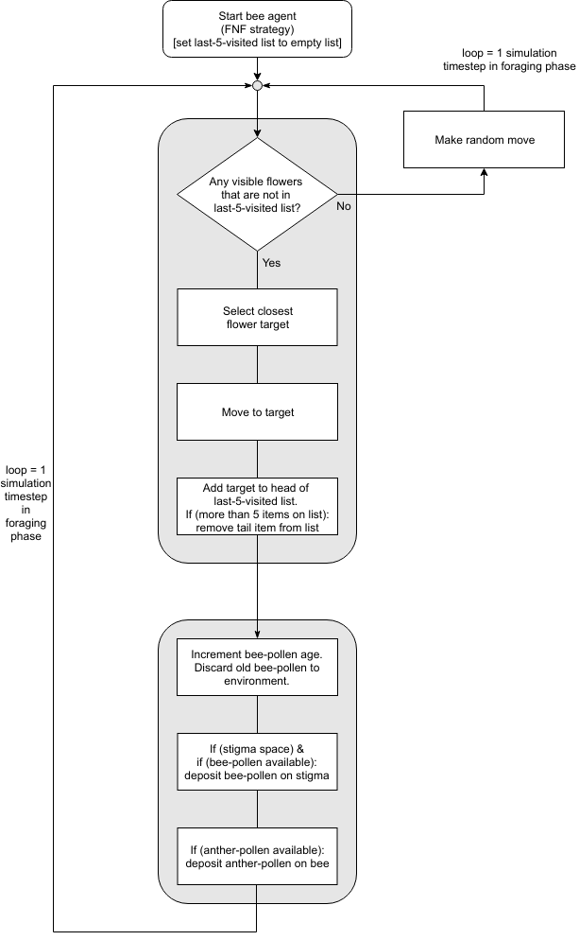 | 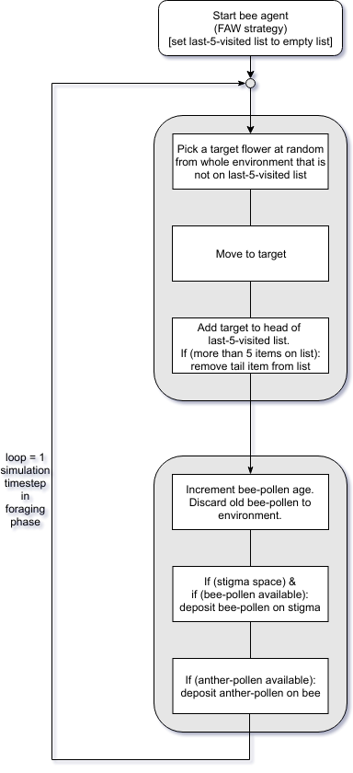
(a) Forage Nearest Flower (FNF) | (b) Forage Anywhere (FAW)
Figure 1. Flow charts for the behaviour of an individual pollinator agent following (a) the Forage Nearest Flower (FNF) strategy, and (b) the Forage Anywhere (FAW) strategy. Bee-pollen refers to pollen carried on the body of the insect and potentially available for deposition on the stigma of a flower for pollination or pollen clogging. Anther-pollen refers to pollen carried on a flower anther and potentially available for deposition on the body of a bee.

Flower dynamics
At the start of a foraging phase, each flower begins with a fixed amount of anther pollen available for collection. Each flower also begins with a stigma free from pollen, but as the foraging phase progresses visiting pollinators may deposit pollen on its stigma. Pollinators may be allowed to deposit pollen from a different species onto the stigma (potentially pollen clogging the flower) depending upon the configuration of the experiment. Configuration options are detailed in Table 2. A parameter specifies the capacity for pollen grains on a stigma. At the end of a foraging phase, every conspecific grain of pollen on the stigma forms a viable seed that enters the gene pool for the next generation of plants as described above (Overview of dynamics section).

Pollinator action on flowers
When a pollinator visits a flower, the following processes occur in the order described. Each pollen grain carried by the pollinator is considered for transfer to the flower’s stigma subject to these limiting factors: the pollinator has a fixed maximum number of grains that it can transfer to the stigma during a visit; the stigma has a fixed maximum capacity for accepting pollen grains (as described in the Flowers section above), and the stigma may or may not be susceptible to receiving pollen grains from a different species (as described in the Flowers section above). Having taken all of these factors into account, if any pollen grains on the pollinator are eligible for transfer, then the determined number of eligible grains are picked at random from the pollinator to be transferred to the stigma. Finally, the flower may transfer some of its anther pollen onto the pollinator’s body. There is a fixed maximum number of grains that may be transferred from the anther in any one pollinator visit, and the anthers start with a specified amount of pollen in each foraging phase; any available pollen on the anther is transferred to the pollinator, up to the fixed maximum transfer limit per visit.

Design concepts
Basic principles
Our simulation builds upon the early work of Waser (1978). One notable difference between our software and his is our use of a continuous spatial environment to avoid potential artefactual effects arising from modelling pollinator movements on a discrete grid [REFS: Bonnell et al 2016; Birch et al 2007]. Modern computing environments also allow us to simulate much larger environments than those that could feasibly be simulated in 1978. We model up to 16,000 plants and 400 pollinators, running for up to 1000 generations, with each experimental condition repeated in 100 replicates (more in some cases), in contrast to 100 plants, 1 pollinator and up to 400 generations with 20 replicates in the early study. We have determined experimentally that the values we employ are sufficient to: confirm that our software’s behaviour matches the behaviour of Waser’s simulations; and, robustly generate the system behaviour we require to explore our own hypotheses — see Testing (Verification and Validation). The novel results we report here arise from experimental configurations that were not considered in Waser’s original paper.

Emergence
The key emergent property of interest in these experiments is whether both plant species X and Y can maintain viable coexistent populations over time for a given experimental configuration, or whether one species will reach fixation with the other dying out. We are primarily interested in whether the pollen clogging configuration (symmetric clogging, asymmetric clogging, or symmetric non-clogging) affects the ability of the species to coexist.

Sensing
When operating under the default Forage Nearest Flower strategy, pollinators are able to see flowers within 1 perceptual distance unit (pdu) of their current position, and move to the nearest flower seen within that distance. The perceptual distance unit is explained in the Spatial Units section (page 6).

Under the alternative Forage Anywhere strategy, the pollinator moves to a random flower over the entire environment. This strategy simulates an aspatial, well-mixed population of plants—it does not represent a real-world situation, but is of interest to indicate the underlying dynamics of the system when spatial factors are removed.
Pollinators are assumed to be able to remember the last 5 individual flowers that they have visited, and will not revisit a flower while it is on this list. However, pollinators are not assumed to be able to distinguish one species from the other, and they will land on a target flower as directed by the FNF or FAW strategy regardless of its species.

Interaction
The only interactions between agents in the simulation are those between an individual pollinator and an individual flower when the pollinator lands on the flower, as described in the Pollinator action on flowers section. There are no direct pollinator-pollinator or flower-flower interactions. It is possible for two or more pollinators to land on the same flower at the same time, although this will be a relatively rare occurrence as the number of flowers generally exceeds the number of pollinators by a factor of 40.

Stochasticity
Stochasticity is used in the followings aspects of the simulation: placement of flowers and pollinators at the start of each foraging phase; the order in which pollinators are processed at each time step during the foraging phase; the direction a pollinator will move if it does not find a suitable nearby flower target in the FNF strategy; the choice of flower to move to in the FAW strategy; the choice of which individual pollen grains are transferred from a pollinator to a flower’s stigma upon landing; and, in the reproduction phase, the order in which viable seeds are considered for producing plants for the next generation.

Observation
In these experiments, the main data recorded during experiments are, at the end of each generation, the generation number and the number of plants of each species X and Y in existence during that generation. For each experiment we also keep a record of the full configuration set-up, and the exact version of the simulation code used to run the experiment.

Initialization
We initialise the first foraging phase of a simulation run with a fixed number of flowering plants of each species X and Y randomly distributed across the species’ refuges and the shared area. In most experiments we start with 8000 of each species (see Table 2).
The common parameter values used in the simulations reported here are shown in Table 2. The values of parameters relating to pollen production, transportation and deposition, indicated with an asterisk (*) match those used by Waser. The ratios between these parameter values were determined by Waser with reference to biological data (Waser 1978, p.233): "The absolute values chosen for the number of pollen grains involved in the pollination cycle were unrealistically small in simulations and may have led to sampling error effects in some cases. However, I chose biologically reasonable ratios for amounts of pollen involved in different phases of pollination...". We tested our simulations using larger absolute values for these parameters while retaining the same ratios, to investigate sampling error effects mentioned by Waser; see the Testing (Validation and Verification) section below for details.

Parameter | Value | Parameter | Value
Environment size (pdu) | 200 x 200 | Plant refuge sizes (pdu) | 40 x 200
Foraging phase duration  (simulations steps) | 100 | Initial pollen on anther* | 100
Number of generations | 50 or 1000 | Anther to pollinator transfer per visit* | 10
Number of pollinators | 400 | Stigma pollen capacity* | 5
Number of plant species | 2 | Pollinator to stigma transfer per visit* | 3
Initial (& max) plant density (mean plants per 1 pdu²) | 0.4 (0.4)  [16000 plants]
Table 2. Simulation parameters. Values indicated with an asterisk (*) match those used by Waser.

Experiments

Testing (Verification and Validation)
Before running the experiments reported below, we verified the correct operation of our simulation as follows: We ran the simulation with real-time visualisation of the environment during each foraging phase, showing the distribution of plants of each species, the positions of pollinators (including trails showing each pollinator's movement since the start of the foraging phase), and the pollination status of each flower. We used this facility as a form of visual debugging [REF Dorin & Geard 2014] and to sanity check that the distribution of plants and the movement of pollinators was as expected. It has been confirmed in the literature [REF Zoe's ECAL paper] that random pollinator movements employed in our simulation do not impact relative pollination rates of randomly distributed flowers compared to other more sophisticated pollinator movement strategies. We used standard software debugging tools and detailed log files to verify that processes of pollen transfer between pollinator and flower agents were operating correctly.

After confirming that the simulation was behaving as expected, we validated its behaviour against Waser's Experiments 1, 2 and 3 (Waser, 1978) using large environmental and population sizes, and large run lengths, with parameters detailed in Table 2 and explained at the beginning of this section (Methods and Materials). Our results qualitatively matched those reported by Waser; in each case the simulations lead to fixation by one plant species after a small number of generations. Hence, in our validation, we have also demonstrated the robustness of the effects Waser noted to population size and run-length, confirming the original results using technology capable of running much larger and longer simulations than was feasible in 1978.

After initial runs of the Experiment 4 simulations reported below, we repeated them with values of each of the four pollen-related parameters (marked (*) in Table 2) set to ten times the value shown in Table 2 to check for sampling error effects caused by the small values of some of these values. This across-the-board multiplication by 10 preserves the ratios Waser notes are important (see our section Model parameter values above). Our re-runs produced the same qualitative results as the original runs reported here, giving us confidence that our results are not affected by stochastic sampling issues.

Pollen Clogging Experiments

As mentioned above, Waser (1978) had introduced plant refuges into his model in an attempt to promote the stable coexistence of two species of flowers (Experiment 4 in his paper). He allowed pollen from each species to clog the stigmas of the other species and found that, despite the presence of the refuges, one plant species would still go to fixation in his simulations after a small number of generations, completely wiping out the other species. We re-run this scenario (symmetric clogging) in Case 1 below, and find the same result. However, we also examine cases of asymmetric clogging (species X clogs species Y, but species Y does not clog species X) in Case 2, and symmetric non-clogging (neither species clogs the other) in Case 3.
We ran 100 replicates of each case for each of the two foraging strategies, Forage Nearest Flower (FNF) and Forage Anywhere (FAW). Results of these experiments are detailed in the next section.

Environment Size Experiments
To gain further insight into the dynamics of our model under Cases 1-3, we conducted a further set of experiments to investigate whether any observed fixation of one species at the expense of the other was the outcome of an actively driven process, or merely due to the model’s stochastic dynamics acting upon a finite population.
If, in any of the cases, one of the flower species tends to go to fixation purely as the result of stochastic dynamics, we would expect that the mean time required to reach fixation would depend upon the initial number of flowers in the environment.
We therefore ran a further series of experiments, for each of the three cases, where we varied the environment size while keeping the plant density constant (therefore also varying the number of plants). The environment sizes investigated were: 50x50, 100x100, 150x150, 200x200, 250x250, 300x300, and 400x400 pdu. For each environment size, the initial number of plants at the start of each foraging phase, and the number of pollinators, were set such that the densities of flowers and pollinators matched those used in the previous experiments. The refuge sizes for the two plant species were also scaled according to the environment size. See Table 3 for details. All other parameters were set as they were in the previous experiments (Table 2).
We ran 100 replicates of each environment size configuration for each of the two foraging strategies, Forage Nearest Flower (FNF) and Forage Anywhere (FAW). Results of these experiments are detailed in the next section.

Environment size  (pdu) | Plant refuge sizes  (pdu) | Number of plants  (density 0.4) | Number of pollinators  (density 0.01)
50x50 | 10x50 | 1000 | 25
100x100 | 20x100 | 4000 | 100
150x150 | 30x150 | 9000 | 225
200x200 | 40x200 | 16000 | 400
250x250 | 50x250 | 25000 | 625
300x300 | 60x300 | 36000 | 900
400x400 | 80x400 | 64000 | 1600
Table 3. Environment size and number of plants and pollinators for the Environment Size Experiments.

Control Model for Stochastic Fixation
To develop a better understanding of the dynamics of a completely stochastic fixation process, we also designed and tested a very simple control model. By running the control model many thousands of times, we could observe the distribution of fixation times to be expected if fixation occurred purely as the result of stochastic events rather than being driven by the internal dynamics of the system. This provides a baseline against which we could compare the dynamics of the pollen clogging model experiments described above.
The operation of the control model is as follows. The model simply keeps track of the number of plants of each of two species over a number of generations of reproduction: call these numbers Xt and Yt for generation t. At the start of a run (generation 0), X0 and Y0 are both initialised to 8000; this gives a total population of 16000 plants, which matches the initial population size in our standard pollen clogging experiments described above. The total population size is kept constant throughout a run (i.e. Xt+Yt=16000); we are interested in how the relative magnitudes of Xt and Yt vary over the generations.
A new generation (t+1) of 16000 plants is created from the current generation (t) by repeating the following operation 16000 times: add a new plant to the new generation with probability Px=(Xt/(Xt+Yt)) of it being of species X, and Py=1-Px of it being species Y. We now have a new generation t+1 of 16000 plants, the constitution of which closely resembles that of generation t, but may be slightly different due to stochastic sampling effects in a finite population.
A run continues by iterating this process of creating a new generation from the existing one until one of the species X or Y goes to fixation (Xt=16000, Yt=0 or vice versa) – once this occurs, there would be no further change in Xt or Yt even if the model was left to run for longer. We record the value of Xt and Yt at each generation for later analysis.
The dynamics of the model closely resembles a Moran process [REF], but in our model a new generation is created in one batch by repeated sampling (with replacement) of the previous generation. By explicitly simulating the process and running it many times, we can observe the actual distribution of fixation times produced without making any assumptions about the shape of the distribution. To obtain a reliable distribution of results, we ran the model 50,000 times.

Results

Pollen Clogging Experiments

Case 1. Symmetric clogging
Pollen from each species may clog stigmas of the other, Table 1 - case 1.

The symmetric clogging scenario results in self-reinforcing competitive exclusion of one species at random. A representative result from one of the 100 runs using the default Forage Nearest Flower (FNF) strategy is shown in Figure 2(a) below, and similarly for the aspatial Forage Anywhere (FAW) strategy in Figure 2(b).
With the default FNF strategy, across the 100 replicate runs we observe an initial “tussle” for dominance between the two species (see Figure 2(a) for an example), but in all runs one species goes to fixation within the first 20 generations. The median fixation time is 12 generations (see Table 4) with a comparatively flat distribution of results across runs in the range 9-20 generations (Figure 3). Which of the two species achieves fixation varies across runs, with 51 runs being dominated by Species X, and 49 by Species Y. This result is consistent with the hypothesis that both species have an equal chance of going to fixation (the probability of these deviations or greater from a 50:50 outcome being p=0.9204 according to the two-tailed binomial distribution).
With the diminished influence of spatiality in the FAW strategy, the median fixation time is quicker than with the FNF strategy at 11 generations. This difference is statistically significant (p<0.00001) according to the two-tailed Mann-Whitney U test (Table 4).
Under this strategy there also appears to be less tussle between the two species at the start of the run (see Figure 2(b) for an example). To quantify this observation, we looked at the dominance time of each run, which we define as the earliest generation at which the eventually fixated species exists in larger numbers than its competitor and is never subsequently out-numbered by the competitor for the remainder of the run. The mean dominance time for the 100 replicates of the FAW strategy was 1.37 generations, compared to 1.77 for the FNF runs (Table 4), showing that the fixated species did indeed become dominant quicker in the FAW runs (however, this difference is not statistically signicant at the p=0.05 level according to the two-tailed Mann-Whitney U test).
As with the FNF strategy, with the FAW strategy which of the two species achieves fixation varies across runs, with 46 runs being dominated by Species X, and 54 by Species Y. These results are consistent with the hypothesis that both species have an equal chance of going to fixation (the probability of these deviations or greater from a 50:50 outcome being p=0.4841 according to the two-tailed binomial distribution).
The mean and standard deviation of fixation times across runs are presented in Table 4 and Figure 10 below.

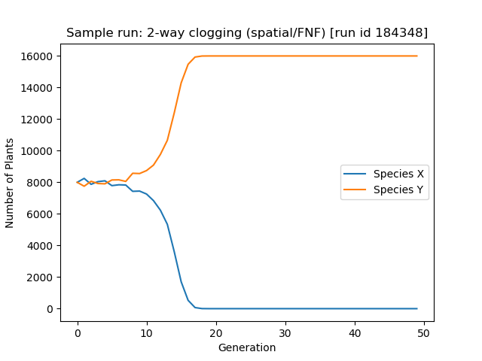 | 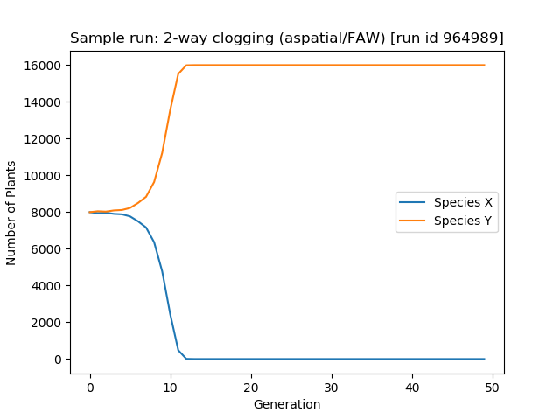
(a) Forage Nearest Flower (FNF) | (b) Forage Anywhere (FAW)
Figure 2. Figure from representative runs showing the number of plants of two competing species over 50 generations with 2-way pollen clogging, using (a) the default Forage Nearest Flower (FNF) strategy, and (b) the Forage Anywhere (FAW) strategy. With the FNF strategy (a), species X and Y “tussle” for dominance up to generation ~8 before species Y rapidly overtakes X and then moves swiftly to fixation. With the diminished influence of spatiality in the FAW strategy (b), the population dynamics are smoother and fixation happens more quickly. For both FNF and FAW stategies, over the 100 replicate runs approximately half of the runs ended with fixation by Species X, and half by Species Y. Summary data for all runs is presented in Table 4 and Figure 10 (2-way clogging).

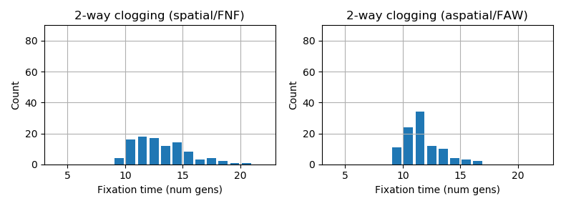
Figure 3. Distributions of the number of generations to fixation across each of the 100 replicate runs of the symmetric (2-way) clogging experiments, using the default Forage Nearest Flower (FNF) strategy (left), and the Forage Anywhere (FAW) strategy (right).

Distributions of the number of generations to fixation across each of the 100 replicate runs of the symmetric (2-way) clogging experiments, using the default Forage Nearest Flower (FNF) strategy (left), and the Forage Anywhere (FAW) strategy (right).

Case 2. Asymmetric clogging
One species can clog stigmas of the other but the reverse is not possible, Table 1 - cases 2a & 2b.

This scenario always results in the dominance of the species that does not suffer clogging. A representative result from one of the 100 runs using the default Forage Nearest Flower (FNF) strategy is shown in Figure 4(a) below, and similarly for the aspatial Forage Anywhere (FAW) strategy in Figure 4(b) In these runs, species X clogged species Y, but species Y did not clog species X. In contrast to the symmetric clogging case (Case 1), species X dominated all 100 replicate runs in this configuration, and we did not observe the initial struggle for dominance between the two species as seen in the symmetric clogging case (Case 1). The mean and standard deviation of fixation times were lower than those for Case 1 (see Table 4 and Figure 10), and the distribution of fixation times across the 100 replicate runs was narrower than in Case 1, for both the FNF and FAW strategies (Figure 5).
Similar to the symmetric clogging case, the median fixation time for the FAW strategy (with diminished influence of spatiality) is lower than with the default spatial FNF strategy: the medians are 5 generations and 7 generations respectively, which is statistically significant (p<0.00001) according to the two-tailed Mann-Whitney U test. Both of these means are also statistically significantly lower than the corresponding means in the symmetric clogging case (Case 1), again at the p<0.00001 level according to the two-tailed Mann-Whitney U test.

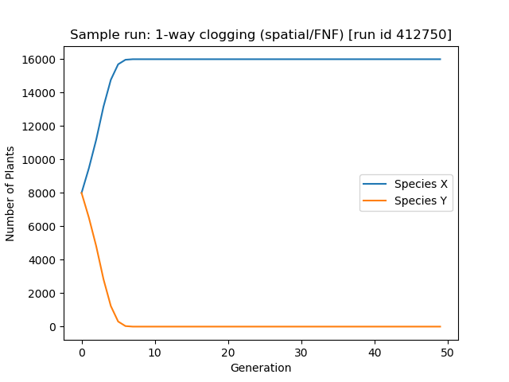 | 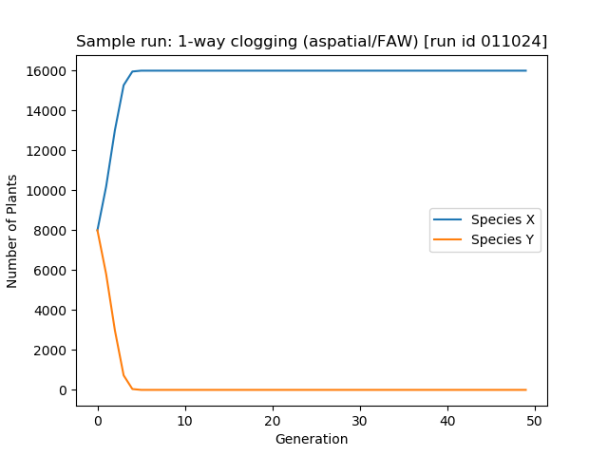
(a) Forage Nearest Flower (FNF) | (b) Forage Anywhere (FAW)
Figure 4. Figure from representative runs showing the number of plants of two competing species over 50 generations with 1-way pollen clogging (Species X clogs Species Y, but Y does not clog X), using (a) the default Forage Nearest Flower (FNF) strategy, and (b) the Forage Anywhere (FAW) strategy. With the FNF strategy (a), species X, which clogs species Y, immediately asserts dominance. The same is true in the case of the dininished influence of spaciality with the FAW strategy (b), and fixation happens slightly quicker in this case. For both the FNF and FAW strategies, Species X was the winning species across all 100 replicate runs. Summary data for all runs is presented in Table 4 and Figure 10 (1-way clogging).

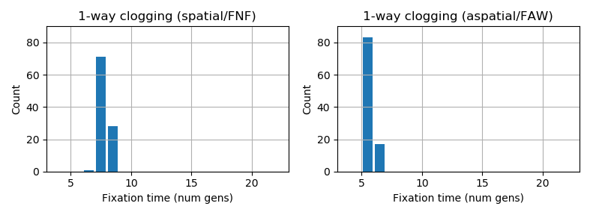
Figure 5. Distributions of the number of generations to fixation across each of the 100 replicate runs of the asymmetric (1-way) clogging experiments, using the default Forage Nearest Flower (FNF) strategy (left), and the Forage Anywhere (FAW) strategy (right).

Case 3. Symmetric non-clogging
Neither species’ pollen clogs the stigmas of the other, Table 1 – case 3.

A representative result from one of the 100 runs using the default Forage Nearest Flower (FNF) strategy is shown in Figure 6(a) below, and similarly for the aspatial Forage Anywhere (FAW) strategy in Figure 6(b). Note that we continued these runs for 1000 generations (compared to 50 generations in Cases 1 and 2) because initial tests showed that they had rarely reached fixation after 50 generations. The results from these runs show that symmetric non-clogging allows for extended cohabitation of the two plant species, with a median fixation time of 74.5 generations over the 100 replicate runs of the default FNF strategy (see Table 4 for details). This is very much longer than the fixation times observed in the runs with pollen clogging, both symmetric (Case 1) and asymmetric (Case 2). Both differences are statistically significant at the p=0.00001 level, which is unsurprising as the median fixation time of 74.5 generations is over 6 times as long as that observed with symmetric clogging (Case 1), and over 10 times as long as that observed with asymmetric clogging (Case 2).
For the FAW strategy, with its diminished influence of spatiality, the results are even more striking. In this case, the median fixation time across the 100 replicate runs was 374 generations, compared to 11 generations for symmetric clogging (Case 1) and 5 generations for asymmetric clogging (Case 2). See Table 4 for details.
Which of the two species eventually achieves fixation varies across 100 replicate runs. For the FNF strategy, 48 runs were fixated by species X, and 52 by species Y. For the FAW strategy, the corresponding figures were 49 and 51 respectively. These results are consistent with the hypothesis that both species have an equal chance of going to fixation (the probability of this deviation or greater from a 50:50 outcome being p=0.7644 for the FNF strategy, and p=0.9204 for the FAW strategy, according to the two-tailed binomial distribution). The mean and standard deviation of fixation times across runs are presented in Table 4 and Figure 10 below.
Beyond the most obvious result of greatly extended periods of coexistence of the two plant species in these experiments compared to the cases with clogging (Case 1 and Case 2), another intriguing finding is that the difference in dynamics between the FNF and FAW foraging strategies is the reverse of what it was in the previous experiments. That is, moving from the spatial FNF strategy to the aspatial FAW strategy in this case results in greatly extended fixation times (Figure 6) and a wider distribution of those fixation times among the 100 replicate runs (Figure 7). These findings are the reverse of those found in either of the cases involving pollen clogging (Case 1/Symmetric clogging – see Figures 2 and 3, and Case 2/Asymmetric clogging – see Figures 4 and 5). Furthermore, in the current case with symmetric non-clogging, even when one species eventually becomes dominant, it still takes a relatively meandering path to fixation (Figure 6); this is in contrast to the cases with clogging, where the graphs of species growth over time once dominance is achieved are much smoother (Figures 2 and 4). These findings hint that different dynamics are at play in Case 3 compared to Cases 1 and 2, with the former (non-clogging) appearing more stochastic and the latter (symmetric/asymmetric clogging) appearing driven.
The Environment Size Experiments were designed to investigate this finding further. The results of the experiments are reported next.

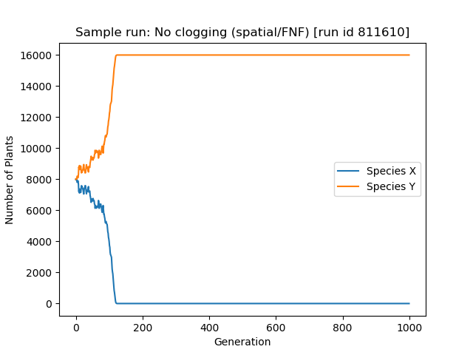 | 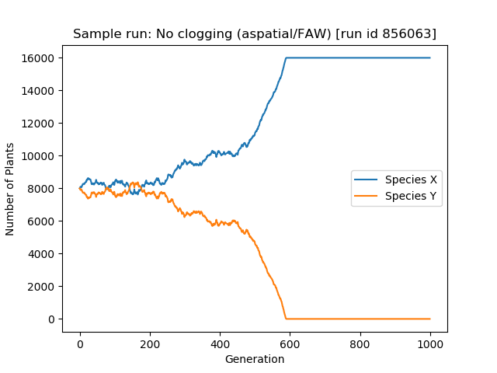
(a) Forage Nearest Flower (FNF) | (b) Forage Anywhere (FAW)
Figure 6. Figure from representative runs showing the number of plants of two competing species over 1000 generations with no pollen clogging (neither species clogs the other one), using (a) the default Forage Nearest Flower (FNF) strategy, and (b) the Forage Anywhere (FAW) strategy Note the greatly extended x-axis scale compared to Figures 2 and 4. With the FNF strategy (a), species X and Y “tussle” for dominance up to generation ~80 before species Y overtakes X and reaches fixation at generation ~120. With the diminished influence of spatiality in the FAW strategy (b), the population dynamics exhibit a stochastic “tussle” for a much longer period, with fixation by Species X finally occuring at generation 590. For both FNF and FAW stategies, over the 100 replicate runs approximately half of the runs ended with fixation by Species X, and half by Species Y. Note the extended scale of the x axis compared to Figures 2 and 3; the fixation time is much longer than those figures. Furthermore, even as Species Y approaches fixation there is still noticeable stochasticity in its change in population size from one generation to the next. Summary data for all runs is presented in Table 4 and Figure 10 (no clogging).

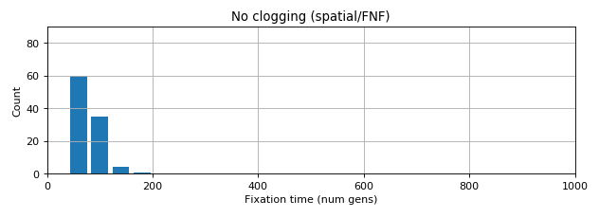
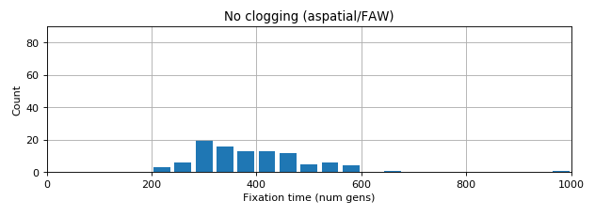
Figure 7. Distribution of the number of generations to fixation across each of the 100 replicate runs of the symmetric non-clogging experiments. Note the greatly extended x-axis scale compared to Figures 2 and 4. Top: default Forage Nearest Flower (FNF) strategy. Bottom: Forage Anywhere (FAW) strategy.

Fixation Time (Num Gens) Statistics Across 100 Replicate Runs For Each Treatment
 | Forage Nearest Flower (FNF) |  |  |  |  |  |  | Forage Anywhere (FAW)
 | Fixation  time |  |  | Dominance time |  | Species fixated  (X/Y) |  | Fixation  time |  |  | Dominance time |  |  | Species fixated (X/Y)
 | median | mean | pop  std  dev | mean | pop std dev |  |  | median | mean | pop std  dev |  | mean | pop std dev
Case 1:  Symmetric  (2-way) clogging | 12.0 | 12.61 | 2.37 | 1.77 | 1.72 | 51/49 |  | 11.0 | 11.20 | 1.59 |  | 1.37 | 0.90 |  | 46/54
Case 2:  Asymmetric  (1-way) clogging | 7.0 | 7.27 | 0.47 | 1.00 | 0.00 | 100/0 |  | 5.0 | 5.17 | 0.38 |  | 1.00 | 0.00 |  | 100/0
Case 3:  Symmetric  non-clogging | 74.5 | 77.37 | 20.8 | 10.30 | 13.95 | 48/52 |  | 374.0 | 392.3 | 112.6 |  | 59.07 | 71.54 |  | 49/51
Table 4. Summary statistics of all results from Pollen Clogging Experiments, grouped by pollen clogging interactions and by foraging stategy. For each of the three clogging treatments (1-way, 2-way and non), there is a statistically significant difference in the median fixation time in the FNF runs compared to the FAW runs for the same treatment. For each of the two spatial/foraging strategy treatments (FNF, FAW), there is a statistically significant difference in the median fixation time between every pair of clogging configurations (1-way:non, 2-way:non, 1-way:2-way) for that treatment. In all cases, statistical significance is determined using the two-tailed Mann-Whitney U test, and p<0.00001 for all comparisons mentioned.

Environment Size Experiments
The results of the Environment Size experiments are shown in Figure 8. The results are very clear: the size of the environment (and therefore the size of the initial plant populations) has almost no effect on fixation times for either symmetric (2-way) or asymmetric (1-way) clogging. In contrast, for the symmetric non-clogging case, larger environments result in longer fixation times. There results hold for both the spatial (FNF) and aspatial (FAW) foraging strategies, although the absolute fixation times, and the variability of those times between runs, is greater in the latter case.
These results lend weight to the conclusion that fixation in the case of pollen clogging (either symmetic or asymmetric) is a a driven process, whereas in the absence of clogging it comes about by stochastic changes in the relative population sizes of the two species. We discuss this point at greater length in the Discussion section. Before that, we describe the results of the Control Model for Stochastic Fixation, which was designed to investigate what fixation dynamics would emerge in a simplified model where changes in the relative population sizes of two plant species arise purely due to stochastic reproduction of each species.

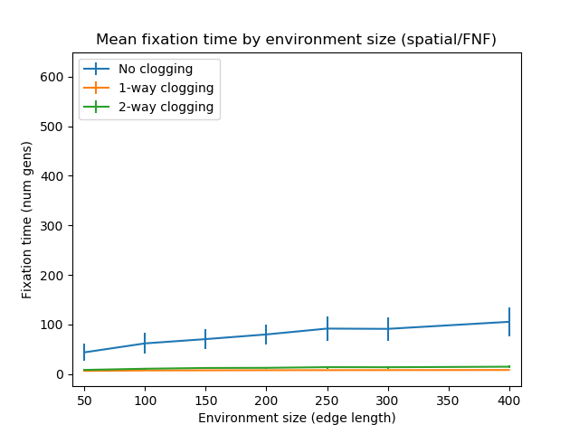 | 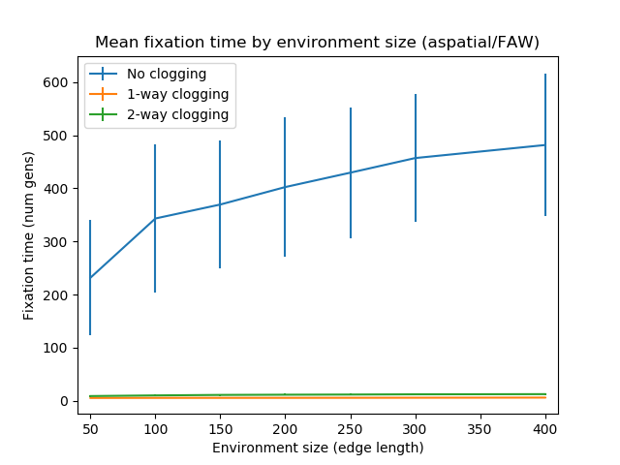
(a) Forage Nearest Flower (FNF) | (b) Forage Anywhere (FAW)
Figure 8. Mean fixation times across 100 replicate runs for different environment sizes, using (a) the default Forage Nearest Flower (FNF) strategy, and (b) the Forage Anywhere (FAW) strategy. Error bars show population standard deviation for each point plotted (error bars for 1-way and 2-way clogging lines are too small to be visible).

Control Model for Stochastic Fixation
The distribution of fixation times observed in 50,000 runs of the Control Model for Stochastic Fixation are shown in Figure 9(a).
For comparison, we also ran 400 further replicates of our full agent based model under the No Clogging configuration with the aspatial (FAW) foraging strategy. We combined these results with the original 100 replicates run in Case 3/Symmetric non-clogging (Figure 7 (bottom)), and plot the distribution of all 500 replicates in Figure 9(b).
The distribution obtained from the control model (Figure 9(a)) is characterised by positive skewness and a long tail. The result from the regular model (Figure 9(b)) also exhibits these properties, but to a less pronounced extent.
We discuss the significance of these results in the following section.
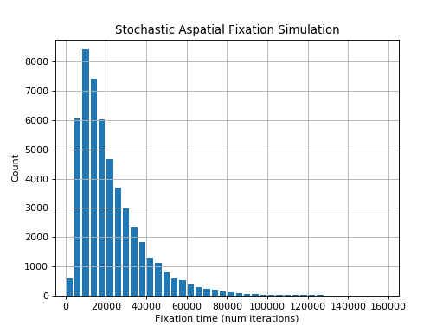 | 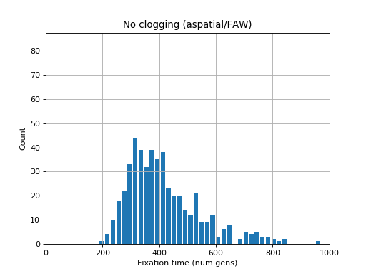
(a) Stochastic Fixation Simulation | (b) No clogging (aspatial/FAW)
Figure 9. (a) Distribution of fixation times obtained from 50,000 runs of the simple stochastic fixation simulation, and (b) for comparison, the distribution obtained from 500 runs of the full agent based model in the No Clogging / Forage Anywhere (FAW) configuration [this is the same configuration as shown in Figure 7 (bottom) – the results shown here include an extra 400 runs in addition to the 100 shown in Figure 7, and narrower histogram bins are used here to give a finer grain picture of the distribution]. In this figure, the histograms in (a) and (b) both use 40 bins, and the vertical scale of (b) is 1/100th that of (a) to reflect the ratio of the number of data points in each case.

Discussion

Talk about the big picture. What all the results tells us. Refer to Figure 5 explicitly (below). What these results mean for agriculture or something like that.

Equations might go in this section explaining our results. Or before?

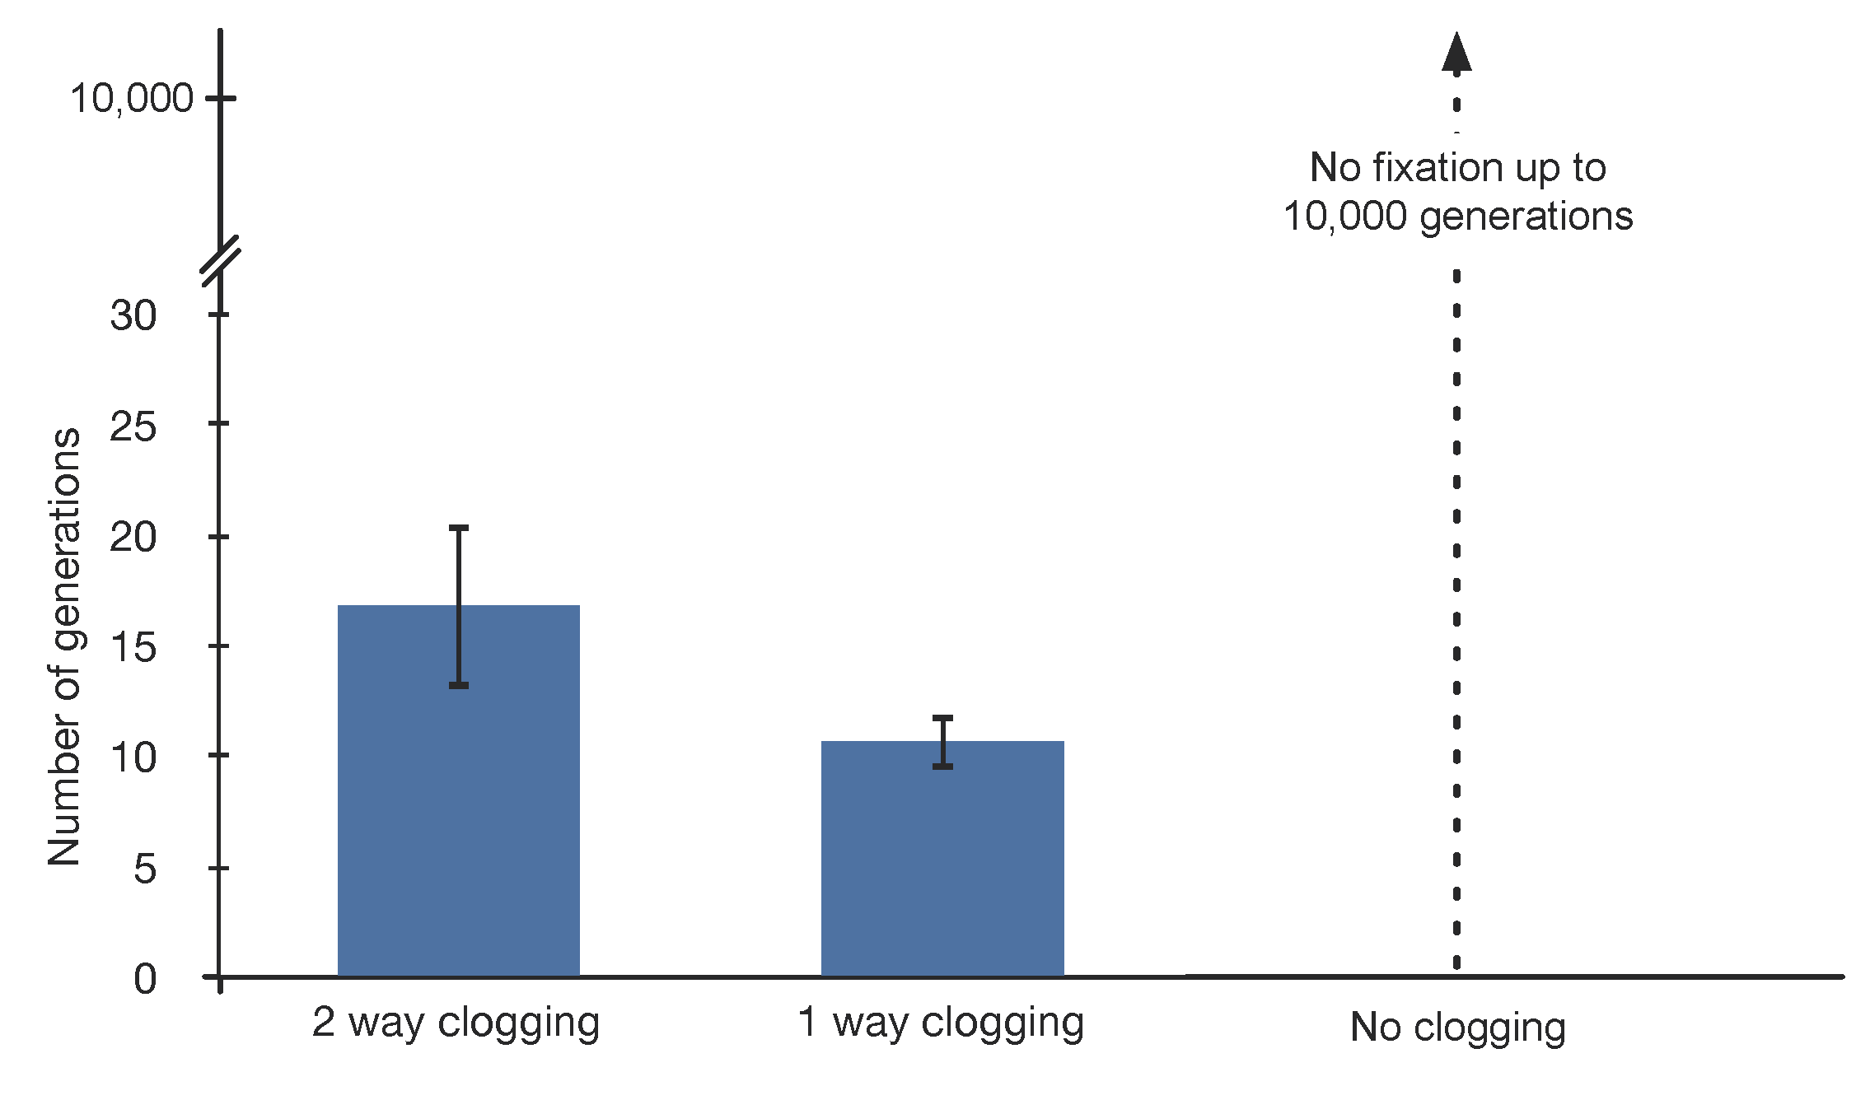
Figure 10. Figure showing the mean time to fixation for one species for 100 replicate runs of each configuration. Error bars = 1 S.D. Simulations up to 1,000 generations without pollen clogging showed no fixation in any run. Symmetrical clogging (Table 1 - case 1) is plotted as “2 way clogging”. Both asymmetrical clogging cases (Table 1 - cases 2 & 3) are combined under “1 way clogging”. “No clogging” refers to (Table 1 – case 4).

So there.

Supplementary Materials

Simulation source code and run configuration files. [[ give URL of GitHub repository https://github.com/tim-taylor/evobee , and upload config and output files to FigShare. Also state Git revision hash of version of code used to run the experiments. ]]

Acknowledgements
We are thankful for the Nobel Prize awarded to our team for this marvellous piece of work but would prefer we just got money for new books and time to read them. And DP16 project …

Appendix – notes for writing paper – to be removed

Notes: our simulated insects are not flower constant. Cases like this do occur (give examples e.g. two flower types that co-habit have similar colours and are hard for bees to tell apart, or where (non-constant) flies might be the main pollinator). In cases where bees are partially but not fully flower constant, what effects will we get? (To be tested in our model… I suspect the same applies as in the no constancy case due to the self-reinforcing effect).

would not actually move to the flower's position from the place where it had just moved to. This has now been fixed. However, this original "forageRandom" strategy has now been superseded by other strategies, as detailed in the following bullet points.

Random Global / Symmetric Non-Clogging expts did not go to fixation after 1000 generations. This run has been excluded from these calculations, so the mean (392.4) and std dev (113.2) in this case are calculated from the 99 runs which did reach fixation.

Random Global (FRG) (fig 9 – below)
RG – asymmetrical clogging

RG – symmetrical clogging (fig 10 – below)

Results

Pollen Clogging Experiments – Mann-Whitney U Tests (2-sided)

>>> scipy.stats.mannwhitneyu(fnf2w,faw2w,False,'two-sided')
MannwhitneyuResult(statistic=6804.0, pvalue=7.5184017592477377e-06)
>>> scipy.stats.mannwhitneyu(fnf1w,faw1w,False,'two-sided')
MannwhitneyuResult(statistic=9991.5, pvalue=1.244732393355609e-38)
>>> scipy.stats.mannwhitneyu(fnf0w,faw0w,False,'two-sided')
MannwhitneyuResult(statistic=0.0, pvalue=2.5012864888449554e-34)
>>>
>>> scipy.stats.mannwhitneyu(fnf0w,fnf1w,False,'two-sided')
MannwhitneyuResult(statistic=10000.0, pvalue=5.9206592668003901e-36)
>>> scipy.stats.mannwhitneyu(fnf0w,fnf2w,False,'two-sided')
MannwhitneyuResult(statistic=10000.0, pvalue=2.0752672806592244e-34)
>>> scipy.stats.mannwhitneyu(fnf1w,fnf2w,False,'two-sided')
MannwhitneyuResult(statistic=0.0, pvalue=4.8619226816383035e-36)
>>>
>>> scipy.stats.mannwhitneyu(faw0w,faw1w,False,'two-sided')
MannwhitneyuResult(statistic=10000.0, pvalue=7.384001504262286e-37)
>>> scipy.stats.mannwhitneyu(faw0w,faw2w,False,'two-sided')
MannwhitneyuResult(statistic=10000.0, pvalue=1.468737232398655e-34)
>>> scipy.stats.mannwhitneyu(faw1w,faw2w,False,'two-sided')
MannwhitneyuResult(statistic=0.0, pvalue=3.9423692530287497e-37)
p < 0.00001 for all comparisons

Dominance Time means

In [13]: np.mean(fnf2wD)
Out[13]: 1.77
In [14]: np.mean(faw2wD)
Out[14]: 1.37
In [15]: np.mean(fnf1wD)
Out[15]: 1.0
In [16]: np.mean(faw1wD)
Out[16]: 1.0
In [17]: np.mean(fnf0wD)
Out[17]: 10.30
In [18]: np.mean(faw0wD)
Out[18]: 59.07

In [25]: np.std(fnf2wD, ddof=1)
Out[25]: 1.7165563365545728
In [26]: np.std(faw2wD, ddof=1)
Out[26]: 0.89504810547317004
In [27]: np.std(fnf1wD, ddof=1)
Out[27]: 0.0
In [28]: np.std(faw1wD, ddof=1)
Out[28]: 0.0
In [29]: np.std(fnf0wD, ddof=1)
Out[29]: 13.946144610427268
In [30]: np.std(faw0wD, ddof=1)
Out[30]: 71.54009330085438
In [35]: scipy.stats.mannwhitneyu(fnf2wD,faw2wD,False,'two-sided')
Out[35]: MannwhitneyuResult(statistic=5343.0, pvalue=0.2588768542195059)
fnf1wD vs faw1wD → all numbers are identical

In [37]: scipy.stats.mannwhitneyu(fnf0wD,faw0wD,False,'two-sided')
Out[37]: MannwhitneyuResult(statistic=2358.0, pvalue=7.2736950577377647e-11)

