How to Use This Field Guide
Each day is a journey, and the journey itself, home.
– Basho
Many years ago my wife and I bought a home near the American River in northern California. I love to walk through the fields and woodlands along the river or to sit by the rushing water. The region is populated with herons, white-tailed kites, hawks, vultures, turkeys, cranes, rabbits, deer, coyotes, otters, rattlesnakes, salmon, pine trees, purple thistles, sycamores, oaks, lupine, and thousands of other species of flora and fauna. I know a little about some of them and less about others.
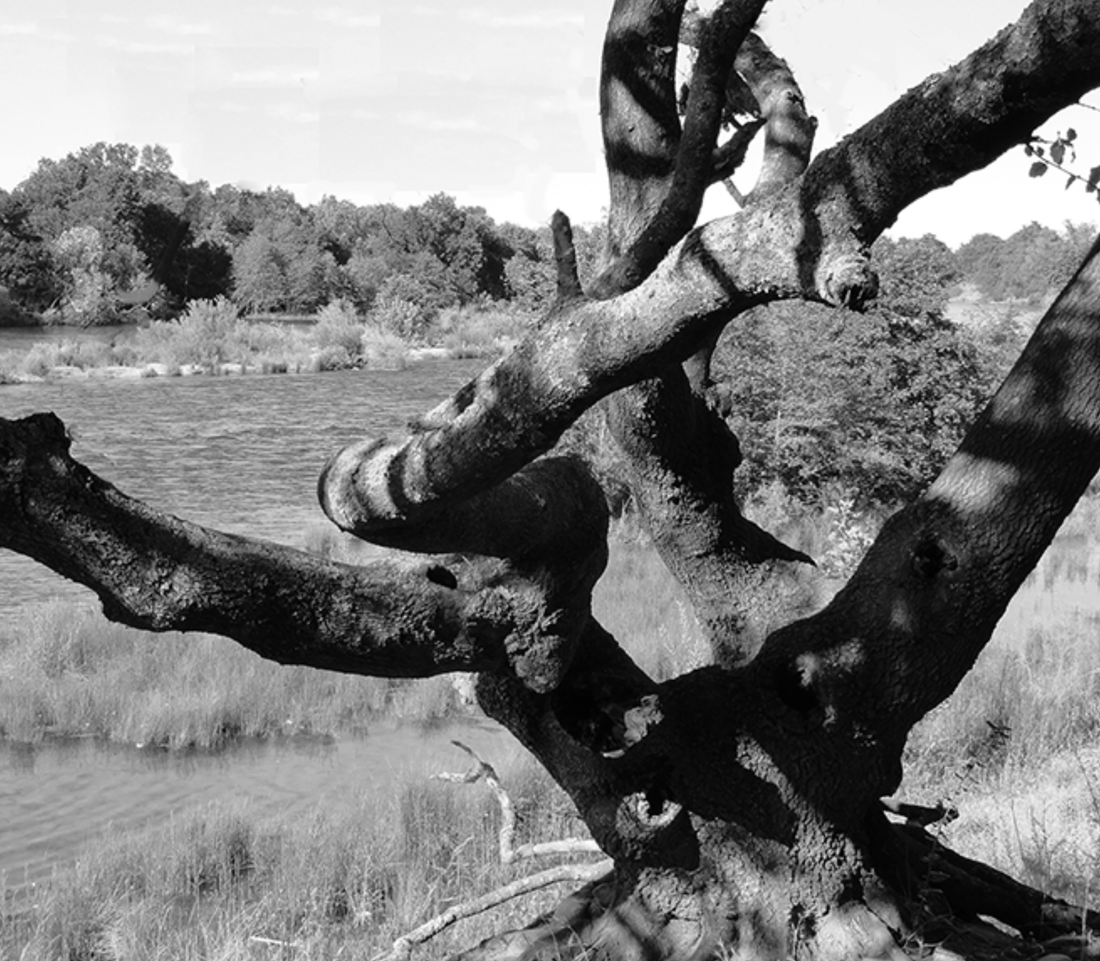
A friend gave me a field guide to wildlife in the area. The guide doesn’t tell me where to find the paths, meadows, groves of trees, or coves along the river. That’s the job of a map. The field guide doesn’t instruct me on how to hike or what to bring or leave behind. It assumes I know enough to get around. Instead, it focuses on the wildlife itself: how to identify creatures and plants, what they do, what’s important to them, and how understanding them is “a key to unlock the gates to greater understanding of the world around us.”

I wrote this Meditator’s Field Guide in a similar spirit. However, rather than focus on the world around us, it focuses on the world within us — the inner landscape revealed by spiritual practice, particularly meditation. Like other field guides, it doesn’t provide a detailed map or beginning instructions. I intend it to be a companion for “hikers” already on a spiritual trail. I imagine you have a few miles behind you already. My earlier books, Buddha’s Map and Beginning the Journey, offer an extensive map and detailed instructions should you need them. (See the resource list on p. 353.)

The Outdoor World of the Sacramento Region, complied and edited by Jo Smith, et al. (The American River Natural History Association, 1993.). p. 1.

