This is a DOCX file. The text background (“writable area”) here is shown in white.

But any other document (ODT anyway) would be shown differently (see below).

Here is my current Application Colors configuration. Note that none of the applied colors is white (even in the “Automatic” options):

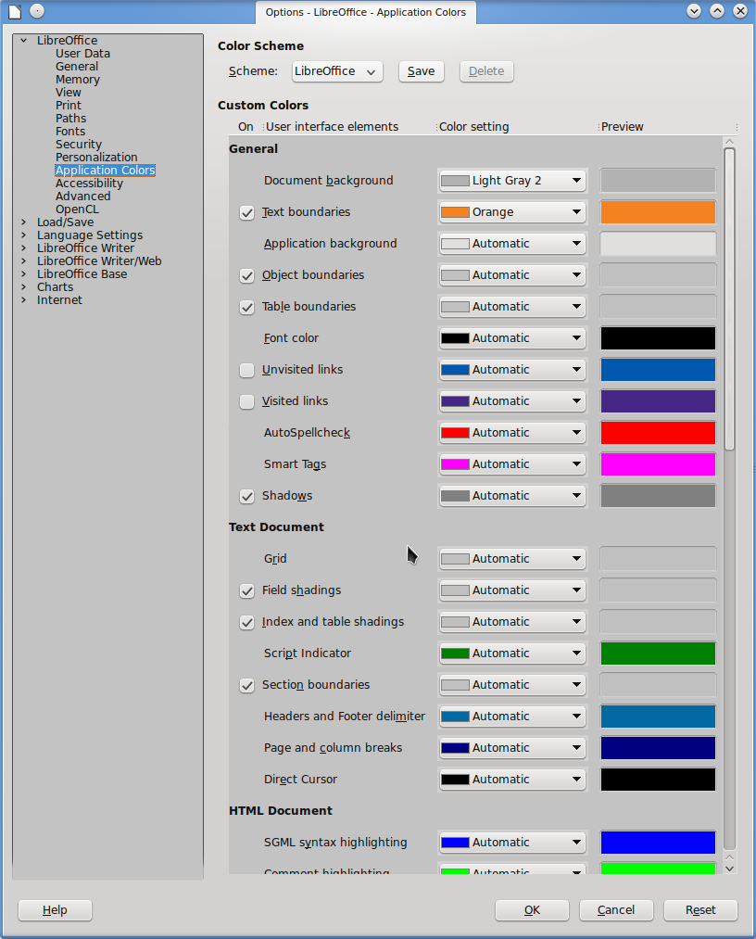

This is how a new ODT file looks like:
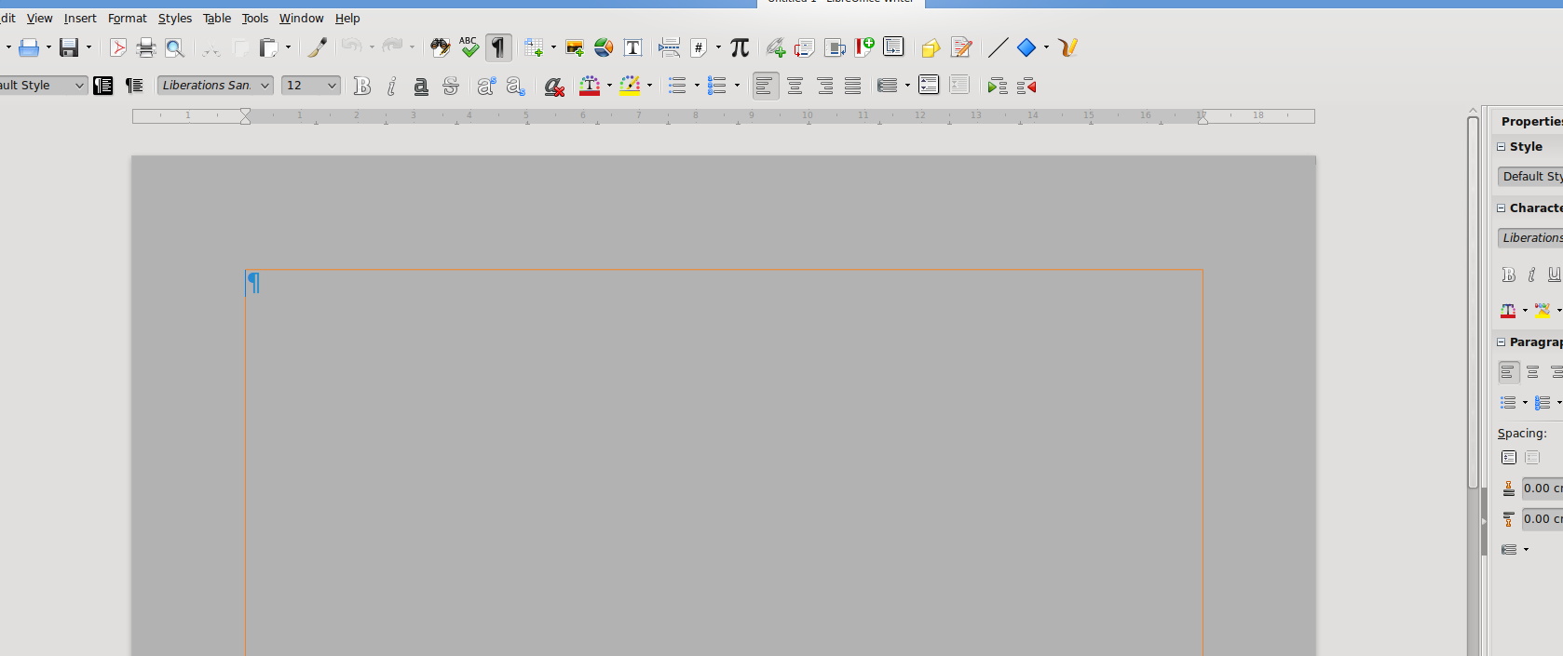
And this is how the DOCX file looks like in my screen:
