Date: 04/12/2017
HW8 (5 pts.)
Requirements:
- A Windows virtual machine
- Recommended textbook: "Practical Malware Analysis"
- Get the lab files here: https://practicalmalwareanalysis.com/labs/
- This homework uses the files Lab07-01.exe, Lab07-02.exe, Lab07-03.dll and Lab07-03.exe.
- Follow the instructions for each question, paste the images respectively IN THIS FILE, save it as "HW8.
- Deadline: 10/12/2017 23:59
- YOU MUST SUBMIT WHOLE-DESKTOP IMAGES TO GET FULL CREDIT!

- This question is related to Lab07-01.exe. (5 images)

  - Examine the imported function list.
  - Slekfnsekglsdklg
  - semgsşdgmse
  - skdgjmsdgk
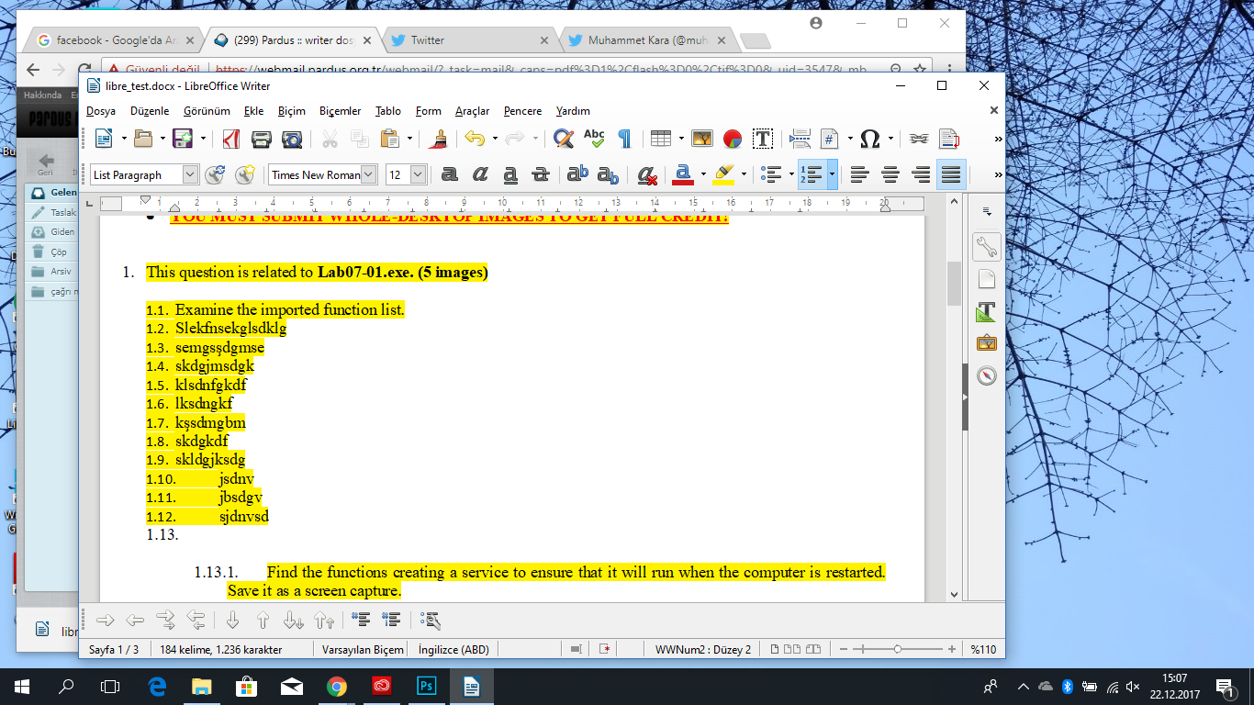
  - klsdnfgkdf
  - lksdngkf
  - kşsdmgbm
  - skdgkdf
  - skldgjksdg
  - jsdnv
  - jbsdgv
  - sjdnvsd

    - Find the functions creating a service to ensure that it will run when the computer is restarted. Save it as a screen capture.

*0000000000000**PASTE IMAGE HERE***

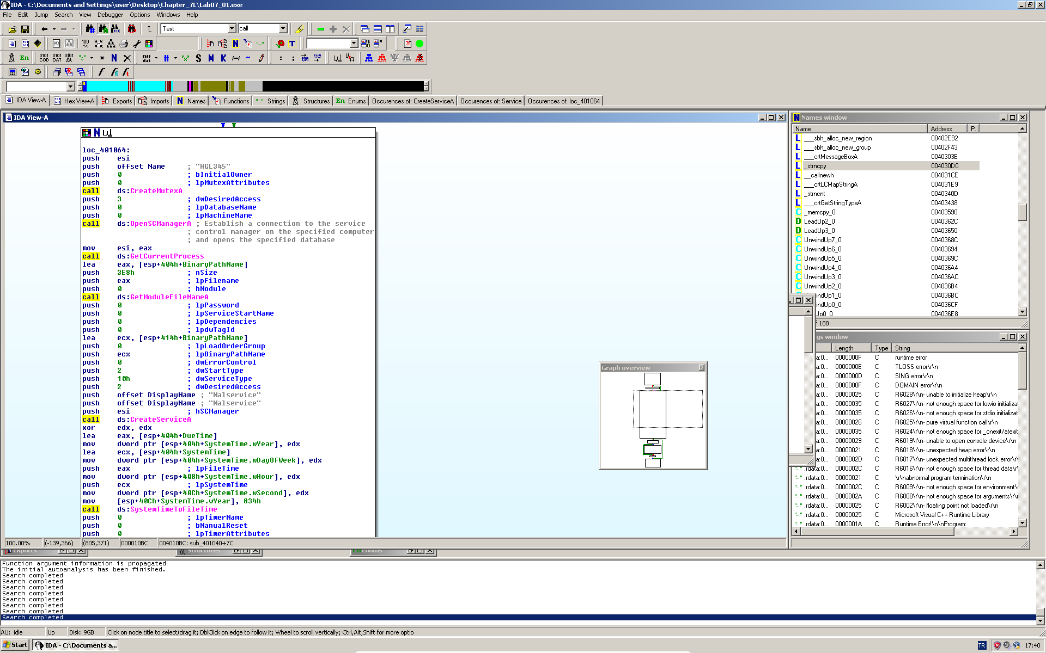

  - Examine the imported function list.
  - Slekfnsekglsdklg
  - semgsşdgmse
  - skdgjmsdgk
  - klsdnfgkdf
  - lksdngkf
  - kşsdmgbm
  - skdgkdf
  - skldgjksdg
  - jsdnv
  - jbsdgv
  - sjdnvsd

    - Fill in the blanks according to the above image.
- Function 1: ____GetCurrentProcess______________.
- Function 2: ____GetModuleFileNameA______________.
- Function 3: ____CreateServiceA______________.

    - Find the functions that might connect to a URL in order to download content. Save it as a screen capture.

