It appears **GetRatingChanges** calls are deleting descriptors on your end.

Context:

* a cert is a bucket of ratings, one for each RA (rating authority), where each RA contains its own ageRating and descriptors;
* when the rating change is for only one RA on that cert (as in Kevin’s example below), we send you only the RA that changed;
* so your code is apparently expecting that we’ll send ALL the descriptors for ALL the RAs whether or not they’ve changed, i.e. your code sees that there are no descriptors for the other RAs and thinks this means we’ve removed those descriptors from those RAs. That’s what it looks like from here, anyway.

### On March 16, on production, I made a rating change where only ESRB changed its rating, the other RAs (rating authorities) had no changes; this was for:

### Certificate ID 6c96e517-22c8-4341-9b1e-a6a59a936abc

### “Test App (957dc14f)”

### Here’s a screen from IARC’s internal app; note that ALL RAs have descriptors.

### cid:image004.jpg@01D18048.49E43BF0

Mozilla’s daily call of **GetRatingChanges** updated ESRB’s rating and descriptors. However, in turn, your portal removed all descriptors from the other RAs:

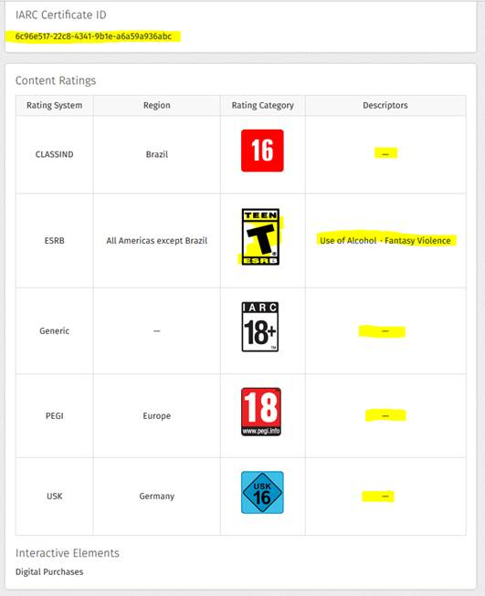

Our **GetRatingChanges** web service response returns the correct data. As you can see, only an ESRB change is shown:

{

  "TotalRecordCount": 1,

  "HasMore": false,

  "Result": {

    "ResponseCode": "Success",

    "ErrorID": "",

    "ErrorMessage": ""

  },

  "CertList": [

    {

      "CertID": "6c96e517-22c8-4341-9b1e-a6a59a936abc",

      "DateCreated": "2016-03-16T14:11:22.847Z",

      "StoreProductID": "f3be93c2-b132-42a2-a7e1-f739101a3644",

      "StoreDeveloperID": "515542",

      "RatingList": [

        {

          "RatingID": "f43c2f04-e7e1-49fd-a4f7-f4d513a6639b",

          "RatingAuthorityID": 1,

          "RatingAuthorityShortText": "ESRB",

          "RatingLogicVersion": "6.5",

          "AgeRatingID": 3,

          "AgeRatingText": "Teen",

          "AgeRatingShortText": "T",

          "NumericLevel": 3,

          "DateCreated": "2016-03-16T15:35:25.61Z",

          "DescriptorList": [

            {

              "DescriptorID": 8,

              "DescriptorText": "ESRB_FantasyViolence",

              "DisplayOrder": 5

            },

            {

              "DescriptorID": 31,

              "DescriptorText": "ESRB_UseofAlcohol",

              "DisplayOrder": 3

            }

          ],

          "InteractiveElementList": [

            {

              "InteractiveElementID": 16,

              "InteractiveElementText": "IE_DigitalPurchases"

            }

          ]

        }

      ]

    }

  ]

}

**A call to SearchCerts shows that all RAs have descriptors:**

{

  "MatchFound": true,

  "CertID": "6c96e517-22c8-4341-9b1e-a6a59a936abc",

  "ProductName": "Test App (957dc14f)",

  "DateCreated": "2016-03-16T14:11:22.847Z",

  "ResponseInstanceIDList": [

    1827,

    1938,

    1940,

    1944,

    1950,

    1956,

    1966,

    1974,

    2221,

    1981,

    1985,

    2025,

    2035,

    2037,

    2042,

    2043,

    2048,

    2054,

    2056,

    2070,

    2095,

    2100,

    2104,

    2107,

    2212,

    2116,

    2159,

    2169,

    2177,

    2181,

    2184,

    2189,

    2193,

    2195

  ],

  "QuestionnaireVersion": "6.5",

  "RatingList": [

    {

      "RatingID": "21df2563-1248-4237-aa55-675ca3332f65",

      "RatingAuthorityID": 7,

      "RatingAuthorityShortText": "ACB",

      "RatingLogicVersion": "6.5",

      "AgeRatingID": 37,

      "AgeRatingText": "R 18+",

      "AgeRatingShortText": "R18+",

      "NumericLevel": 5,

      "DateCreated": "2016-03-16T14:11:22.847Z",

      "DescriptorList": [

        {

          "DescriptorID": 159,

          "DisplayOrder": 3,

          "DescriptorText": "ACB_HighImpactSexScenes"

        },

        {

          "DescriptorID": 199,

          "DisplayOrder": 2,

          "DescriptorText": "ACB_ReferencestoSexualViolence"

        }

      ],

      "InteractiveElementList": [

        {

          "InteractiveElementID": 16,

          "InteractiveElementText": "IE_DigitalPurchases"

        }

      ]

    },

    {

      "RatingID": "a88487ef-85a0-4272-a13e-7d7d3ec0f4c4",

      "RatingAuthorityID": 4,

      "RatingAuthorityShortText": "ClassInd",

      "RatingLogicVersion": "6.5",

      "AgeRatingID": 15,

      "AgeRatingText": "16+",

      "AgeRatingShortText": "16",

      "NumericLevel": 5,

      "DateCreated": "2016-03-16T14:11:22.847Z",

      "DescriptorList": [

        {

          "DescriptorID": 60,

          "DisplayOrder": 1,

          "DescriptorText": "ClassInd_Violencia"

        },

        {

          "DescriptorID": 64,

          "DisplayOrder": 5,

          "DescriptorText": "ClassInd_Sexo"

        },

        {

          "DescriptorID": 69,

          "DisplayOrder": 10,

          "DescriptorText": "ClassInd_LinguagemImpropria"

        }

      ],

      "InteractiveElementList": [

        {

          "InteractiveElementID": 16,

          "InteractiveElementText": "IE_DigitalPurchases"

        }

      ]

    },

    {

      "RatingID": "f43c2f04-e7e1-49fd-a4f7-f4d513a6639b",

      "RatingAuthorityID": 1,

      "RatingAuthorityShortText": "ESRB",

      "RatingLogicVersion": "6.5",

      "AgeRatingID": 3,

      "AgeRatingText": "Teen",

      "AgeRatingShortText": "T",

      "NumericLevel": 3,

      "DateCreated": "2016-03-16T15:35:25.61Z",

      "DescriptorList": [

        {

          "DescriptorID": 8,

          "DisplayOrder": 5,

          "DescriptorText": "ESRB_FantasyViolence"

        },

        {

          "DescriptorID": 31,

          "DisplayOrder": 3,

          "DescriptorText": "ESRB_UseofAlcohol"

        }

      ],

      "InteractiveElementList": [

        {

          "InteractiveElementID": 16,

          "InteractiveElementText": "IE_DigitalPurchases"

        }

      ]

    },

    {

      "RatingID": "d27674a6-5a33-4a78-abeb-c35f0817552d",

      "RatingAuthorityID": 3,

      "RatingAuthorityShortText": "PEGI",

      "RatingLogicVersion": "6.5",

      "AgeRatingID": 10,

      "AgeRatingText": "18+",

      "AgeRatingShortText": "18",

      "NumericLevel": 5,

      "DateCreated": "2016-03-16T14:11:22.847Z",

      "DescriptorList": [

        {

          "DescriptorID": 54,

          "DisplayOrder": 4,

          "DescriptorText": "PEGI_Sex"

        }

      ],

      "InteractiveElementList": [

        {

          "InteractiveElementID": 16,

          "InteractiveElementText": "IE_DigitalPurchases"

        }

      ]

    },

    {

      "RatingID": "8154fdfa-6be5-4212-ae5c-95add68a199b",

      "RatingAuthorityID": 5,

      "RatingAuthorityShortText": "USK",

      "RatingLogicVersion": "6.5",

      "AgeRatingID": 25,

      "AgeRatingText": "16+",

      "AgeRatingShortText": "16",

      "NumericLevel": 4,

      "DateCreated": "2016-03-16T14:11:22.847Z",

      "DescriptorList": [

        {

          "DescriptorID": 133,

          "DisplayOrder": 2,

          "DescriptorText": "USK_Gewalt"

        },

        {

          "DescriptorID": 138,

          "DisplayOrder": 1,

          "DescriptorText": "USK_Diskriminierung"

        },

        {

          "DescriptorID": 205,

          "DisplayOrder": 4,

          "DescriptorText": "USK_SexErotik"

        },

        {

          "DescriptorID": 210,

          "DisplayOrder": 1,

          "DescriptorText": "USK_AndeutungenSexuellerGewalt"

        }

      ],

      "InteractiveElementList": [

        {

          "InteractiveElementID": 16,

          "InteractiveElementText": "IE_DigitalPurchases"

        }

      ]

    },

    {

      "RatingID": "cac3bbfc-211d-4e17-a93e-b84128be8186",

      "RatingAuthorityID": 6,

      "RatingAuthorityShortText": "Generic",

      "RatingLogicVersion": "6.5",

      "AgeRatingID": 10,

      "AgeRatingText": "18",

      "AgeRatingShortText": "18",

      "NumericLevel": 5,

      "DateCreated": "2016-03-16T14:11:22.847Z",

      "DescriptorList": [

        {

          "DescriptorID": 54,

          "DisplayOrder": 4,

          "DescriptorText": "PEGI_Sex"

        }

      ],

      "InteractiveElementList": [

        {

          "InteractiveElementID": 16,

          "InteractiveElementText": "IE_DigitalPurchases"

        }

      ]

    }

  ]

}