Queen's Gate

Date range: 1 September, 2017 - 11 October, 2017

Queen's Gate
Y9
Date range: 1 September, 2017 - 11 October, 2017
Average teacher performance : 2.625

Overall comment: Stephanie Goreli, Honor Makhlouf, Katherine Neely,

*Please see the following pages for an individual class breakdown and performance*

Queen's Gate
Class Y9
Date range: 1 September, 2017 - 11 October, 2017
Total number of students found : 8
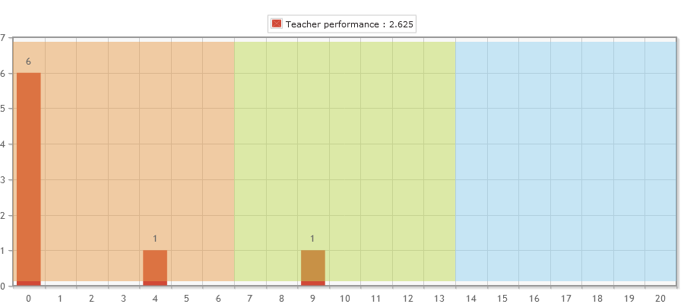

Queen's Gate
Class Y9
Date range: 1 September, 2017 - 11 October, 2017
Name | Fu | Total Points | Homework Points | Sound Game Points | Character Game Points | Stroke of Genius Points | Behaviour Points
Stephanie Goreli | Light Brown Fu | 4360 | 0 | 1045 | 975 | 940 | 1400
Honor Makhlouf | Dark Blue Fu | 1805 | 0 | 125 | 220 | 1060 | 400
Katherine Neely | No Fu | 0 | 0 | 0 | 0 | 0 | 0
Isla Wallrock | No Fu | 0 | 0 | 0 | 0 | 0 | 0
Lweji Lopes Padre | No Fu | 0 | 0 | 0 | 0 | 0 | 0
Anoushka Dhillon | No Fu | 0 | 0 | 0 | 0 | 0 | 0
Aurore Ashe-Taylor | No Fu | 0 | 0 | 0 | 0 | 0 | 0
Leila Khan | No Fu | 0 | 0 | 0 | 0 | 0 | 0

