Health and Safety Information
for
CONTRACTORS

Department of Physics
May 2017

Health and Safety Information for Contractors

Index

 | Page
Contact and access details | 3
Welfare and emergency arrangements | 4
Fire precautions | 4
Hazards specific to the Department | 6
Asbestos | 8
Waste disposal & recycling | 9

Contractor company: | Contractor’s name (please print):
Date: | Emergency Contact Number:

Contact and Access Details

Contacts in the Department

Your project should have been discussed with the Laboratory Superintendent or the Maintenance team in advance. These are working laboratories and it is important not to wander about the Department – there are several situations which could kill!

If you need to interrupt services, such as electricity, gas, water, ventilation etc, please liaise with the Laboratory Superintendent/ Maintenance team before doing so, in order that people are able to make their area safe.
We expect you to:
- have the necessary skills for your work,
- put together risk assessments and method statements
- work to recognised standards where applicable (e.g. wiring regulations).

We reserve the right to request copies of risk assessments and method statements, even if you have already submitted these to Estates Management.

Key Contacts
Role | Name | Room number | Telephone | Mobile
Laboratory Superintendent | Peter Norman | 222 | 01223 337417 | 07768 684031
Maintenance Supervisor | Alan Turner |  | 01223 337404 | 07824 317366
Safety Officer, Fire Safety Manager | Saba Alai | 208B | 01223 337397 | 07817 602858
Safety Technician, Deputy Fire Safety Manager | Damion Box | 208B | 01223 337421 | 07834 319547
Reception |  |  | 01223 337200
Security |  |  | 01223 331818
Emergency Number for Physics |  |  | 01223 337499

Access Arrangements

Your hours of access are: ………………. To ……………………….
Exceptions are by special arrangement.
Please sign in at Reception to receive a Visitors’ badge EACH DAY you are on site.
You may only park where designated by Reception.
Materials and waste may be stored temporarily here:………………………………

Welfare and Emergency Arrangements

Please read the ‘Emergencies’ notice posted up around the department

Welfare Arrangements
There are toilet and washing facilities scattered around the buildings – you may use them unless otherwise discussed.

The canteen opposite Reception is available to all, and you can take your own food and drink in there. We ask that you don’t walk mud into the facilities. There are machines for sandwiches and snacks at the entrance on the south side of the Bragg building (close to the cycle sheds). You are welcome to use the seating in that area.
First Aid
If you need a first aider either call the Department emergency number 01223 337499 (just 37499 from an internal telephone), or press ‘1’ from a red telephone and give full details of where you are and what the problem is. Alternatively send someone to Reception for help. The Department has First Aiders who can be called quickly if you call the above emergency number. We do not have first aid arrangements before 8:30am and after 5pm or at weekends.

Fire Alarms
Wherever you work, find at least two ways out of the building before starting.
If you find a fire, press the red break glass button on your way out of the building.
On hearing the alarm please leave your work area (in a safe condition)and the building. Report to the Fire Safety manager outside Reception.

If you think you may have accidentally triggered the alarm yourselves, please come to Reception (or call 01223 337499) and tell us as quickly as possible, so that we can inform the Fire Serviceand avoid them having a wasted journey. They will fine us if there are too many such false alarms.

If your work is likely to create dust, for example by drilling holes in walls, cleaning filters, or hot work,please let us know so that we can cover the alarms and/or disable them.
Other Emergencies
If your work causes a flood or other problem, contact Reception on 01223 337499, or send someone there quickly, so that someone from Maintenance can be called to deal with the issue.

Fire Precautions
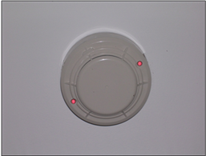
Smoke heads
These are sensitive to dust, fumes etc. If you are doing anything that could set them off, please cover the smoke heads in the immediate area after discussion with Maintenance, who will also provide suitable covers or will disable the heads. At the end of each day, and when you have finished the job, smoke heads MUST be left uncovered.

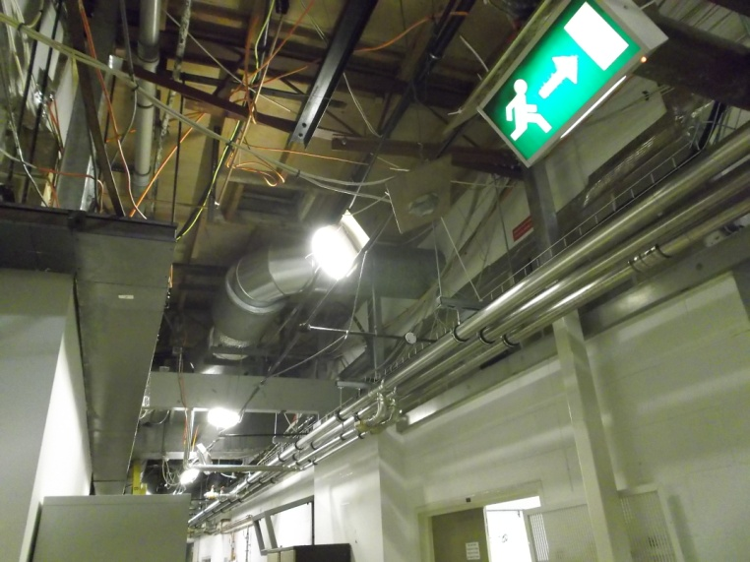

Signage/emergency lights and other precautions
If you have to move these or disturb their mountings, please ensure that they are replaced, pointing in the right direction, at the end of your work. Please ask for help from the Maintenance team if this is difficult.

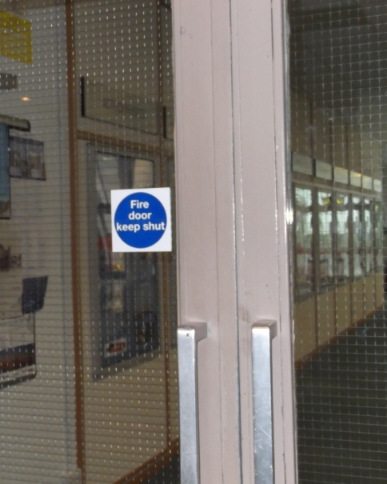

‘Fire door – Keep Shut’ (1)
This type of fire door MUST be kept shut as there are high fire risks in the department. In EXCEPTIONAL circumstances a door can be open provided:
- You never leave it open unattended
- You close it immediately if the fire alarm sounds
- You have permission to do so from the Maintenance team.

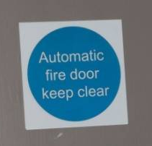
‘Fire door – Keep Clear’ (2)
This type of fire door MUST be kept open, but the floor area around it must be kept clear so that when the magnets release the door it will actually close. Do not put anything in the way.

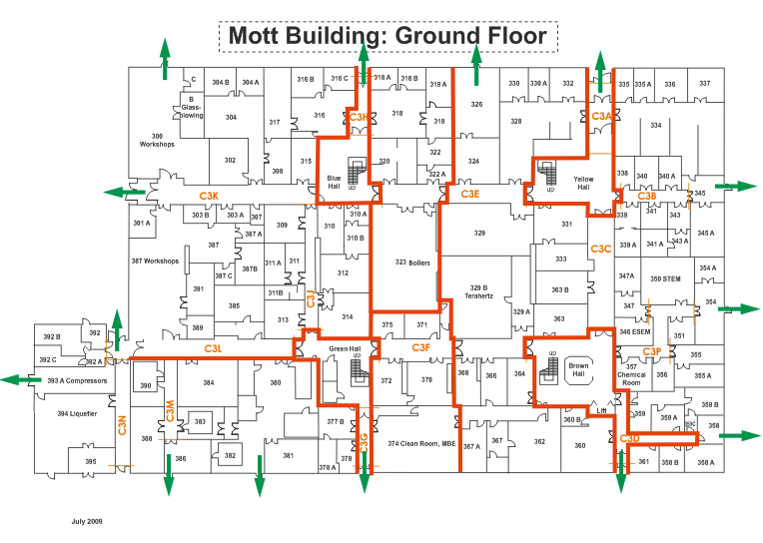

Fire resisting walls
Fire resisting walls are in place in many buildings to delay the spread of fire. Some are made of asbestos. Any hole must be properly sealed to avoid breaching the fire precautions. Please check with Maintenance personnel and ensure that you follow any instructions you are given by them.
See example of fire resisting walls in one building in this diagram:

Fire evacuation and assembly
Before starting work, look for the nearest two fire exit routes (in case one is blocked), and assembly points. Alarms are tested on Monday mornings between 0800 and 0900. If you hear an alarm at other times, or at this time for more than 30 seconds, leave your work area and go to the assembly point nearest you (see diagram). If it will not delay you, leave the work area safe – always turn off gases you are working with. Fire wardens or members of the Emergency Bronze team will notify you when it is safe to go back, or will move you further from the building if the fire is spreading, to avoid injury from rupturing compressed gas cylinders.

Please note at the Battcock Centre – Assembly is on the Telescope Lawn.
A5
A2
A3

A4
Maxwell Centre
A1
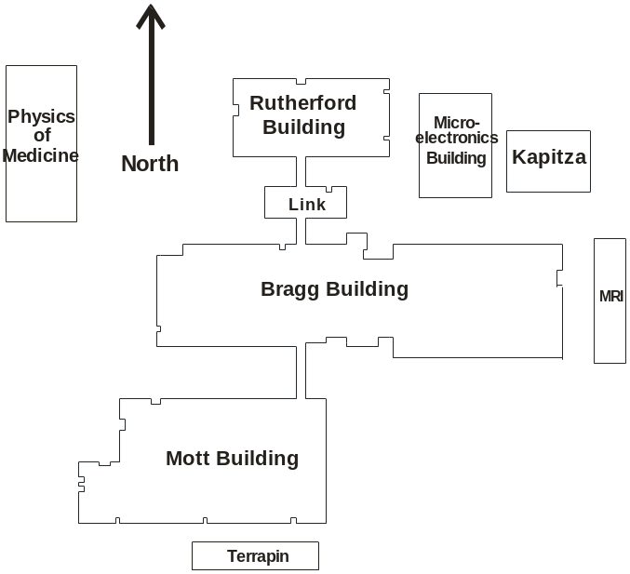
A6
The Main Cavendish Site

A Indicates Assembly Area

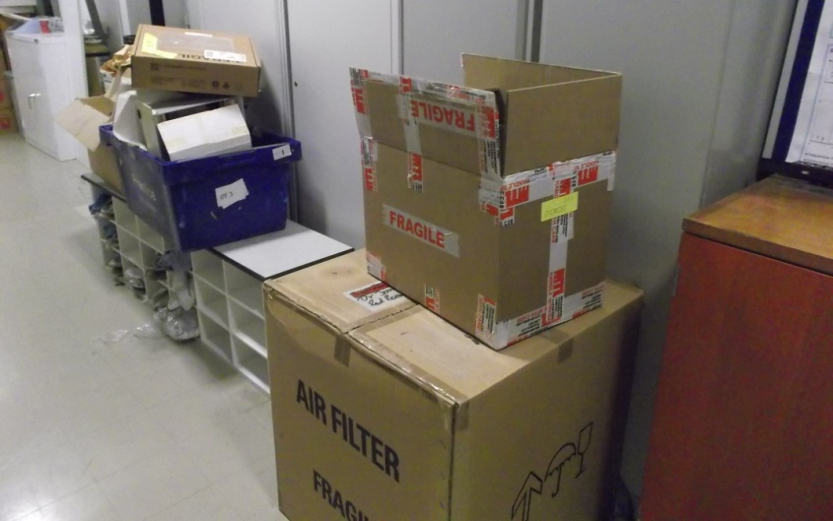
Housekeeping
Keep the area tidy; DO NOT obstruct escape routes or fire doors. Please talk to the Maintenance team about your work layout and whether this might affect exit routes (e.g. needing to keep fire doors open).

Avoiding Fires in Waste
Please ensure that you remove waste regularly, especially combustible waste. Please ask the Maintenance team where each type of waste can be placed, or if you need to take all waste away when you leave.

Hazards Specific to the Department
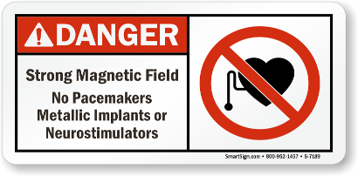
Magnets/Electromagnetic Fields: A lot of our labs include strong magnets that are permanently on and generate strong magnetic fields. These are dangerous to people with pacemakers, metal implants and other devices. If you have these, please notify Maintenance immediately so we can make suitable arrangements. Some of the magnets will also cause metal objects to go flying and can cause injuries – you must find out about each room you are likely to work in, if you see the signs for magnetic fields.

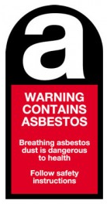
Asbestos: most of the buildings contain asbestos –
see the next section. You will need a Permit to Work from
Maintenance team if you need to drill holes in any walls, floors or ceilings.

Cryogenic Gases
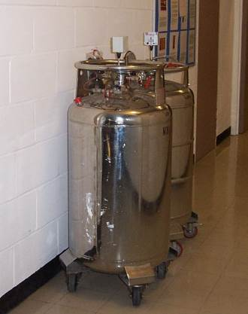
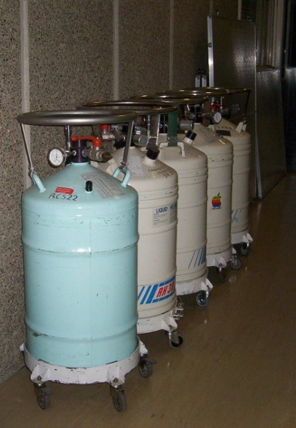
The vessels shown are called Dewars and contain liquid nitrogen or liquid helium. This is VERY COLD and can cause burns. The vapour also can cause death by asphyxiation (suffocation).

If one of these is knocked over, making a lot of noise or releasing clouds of vapour or liquid,
DO NOT go near it. Call the emergency number
for the department to get someone to help.

Piped nitrogen Gas
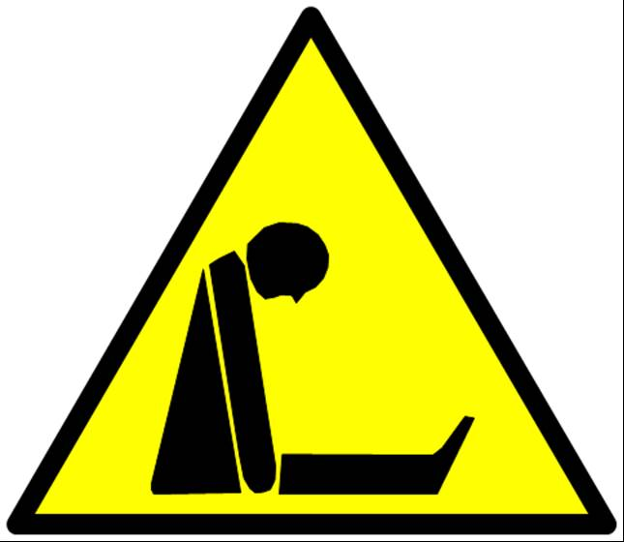
Lines that are marked ‘nitrogen’ in the older buildings are fed with this gas from the big tanks outside. If one of these lines is leaking, it could cause death by asphyxiation. If you become aware of a leak (for example an oxygen monitor is beeping) or feel slightly drunk, report it immediately. The nitrogen lines in the Physics of Medicine will not release as much gas, and in the Maxwell and parts of Microelectronics buildings there are fixed oxygen monitors that will alert to you to leak of nitrogen or other asphyxiating gas (such as Argon or Helium). Get OUT of the building if these alarms go off, walking away from the sound.

Gas Cylinders (Pressurised Gas)
These SHOULD be tethered. However, sometimes you may come across one that isn’t. If you do, please give it a wide berth and inform the Safety Officer.

Lasers
Many rooms contain lasers, which could damage your eyes – these usually have interlocked doors and the sign on the right. If you need to enter such a room, please knock and wait.

Rooms with Chemicals, Biological Work, Radioactive Substances
If your work is likely to take you into these areas you will be shown around and given information about what you should avoid touching. Some warning signs to watch out for are:
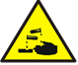
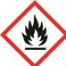
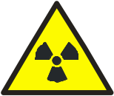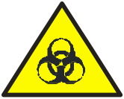

INCLUDEPICTURE "https://www.sksigns.co.uk/v/vspfiles/photos/DS_000032-2.jpg" \* MERGEFORMATINET

Work at Height, on Roofs or Hot Work
These activities will require a Permit to Work – obtainable from Maintenance team.

Work that Disturbs the Fabric of the Building
Any work that involves drilling holes in, or otherwise disturbing or damaging, the fabric of the building, might affect asbestos, and will require a Permit to Work from the Maintenance team.

If in doubt, please ASK!
Asbestos Information for Contractors Working in the Cavendish Laboratory

The site contains 8 buildings; all except the garage and Physics of Medicine are built to the CLASP methodology. The Mott, Rutherford, Link and Bragg buildings were constructed in the 1970s and it is probable that they are Mark 4 CLASP buildings.

- Buildings that contain asbestos materials within their fabric are:
- Rutherford
- Link (Estate Management call this building the Workshop Building)
- Bragg
- Mott
- Garage

- Buildings that do not contain asbestos materials in their fabric are:
- Microelectronics/Hitachi
- Kapitza (formerly known as IRC in Superconductivity)
- Physics of Medicine
- Maxwell Centre

Asbestos Materials and Department Policy
You must not carry out any work that could affect the fabric of any building shown in A above, without first obtaining a Permit to Work from the Maintenance team. This is so you can avoid releasing asbestos fibres into the air, and creating a risk of breathing them in for yourself and others.

You are also not permitted to lift false (suspended) ceiling tiles without permission from Maintenance.

The department has a strict rule that asbestos-containing materials are not to be disturbed, worked on or damaged. Where major refurbishment works are carried out, a licensed contractor is called in to remove the asbestos materials with the exception of the cladding around the steel columns. Clearance certificates are obtained.

Contractors called in to do minor works are given information about the asbestos-containing materials.

All personnel who work in the Department on the fabric of the building should have received asbestos awareness training. If your personnel have not then the Department can offer this training free of charge.

Emergency Procedures
Members of the Department have been instructed to report any damage to asbestos- As a Contractor, if you accidentally disturb asbestos, or discover what appears to be damaged asbestos material in the course of your work, please cordon off the area and report it to the Maintenance Team or Departmental Safety Officer as soon as possible.
The report would then be actioned by:
- (If the asbestos is released or liable to be released) clearing the area and securing it
- Informing the asbestos team at Estate Management
- Making any report required under RIDDOR
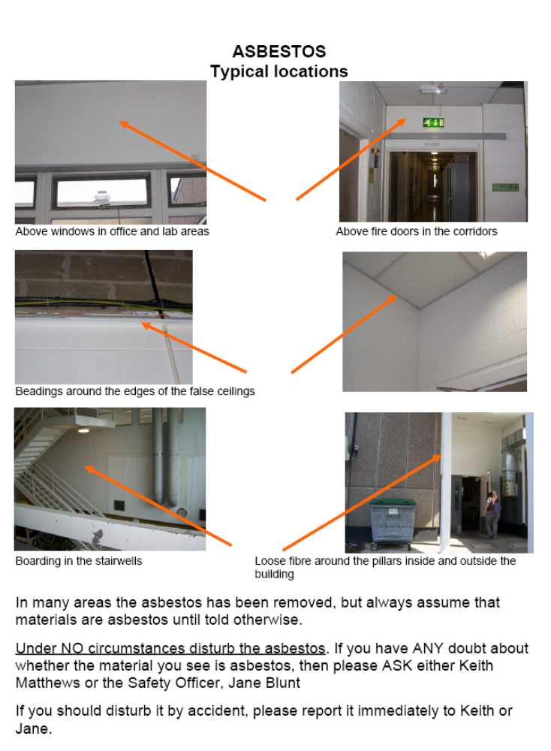

Waste Disposal and Recycling
You must plan to remove any waste produced by your work. If this is not possible, discuss with the Maintenance team in advance, to determine what you must do.

