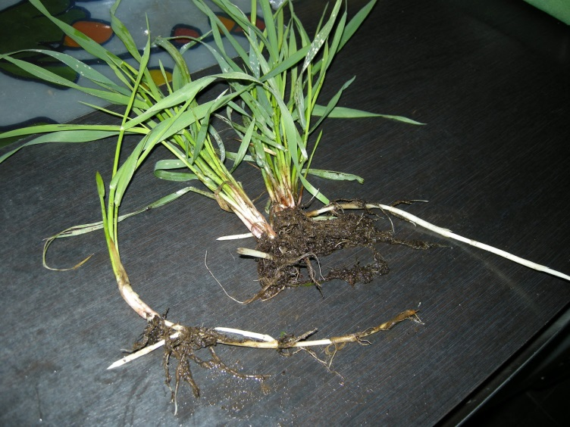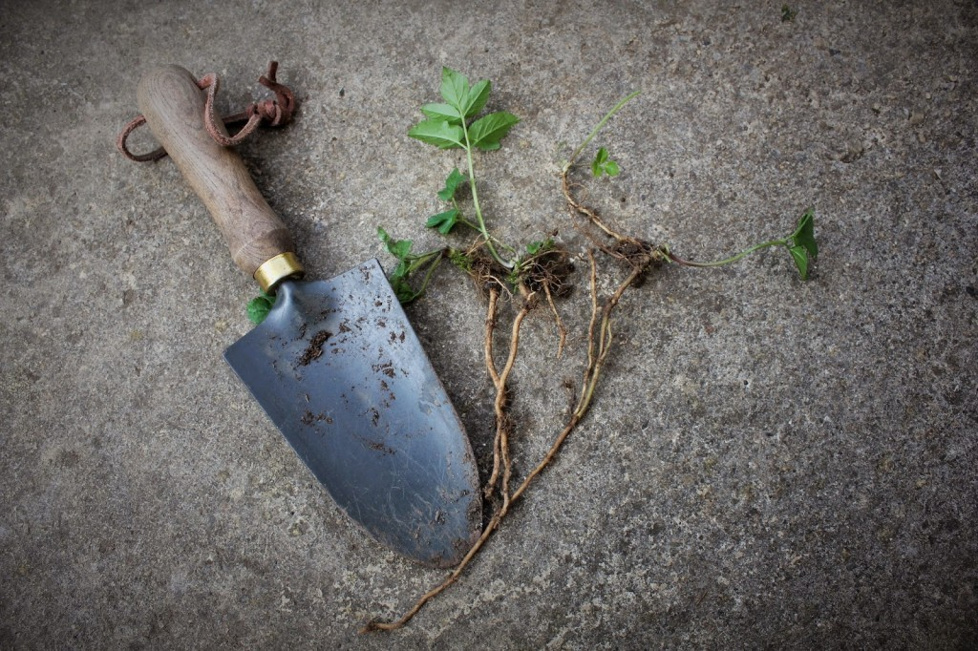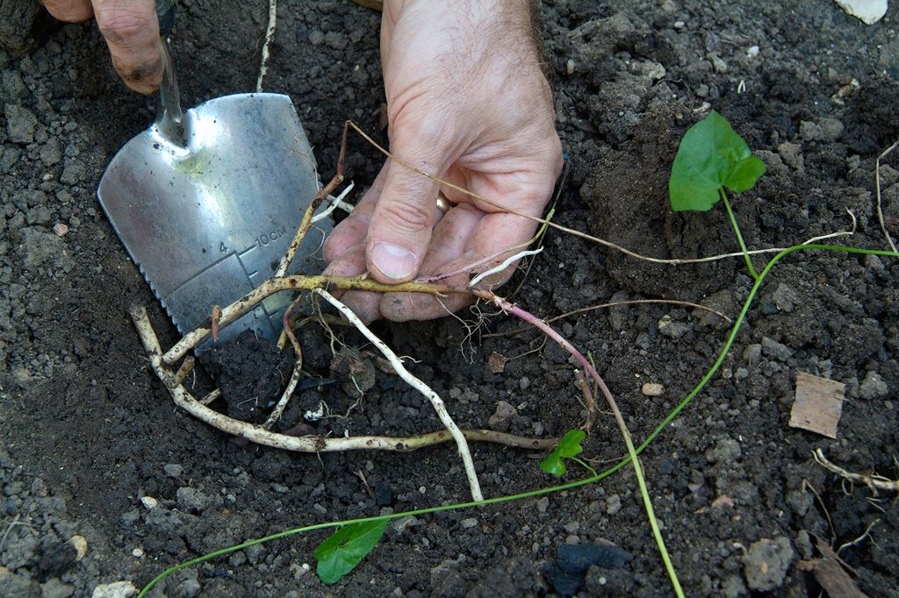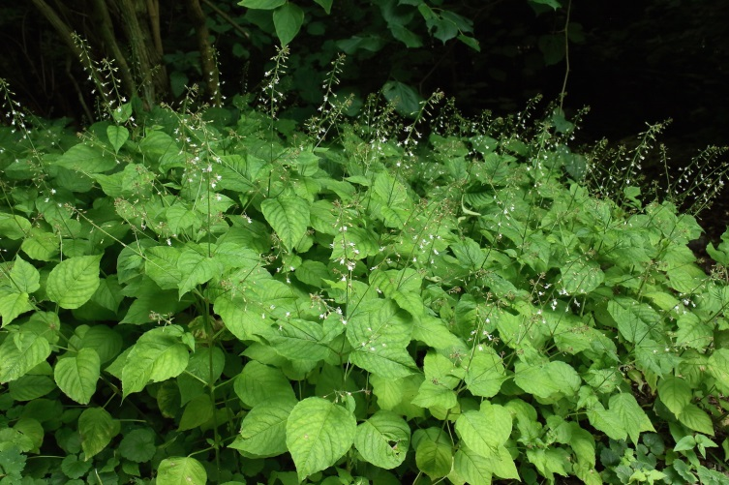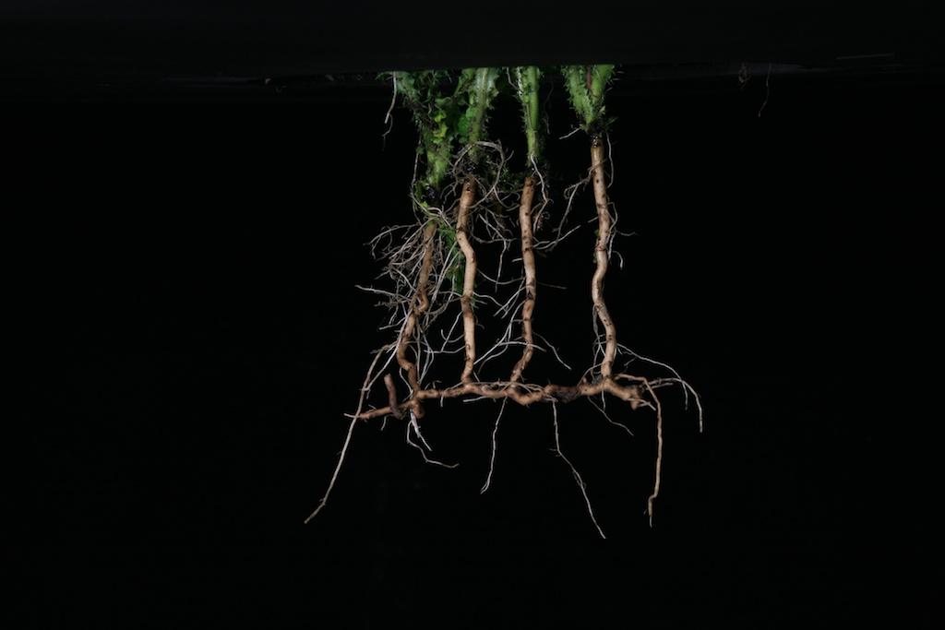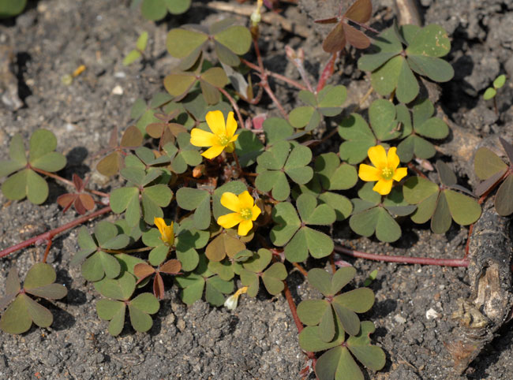

Ground elder

Couch grass

Field bindweed

Hedge bindweed

Creeping thistle

Enchanter’s nightshade

Horsetail

Yarrow

Creeping buttercup

Creeping woodsorrel

Dog’s Mercury

Mint

Bamboo

Raspberry

**Plants with spreading rhizomes/roots**

DO NOT COMPOST