Subject has the correct encoding after import from outlook

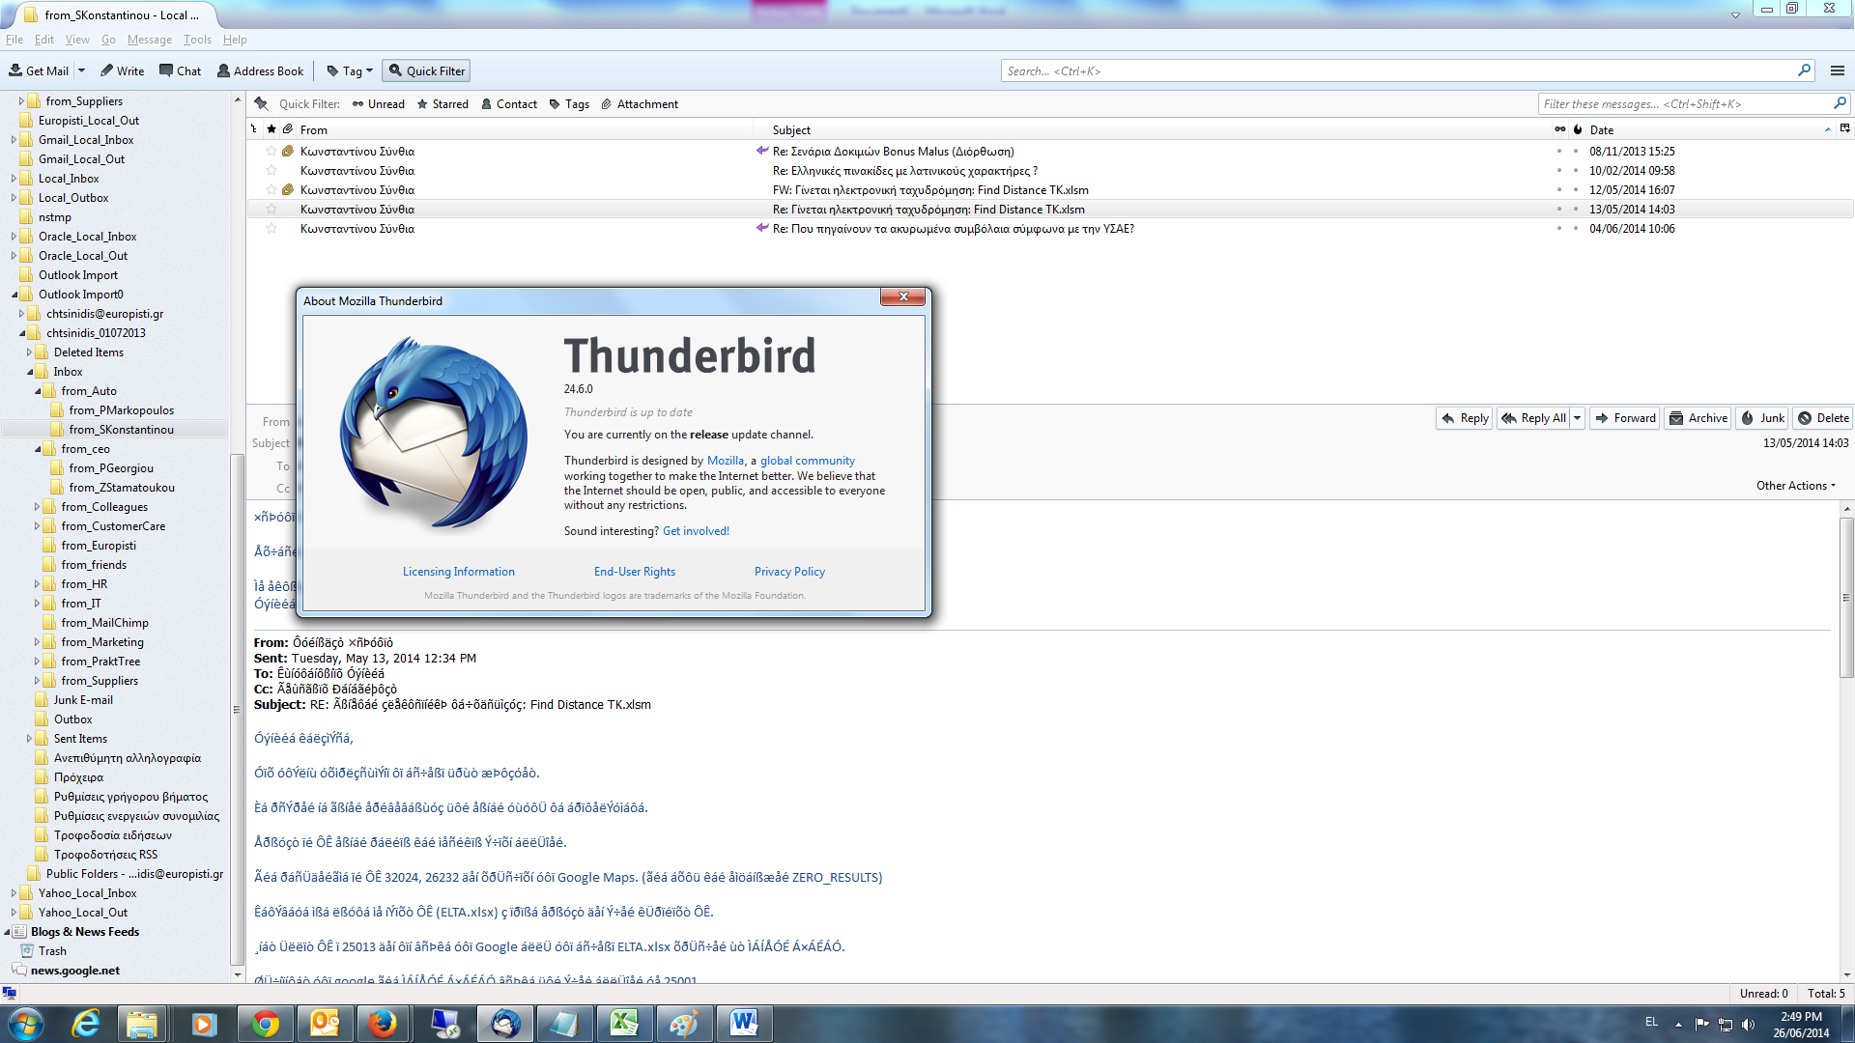

Body has not the correct encoding after import from outlook