Vulnerability Disclosure – Jbig2dec library (latest version)
Title: Denial of Service (crash) due to access Null pointer when parsing an illegal file.
Vendor: Open Source (https://artifex.com/developers-ghostscript-jbig2dec/ )
Affected Product name(s) and versions: Jbig2dec latest version including stable version (0.13)
Platform used (OS): Linux – Ubuntu 16.04 x86_64
Summary of the issue:
Jbig2dec latest version, as used in MuPDF and Ghostscript, has a NULL pointer dereference in the jbig2_huffman_get function in jbig2_huffman.c. For example, the jbig2dec utility will crash (segmentation fault) when parsing an invalid file.
Example output:
./jbig2dec ../crash/crash0000
jbig2dec FATAL ERROR missing glyph 0/0! (segment 0x01)
ASAN:DEADLYSIGNAL
=================================================================
==79982==ERROR: AddressSanitizer: SEGV on unknown address 0x000000000000 (pc 0x7fc274de397d bp 0x7ffefb069590 sp 0x7ffefb069370 T0)
#0 0x7fc274de397c (/home/root/fuzz/jbig2dec-clang/.libs/libjbig2dec.so.0+0x1697c)
#1 0x7fc274dfc925 (/home/root/fuzz/jbig2dec-clang/.libs/libjbig2dec.so.0+0x2f925)
#2 0x7fc274df404d (/home/root/fuzz/jbig2dec-clang/.libs/libjbig2dec.so.0+0x2704d)
#3 0x7fc274deff04 (/home/root/fuzz/jbig2dec-clang/.libs/libjbig2dec.so.0+0x22f04)
#4 0x7fc274de8a2e (/home/root/fuzz/jbig2dec-clang/.libs/libjbig2dec.so.0+0x1ba2e)
#5 0x7fc274dde0a0 (/home/root/fuzz/jbig2dec-clang/.libs/libjbig2dec.so.0+0x110a0)
#6 0x4eaea2 (/home/root/fuzz/jbig2dec-clang/.libs/lt-jbig2dec+0x4eaea2)
#7 0x7fc273a9d82f (/lib/x86_64-linux-gnu/libc.so.6+0x2082f)
#8 0x418fe8 (/home/root/fuzz/jbig2dec-clang/.libs/lt-jbig2dec+0x418fe8)

AddressSanitizer can not provide additional info.
SUMMARY: AddressSanitizer: SEGV (/home/root/fuzz/jbig2dec-clang/.libs/libjbig2dec.so.0+0x1697c)
==79982==ABORTING
Debug info:
Starting program: /home/root/fuzz/jbig2dec/jbig2dec ../crash/crash0000
jbig2dec FATAL ERROR missing glyph 0/0! (segment 0x01)

Program received signal SIGSEGV, Segmentation fault.
jbig2_huffman_get (hs=hs@entry=0x651370, table=0x0, oob=oob@entry=0x7fffffffc970) at jbig2_huffman.c:274
274 int log_table_size = table->log_table_size;
(gdb) p table
$1 = (const Jbig2HuffmanTable *) 0x0
(gdb) bt
#0 jbig2_huffman_get (hs=hs@entry=0x651370, table=0x0, oob=oob@entry=0x7fffffffc970) at jbig2_huffman.c:274
#1 0x0000000000408092 in jbig2_decode_text_region (ctx=ctx@entry=0x619240, segment=segment@entry=0x626da0, params=params@entry=0x627120, dicts=dicts@entry=0x626fd0, n_dicts=n_dicts@entry=1,
image=image@entry=0x651320, data=0x61a474 "\336\177\001", size=34, GR_stats=0x64f2c0 "", as=0x626e00, ws=0x626de0) at jbig2_text.c:340
#2 0x0000000000405e87 in jbig2_decode_symbol_dict (GR_stats=<optimized out>, GB_stats=<optimized out>, size=<optimized out>, data=<optimized out>, params=0x7fffffffcce0, segment=0x626da0, ctx=0x619240)
at jbig2_symbol_dict.c:496
#3 jbig2_symbol_dictionary (ctx=ctx@entry=0x619240, segment=segment@entry=0x626da0, segment_data=<optimized out>) at jbig2_symbol_dict.c:996
#4 0x0000000000404530 in jbig2_parse_segment (ctx=ctx@entry=0x619240, segment=segment@entry=0x626da0, segment_data=<optimized out>) at jbig2_segment.c:234
#5 0x0000000000403a21 in jbig2_data_in (ctx=ctx@entry=0x619240, data=data@entry=0x7fffffffce60 "\227JB2\r\n\032\n\001", size=<optimized out>) at jbig2.c:312
#6 0x0000000000401697 in main (argc=<optimized out>, argv=0x7fffffffdf88) at jbig2dec.c:456

Explanation:
Object tparams is the instance of struct Jbig2TextRegionParams.
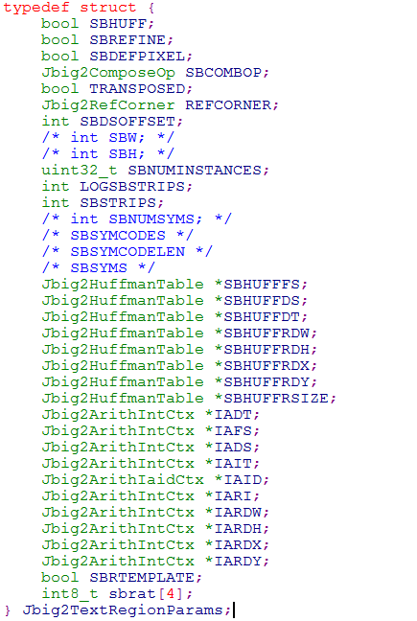
tparams instance is initialized in line 449 of jbig2_decode_symbol_dict function in jbig2_symbol_dict.c. And, it is passed into jbig2_decode_text_region as a parameter in line 496 of jbig2_decode_symbol_dict function. We can see that, tparms->SBHUFFRSIZE is not changed from line 449 to line 496.
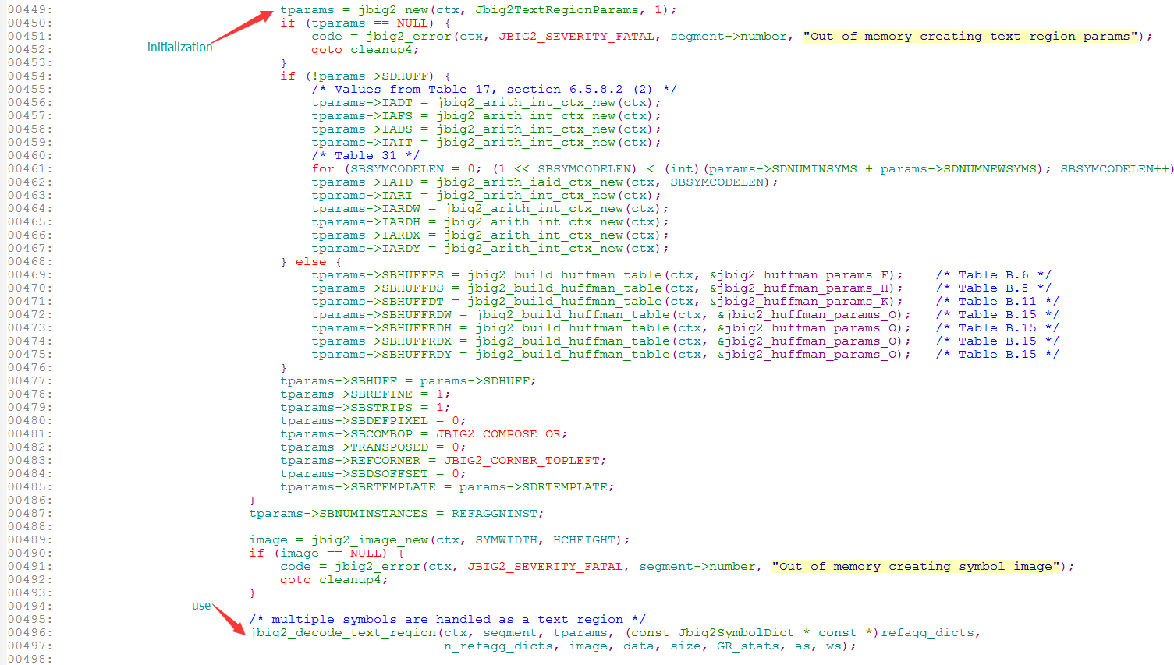
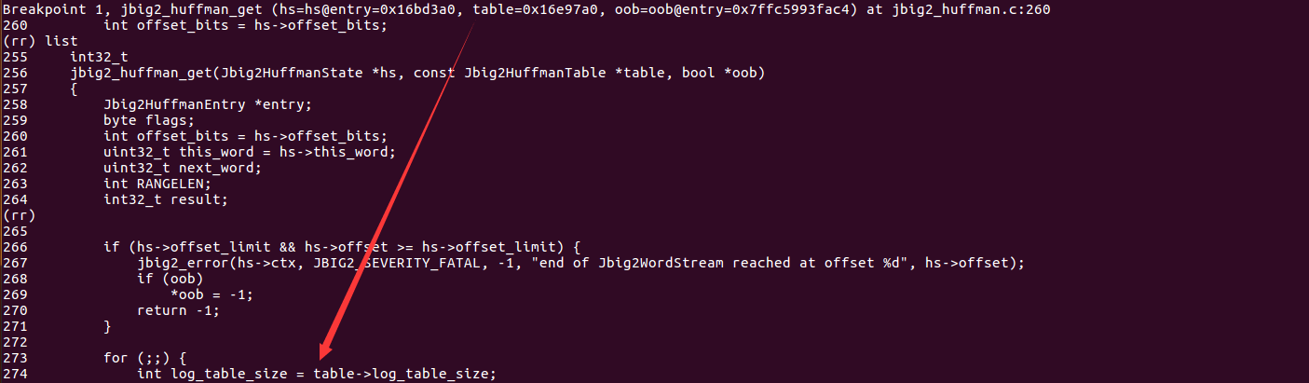
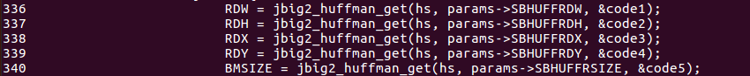
In line 340 of jbig2_test.c, tparams-> SBHUFFRSIZE is passed to jbig2_huffman_get function as a parameter. Then when program try to access tparams-> SBHUFFRSIZE->log_table_size, it crash for Null pointer deference.

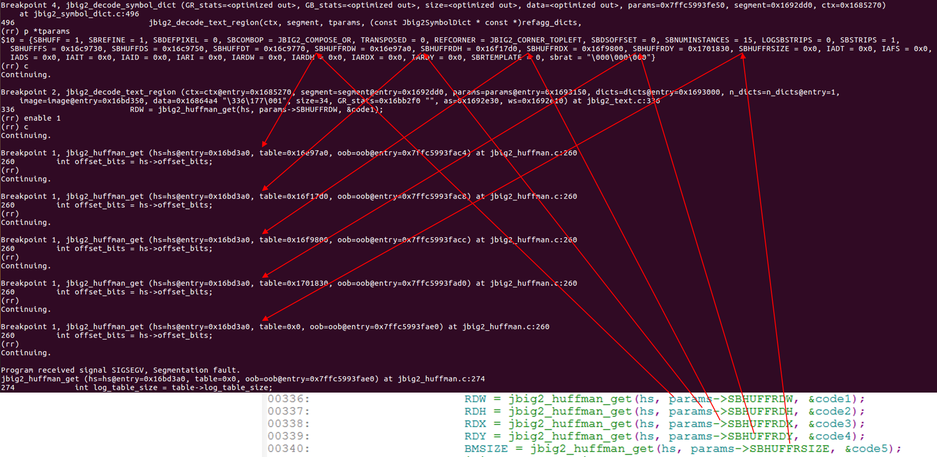
Suggestion for patch:
Assign tparams-> SBHUFFRSIZE with something instead 0x0.
Credits:
Young_X and Chenghao Rong from VARAS@IIE

