XSS in GhostScript

Affected URL :- https://bugs.ghostscripts.com/popup/searchTaxes.php
Screenshots:-

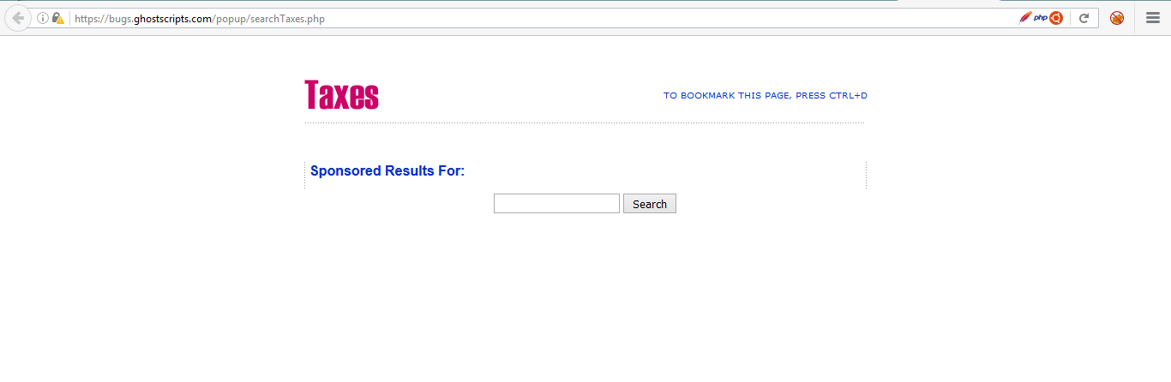

Payload:- <script>alert(“you have been hacked”)</script>

Enter the payload in the search filed and you will get end in executing the script and getting popup.

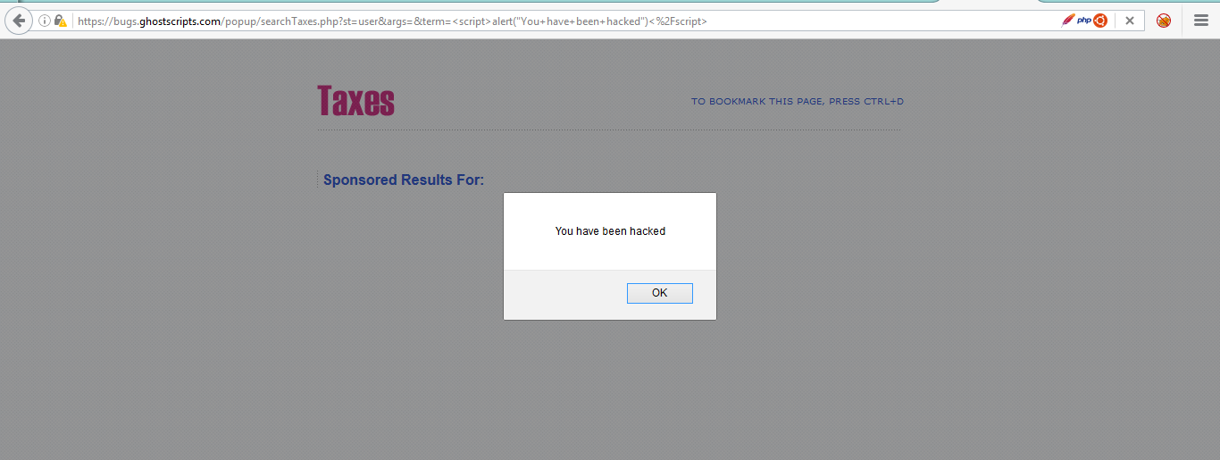

Remediation :- https://www.owasp.org/index.php/XSS_(Cross_Site_Scripting)_Prevention_Cheat_Sheet
Please follow the OWASP prevention sheet to remediate XSS.

