Critical Directory Browsing

Affected URL :- https://ghostscript.com/doc/openjpeg/src/lib/openjp2/
https://ghostscript.com/doc/

By doing some enumeration from the directory I got the source code of the various applications which are written in c language.

POC
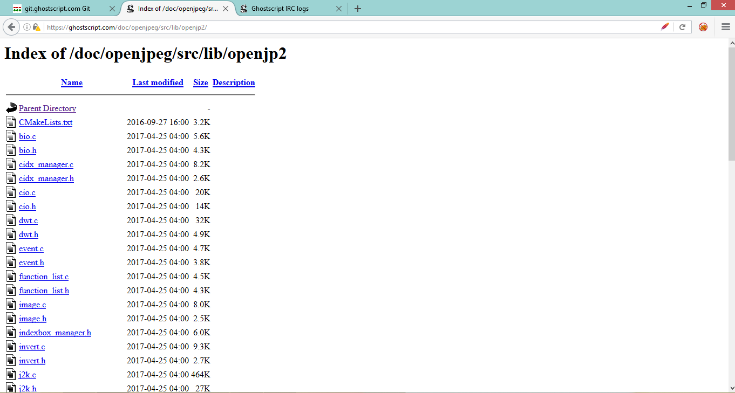

Also I am able to read the conversation of the users via access the IRC logs.

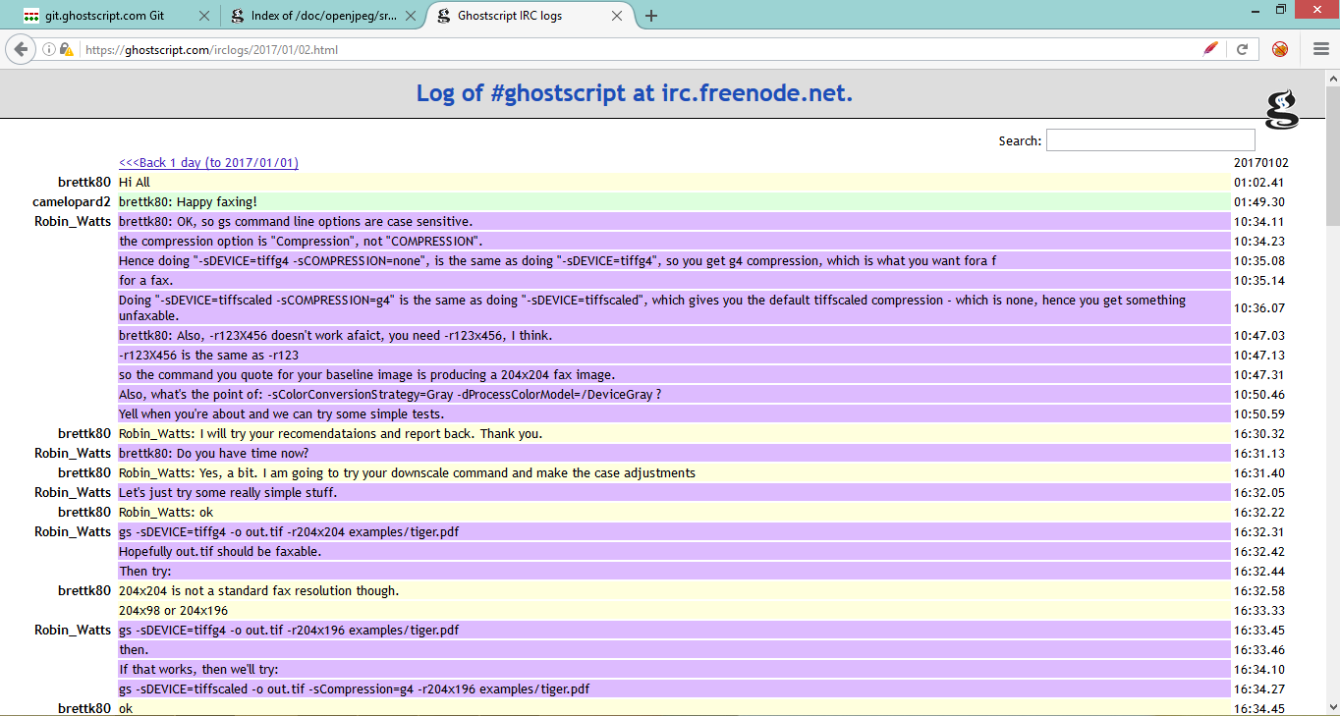

Remediation:- Access to the directories should not be allowed as it may disclose the critical information.

