- I’m trying to print a .pdf with the following command
gsprint.exe -noquery -potrait -dPDFFitPage -I="C:\Program Files\gs\gs9.19\fonts" -sFONTPATH="%windir%\fonts" -dEmbedAllFonts=true -printer"PHL0PKM423" "C:\Program Files\gs\gs9.19\bin\46996138.pdf"
- When I run the command it prints the pdf and substitutes the barcode font and displays on the printed copy.
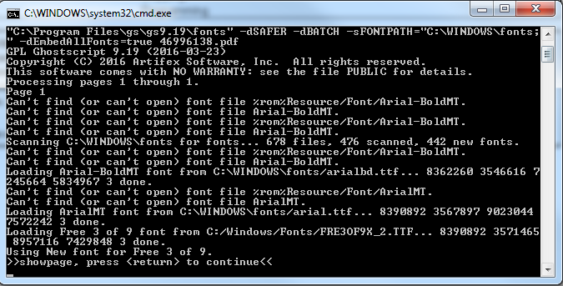
- Since the Free 3 of 9 font is not embedded in the pdf I’ve created a FONTMAP.GS file with these 2 lines. Without the 2 lines it does not work.
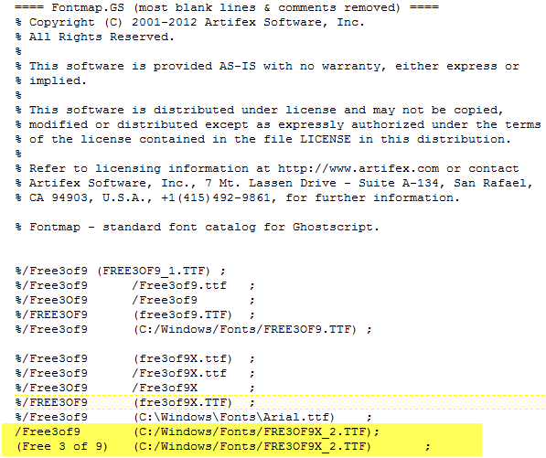
- The pdf does not convert the bar code correctly. The value in the barcode reads *405-30024517-1*.
This converts into 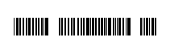the empty spaces appear to be the hyphens not converted correctly.
- To debug further, I converted the pdf to .ps file using pdf2write, on looking at the .ps file it appears that the “-“ hyphens are not converting correctly to in the bar code.
"C:\Program Files\gs\gs9.19\bin\gswin64c.exe" -dNOPAUSE -dBATCH -sDEVICE=ps2write -sOutputFile="C:\Program Files\gs\gs9.19\bin\46996138.ps" "C:\Program Files\gs\gs9.19\bin\46996138.pdf"
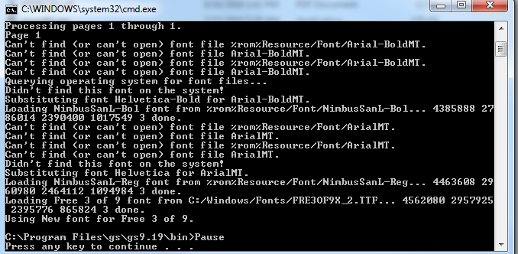

- When I try to open the file via CSView in preview window the barcode appears correct. I do not see the spaces.
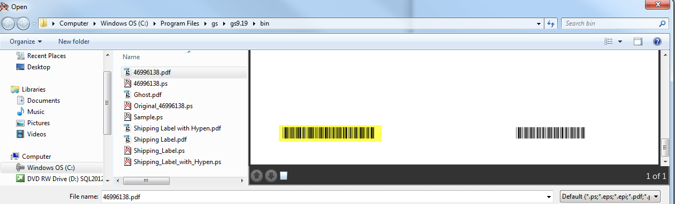
- Once it opens in GsView it adds the spaces again.
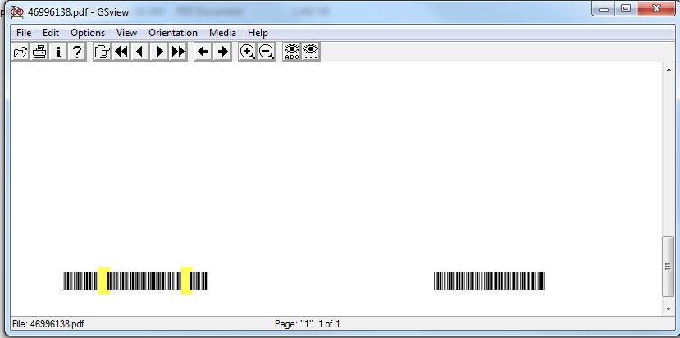
- Opening original pdf in Adobe display the following fonts.
