- The VB.Net coding in my project to convert pdf to image by using the Ghostscript library
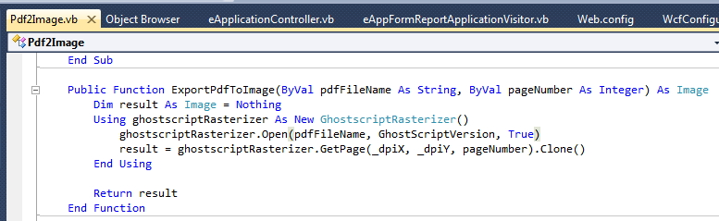

- Correct Khmer display in the pdf form
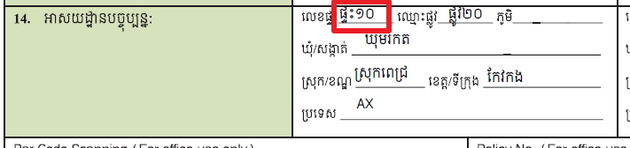
- Incorrect Khmer display in the jpg after convert from pdf by using the ghostscript
